Classification Report 2022-06-15 13:51:05.912129

## Column : Label (Disease Yes/No)

Model : lr_Classifier

Accuracy_score : 89.52 %

Loss : 10.48 %

Precision : 89.24 %

Recall : 85.01 %

f1_score : 87.07 %

Cohen_kappa_score : 78.27 %

Classification_report :   
 precision recall f1-score support  
  
 0 0.90 0.93 0.91 742  
 1 0.89 0.85 0.87 527  
  
 accuracy 0.90 1269  
 macro avg 0.89 0.89 0.89 1269  
weighted avg 0.90 0.90 0.89 1269

Confusion_matrix :   
[[688 54]  
 [ 79 448]]

### Image of images/Label_Disease_Yes_No__lr_Classifier_Accuracy_90.png :

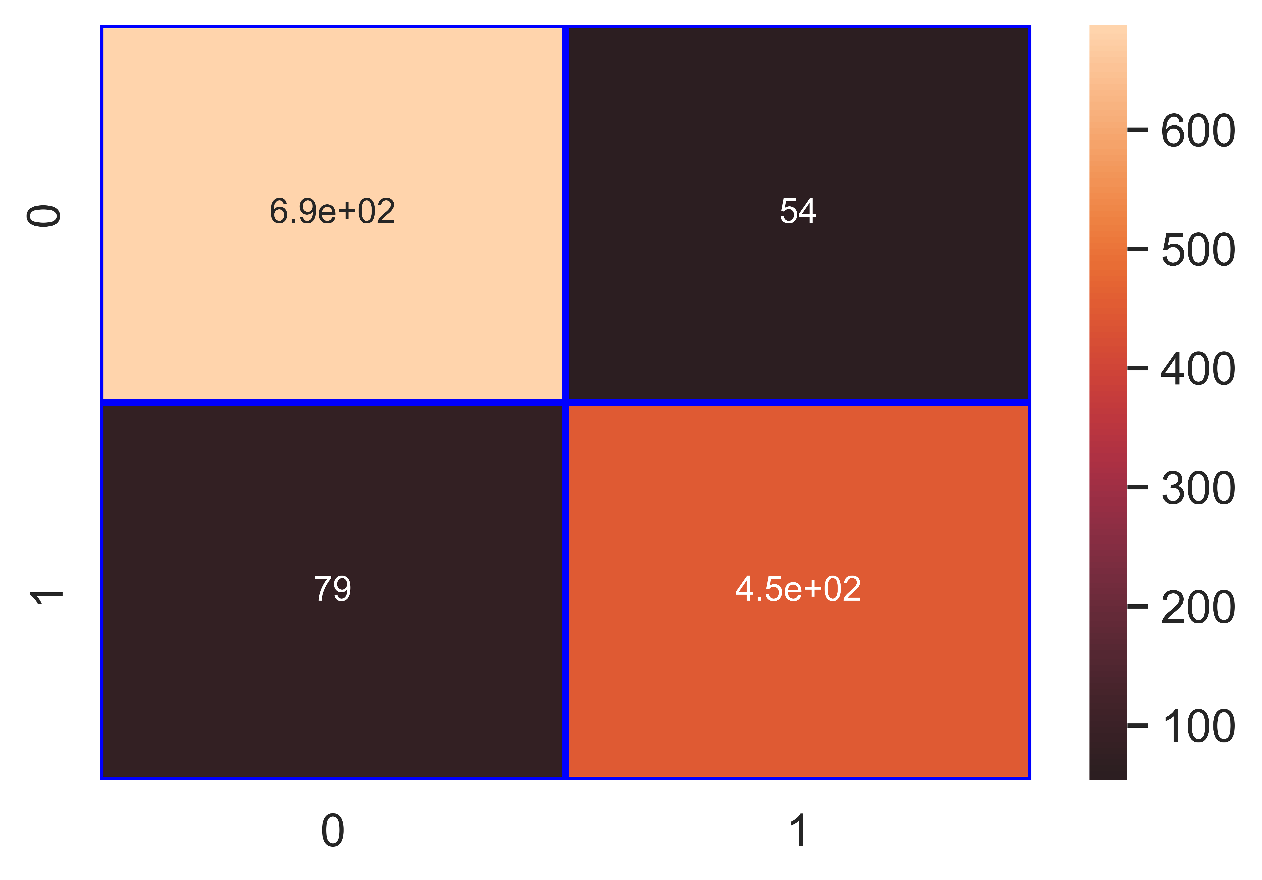

File saved : Label_Disease_Yes_No__lr_Classifier.pkl

data : {'Accuracy': 89.52, 'Loss': 10.48, 'Precision': 89.24, 'Recall': 85.01, 'f1_score': 87.07, 'Cohen_kappa': 78.27, 'Feature_name': 'Label (Disease Yes/No)', 'Model_name': 'lr_Classifier', 'Filename': 'Label_Disease_Yes_No__lr_Classifier.pkl'}

Model : knn_Classifier

Accuracy_score : 88.1 %

Loss : 11.9 %

Precision : 89.83 %

Recall : 80.46 %

f1_score : 84.88 %

Cohen_kappa_score : 75.12 %

Classification_report :   
 precision recall f1-score support  
  
 0 0.87 0.94 0.90 742  
 1 0.90 0.80 0.85 527  
  
 accuracy 0.88 1269  
 macro avg 0.88 0.87 0.88 1269  
weighted avg 0.88 0.88 0.88 1269

Confusion_matrix :   
[[694 48]  
 [103 424]]

### Image of images/Label_Disease_Yes_No__knn_Classifier_Accuracy_88.png :

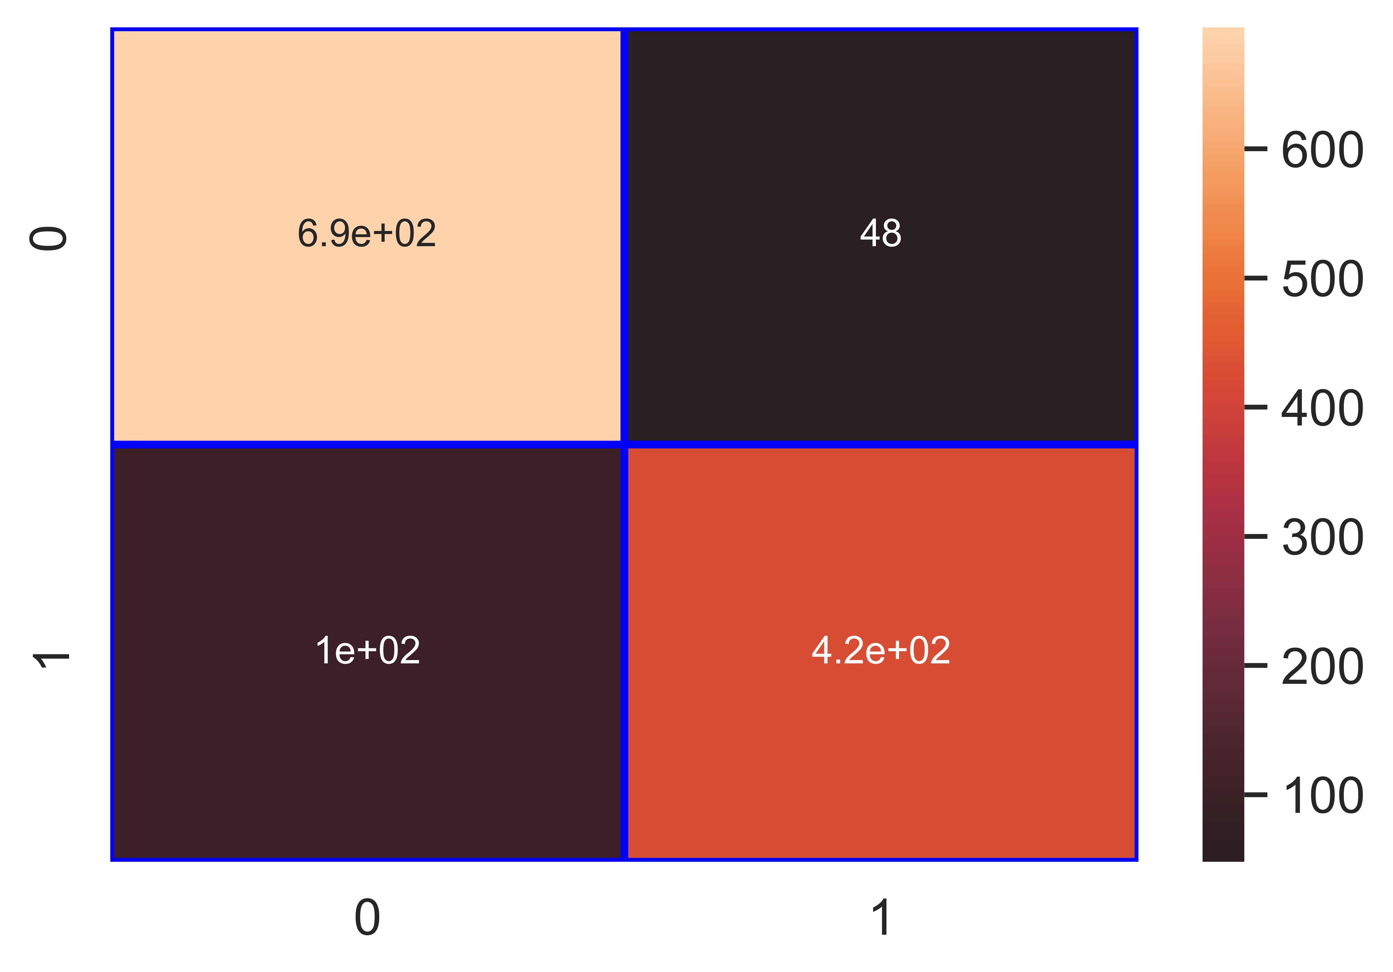

File saved : Label_Disease_Yes_No__knn_Classifier.pkl

data : {'Accuracy': 88.1, 'Loss': 11.9, 'Precision': 89.83, 'Recall': 80.46, 'f1_score': 84.88, 'Cohen_kappa': 75.12, 'Feature_name': 'Label (Disease Yes/No)', 'Model_name': 'knn_Classifier', 'Filename': 'Label_Disease_Yes_No__knn_Classifier.pkl'}

Model : nb_Classifier

Accuracy_score : 86.84 %

Loss : 13.16 %

Precision : 89.47 %

Recall : 77.42 %

f1_score : 83.01 %

Cohen_kappa_score : 72.36 %

Classification_report :   
 precision recall f1-score support  
  
 0 0.85 0.94 0.89 742  
 1 0.89 0.77 0.83 527  
  
 accuracy 0.87 1269  
 macro avg 0.87 0.85 0.86 1269  
weighted avg 0.87 0.87 0.87 1269

Confusion_matrix :   
[[694 48]  
 [119 408]]

### Image of images/Label_Disease_Yes_No__nb_Classifier_Accuracy_87.png :

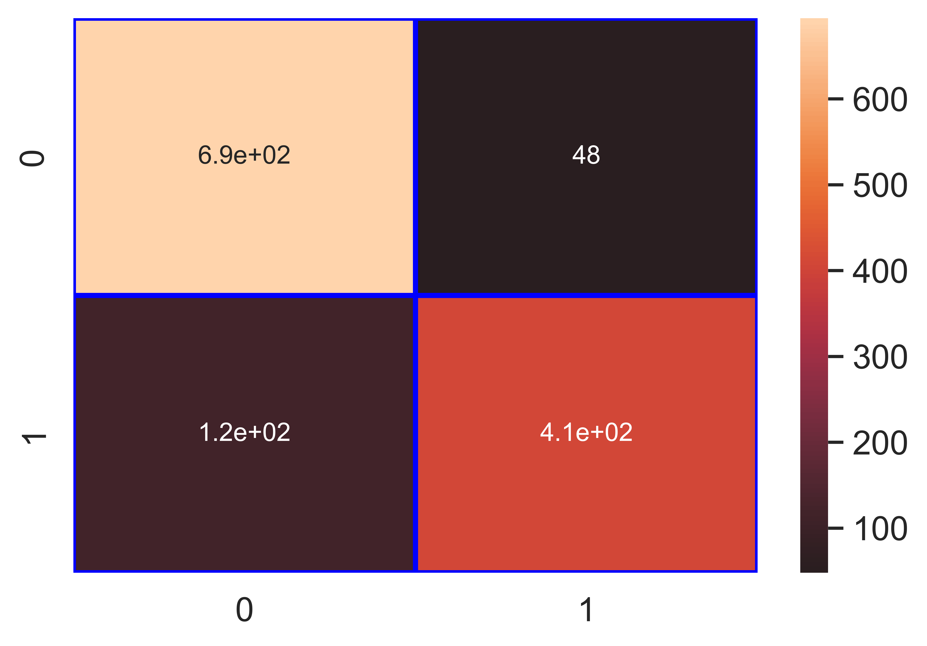

File saved : Label_Disease_Yes_No__nb_Classifier.pkl

data : {'Accuracy': 86.84, 'Loss': 13.16, 'Precision': 89.47, 'Recall': 77.42, 'f1_score': 83.01, 'Cohen_kappa': 72.36, 'Feature_name': 'Label (Disease Yes/No)', 'Model_name': 'nb_Classifier', 'Filename': 'Label_Disease_Yes_No__nb_Classifier.pkl'}

Model : svm_Classifier

Accuracy_score : 88.97 %

Loss : 11.03 %

Precision : 87.0 %

Recall : 86.34 %

f1_score : 86.67 %

Cohen_kappa_score : 77.26 %

Classification_report :   
 precision recall f1-score support  
  
 0 0.90 0.91 0.91 742  
 1 0.87 0.86 0.87 527  
  
 accuracy 0.89 1269  
 macro avg 0.89 0.89 0.89 1269  
weighted avg 0.89 0.89 0.89 1269

Confusion_matrix :   
[[674 68]  
 [ 72 455]]

### Image of images/Label_Disease_Yes_No__svm_Classifier_Accuracy_89.png :

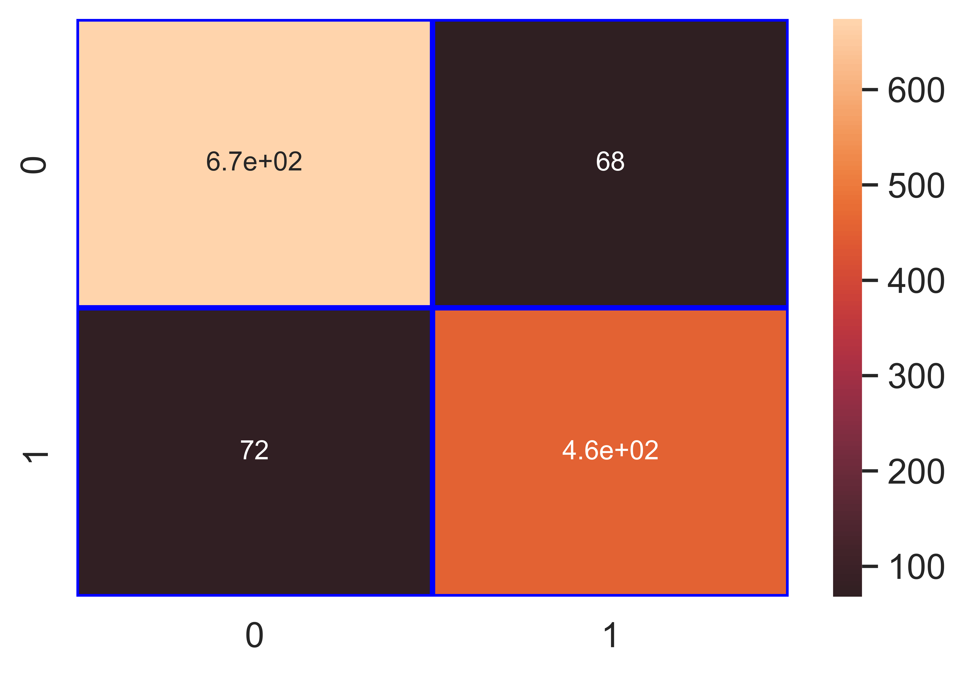

File saved : Label_Disease_Yes_No__svm_Classifier.pkl

data : {'Accuracy': 88.97, 'Loss': 11.03, 'Precision': 87.0, 'Recall': 86.34, 'f1_score': 86.67, 'Cohen_kappa': 77.26, 'Feature_name': 'Label (Disease Yes/No)', 'Model_name': 'svm_Classifier', 'Filename': 'Label_Disease_Yes_No__svm_Classifier.pkl'}

Model : dt_Classifier

Accuracy_score : 93.46 %

Loss : 6.54 %

Precision : 94.4 %

Recall : 89.56 %

f1_score : 91.92 %

Cohen_kappa_score : 86.43 %

Classification_report :   
 precision recall f1-score support  
  
 0 0.93 0.96 0.95 742  
 1 0.94 0.90 0.92 527  
  
 accuracy 0.93 1269  
 macro avg 0.94 0.93 0.93 1269  
weighted avg 0.93 0.93 0.93 1269

Confusion_matrix :   
[[714 28]  
 [ 55 472]]

### Image of images/Label_Disease_Yes_No__dt_Classifier_Accuracy_93.png :

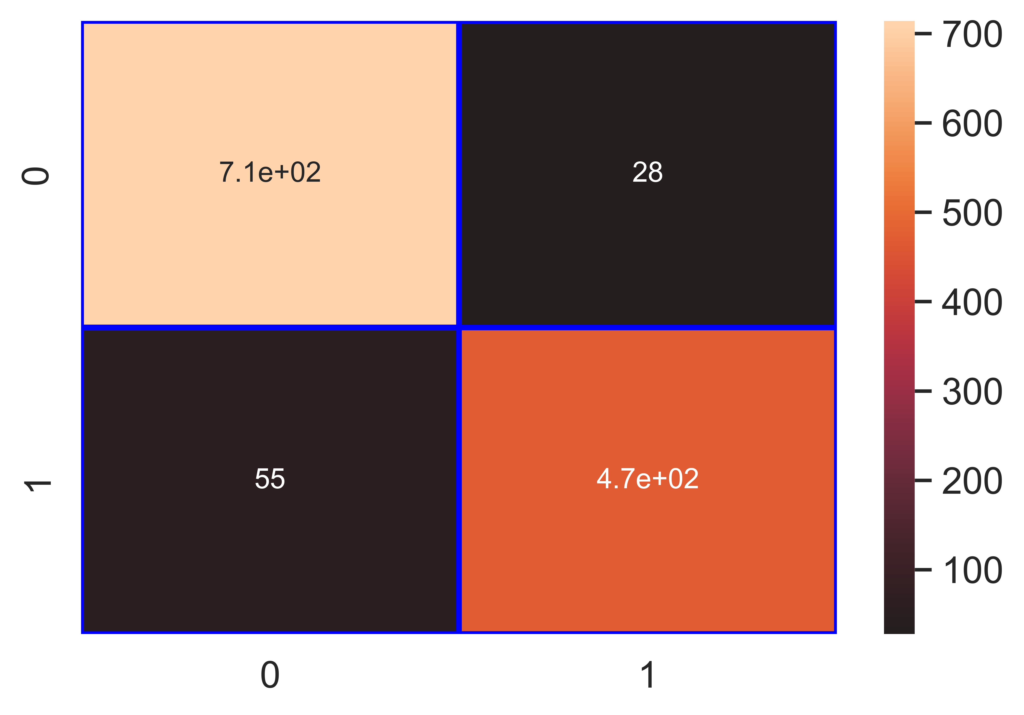

File saved : Label_Disease_Yes_No__dt_Classifier.pkl

data : {'Accuracy': 93.46, 'Loss': 6.54, 'Precision': 94.4, 'Recall': 89.56, 'f1_score': 91.92, 'Cohen_kappa': 86.43, 'Feature_name': 'Label (Disease Yes/No)', 'Model_name': 'dt_Classifier', 'Filename': 'Label_Disease_Yes_No__dt_Classifier.pkl'}

Model : rf_Classifier

Accuracy_score : 96.53 %

Loss : 3.47 %

Precision : 94.81 %

Recall : 96.96 %

f1_score : 95.87 %

Cohen_kappa_score : 92.88 %

Classification_report :   
 precision recall f1-score support  
  
 0 0.98 0.96 0.97 742  
 1 0.95 0.97 0.96 527  
  
 accuracy 0.97 1269  
 macro avg 0.96 0.97 0.96 1269  
weighted avg 0.97 0.97 0.97 1269

Confusion_matrix :   
[[714 28]  
 [ 16 511]]

### Image of images/Label_Disease_Yes_No__rf_Classifier_Accuracy_97.png :

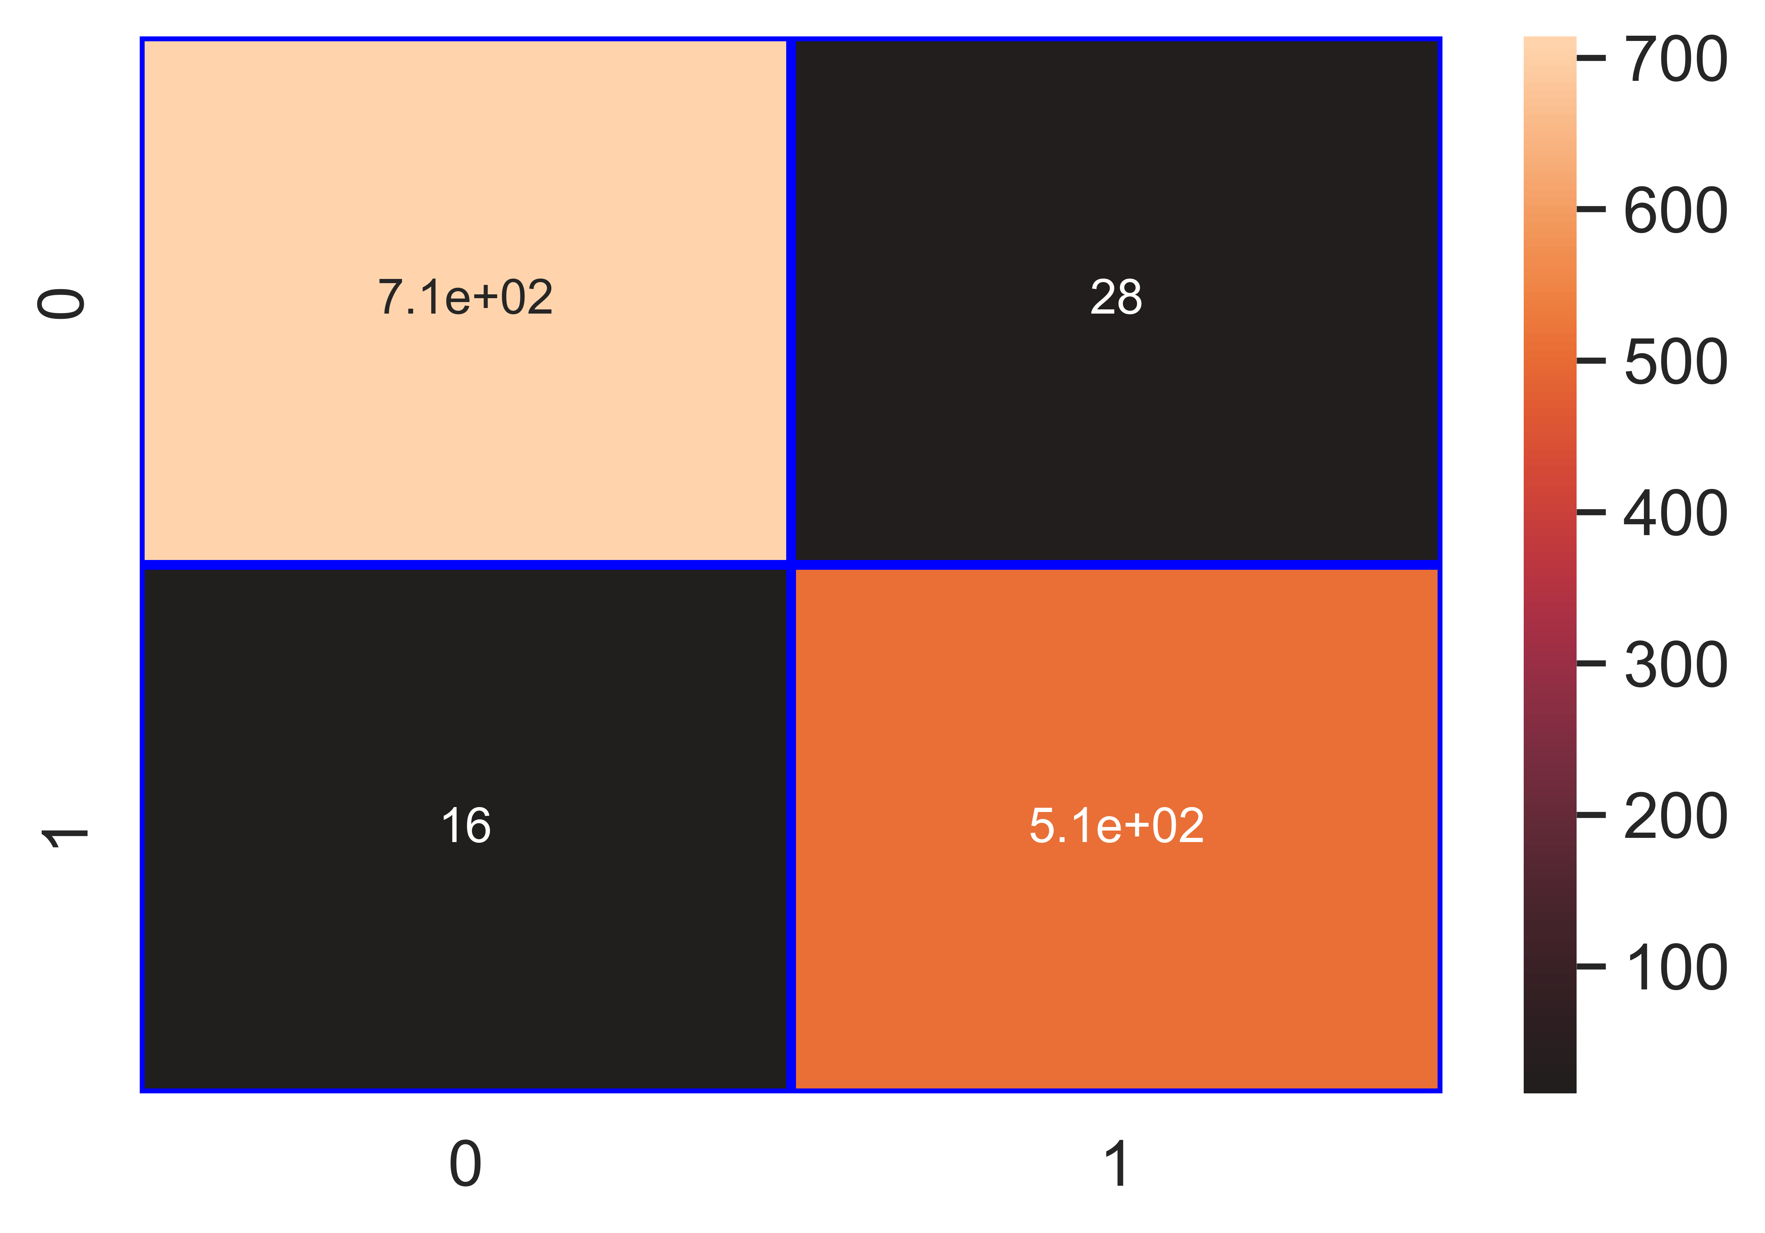

File saved : Label_Disease_Yes_No__rf_Classifier.pkl

data : {'Accuracy': 96.53, 'Loss': 3.47, 'Precision': 94.81, 'Recall': 96.96, 'f1_score': 95.87, 'Cohen_kappa': 92.88, 'Feature_name': 'Label (Disease Yes/No)', 'Model_name': 'rf_Classifier', 'Filename': 'Label_Disease_Yes_No__rf_Classifier.pkl'}

Model : gb_Classifier

Accuracy_score : 96.45 %

Loss : 3.55 %

Precision : 94.8 %

Recall : 96.77 %

f1_score : 95.77 %

Cohen_kappa_score : 92.72 %

Classification_report :   
 precision recall f1-score support  
  
 0 0.98 0.96 0.97 742  
 1 0.95 0.97 0.96 527  
  
 accuracy 0.96 1269  
 macro avg 0.96 0.97 0.96 1269  
weighted avg 0.96 0.96 0.96 1269

Confusion_matrix :   
[[714 28]  
 [ 17 510]]

### Image of images/Label_Disease_Yes_No__gb_Classifier_Accuracy_96.png :

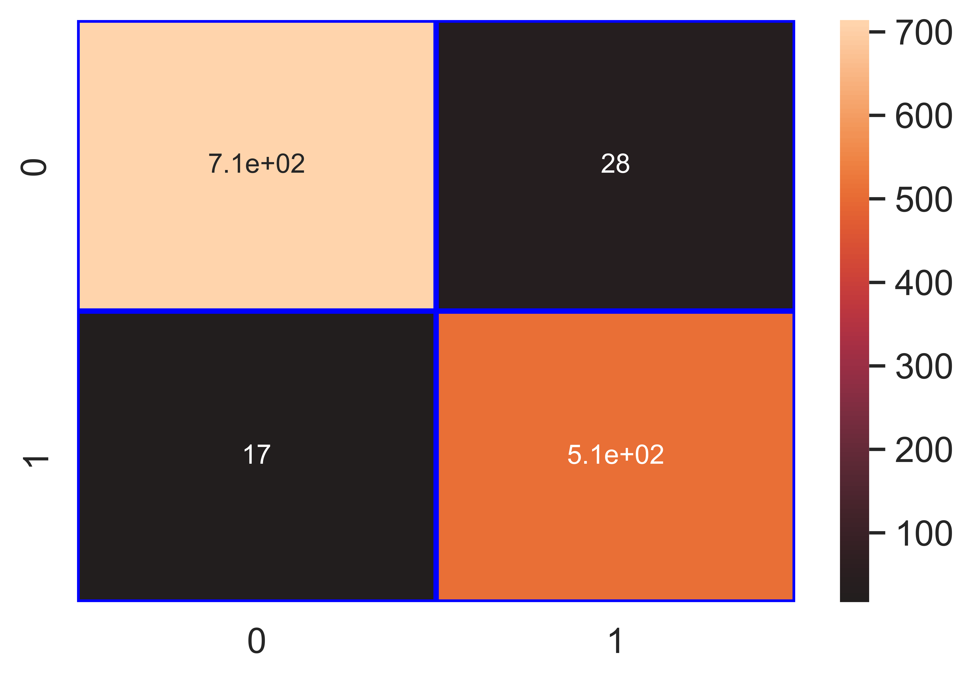

File saved : Label_Disease_Yes_No__gb_Classifier.pkl

data : {'Accuracy': 96.45, 'Loss': 3.55, 'Precision': 94.8, 'Recall': 96.77, 'f1_score': 95.77, 'Cohen_kappa': 92.72, 'Feature_name': 'Label (Disease Yes/No)', 'Model_name': 'gb_Classifier', 'Filename': 'Label_Disease_Yes_No__gb_Classifier.pkl'}

Model : ab_Classifier

Accuracy_score : 95.11 %

Loss : 4.89 %

Precision : 94.12 %

Recall : 94.12 %

f1_score : 94.12 %

Cohen_kappa_score : 89.94 %

Classification_report :   
 precision recall f1-score support  
  
 0 0.96 0.96 0.96 742  
 1 0.94 0.94 0.94 527  
  
 accuracy 0.95 1269  
 macro avg 0.95 0.95 0.95 1269  
weighted avg 0.95 0.95 0.95 1269

Confusion_matrix :   
[[711 31]  
 [ 31 496]]

### Image of images/Label_Disease_Yes_No__ab_Classifier_Accuracy_95.png :

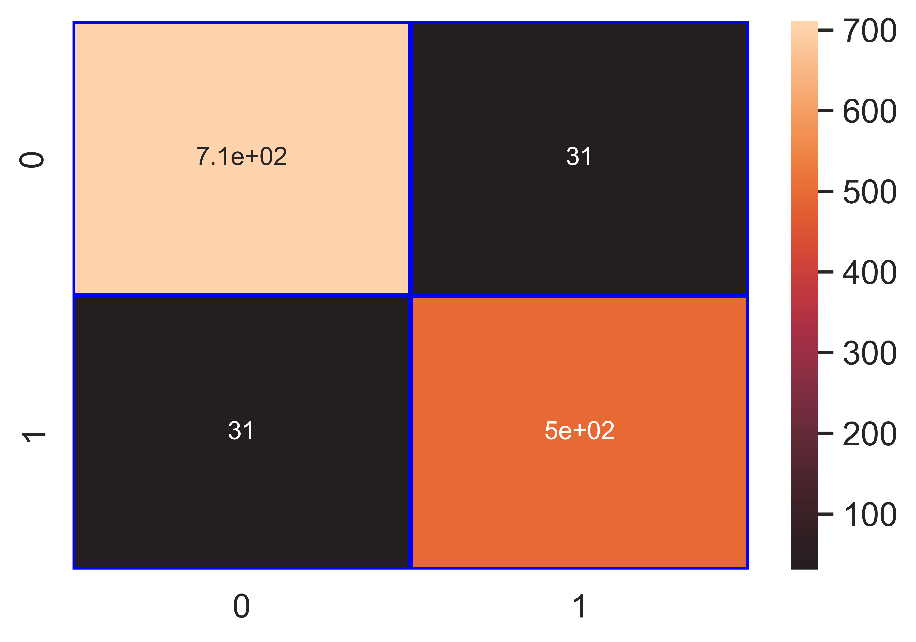

File saved : Label_Disease_Yes_No__ab_Classifier.pkl

data : {'Accuracy': 95.11, 'Loss': 4.89, 'Precision': 94.12, 'Recall': 94.12, 'f1_score': 94.12, 'Cohen_kappa': 89.94, 'Feature_name': 'Label (Disease Yes/No)', 'Model_name': 'ab_Classifier', 'Filename': 'Label_Disease_Yes_No__ab_Classifier.pkl'}

## Column : Type of Disease (Bacterial Blight/Telya)

Model : lr_Classifier

Accuracy_score : 84.4 %

Loss : 15.6 %

Precision : 78.95 %

Recall : 59.66 %

f1_score : 67.96 %

Cohen_kappa_score : 57.91 %

Classification_report :   
 precision recall f1-score support  
  
 0 0.86 0.94 0.90 917  
 1 0.79 0.60 0.68 352  
  
 accuracy 0.84 1269  
 macro avg 0.82 0.77 0.79 1269  
weighted avg 0.84 0.84 0.84 1269

Confusion_matrix :   
[[861 56]  
 [142 210]]

### Image of images/Type_of_Disease_Bacterial_Blight_Telya__lr_Classifier_Accuracy_84.png :

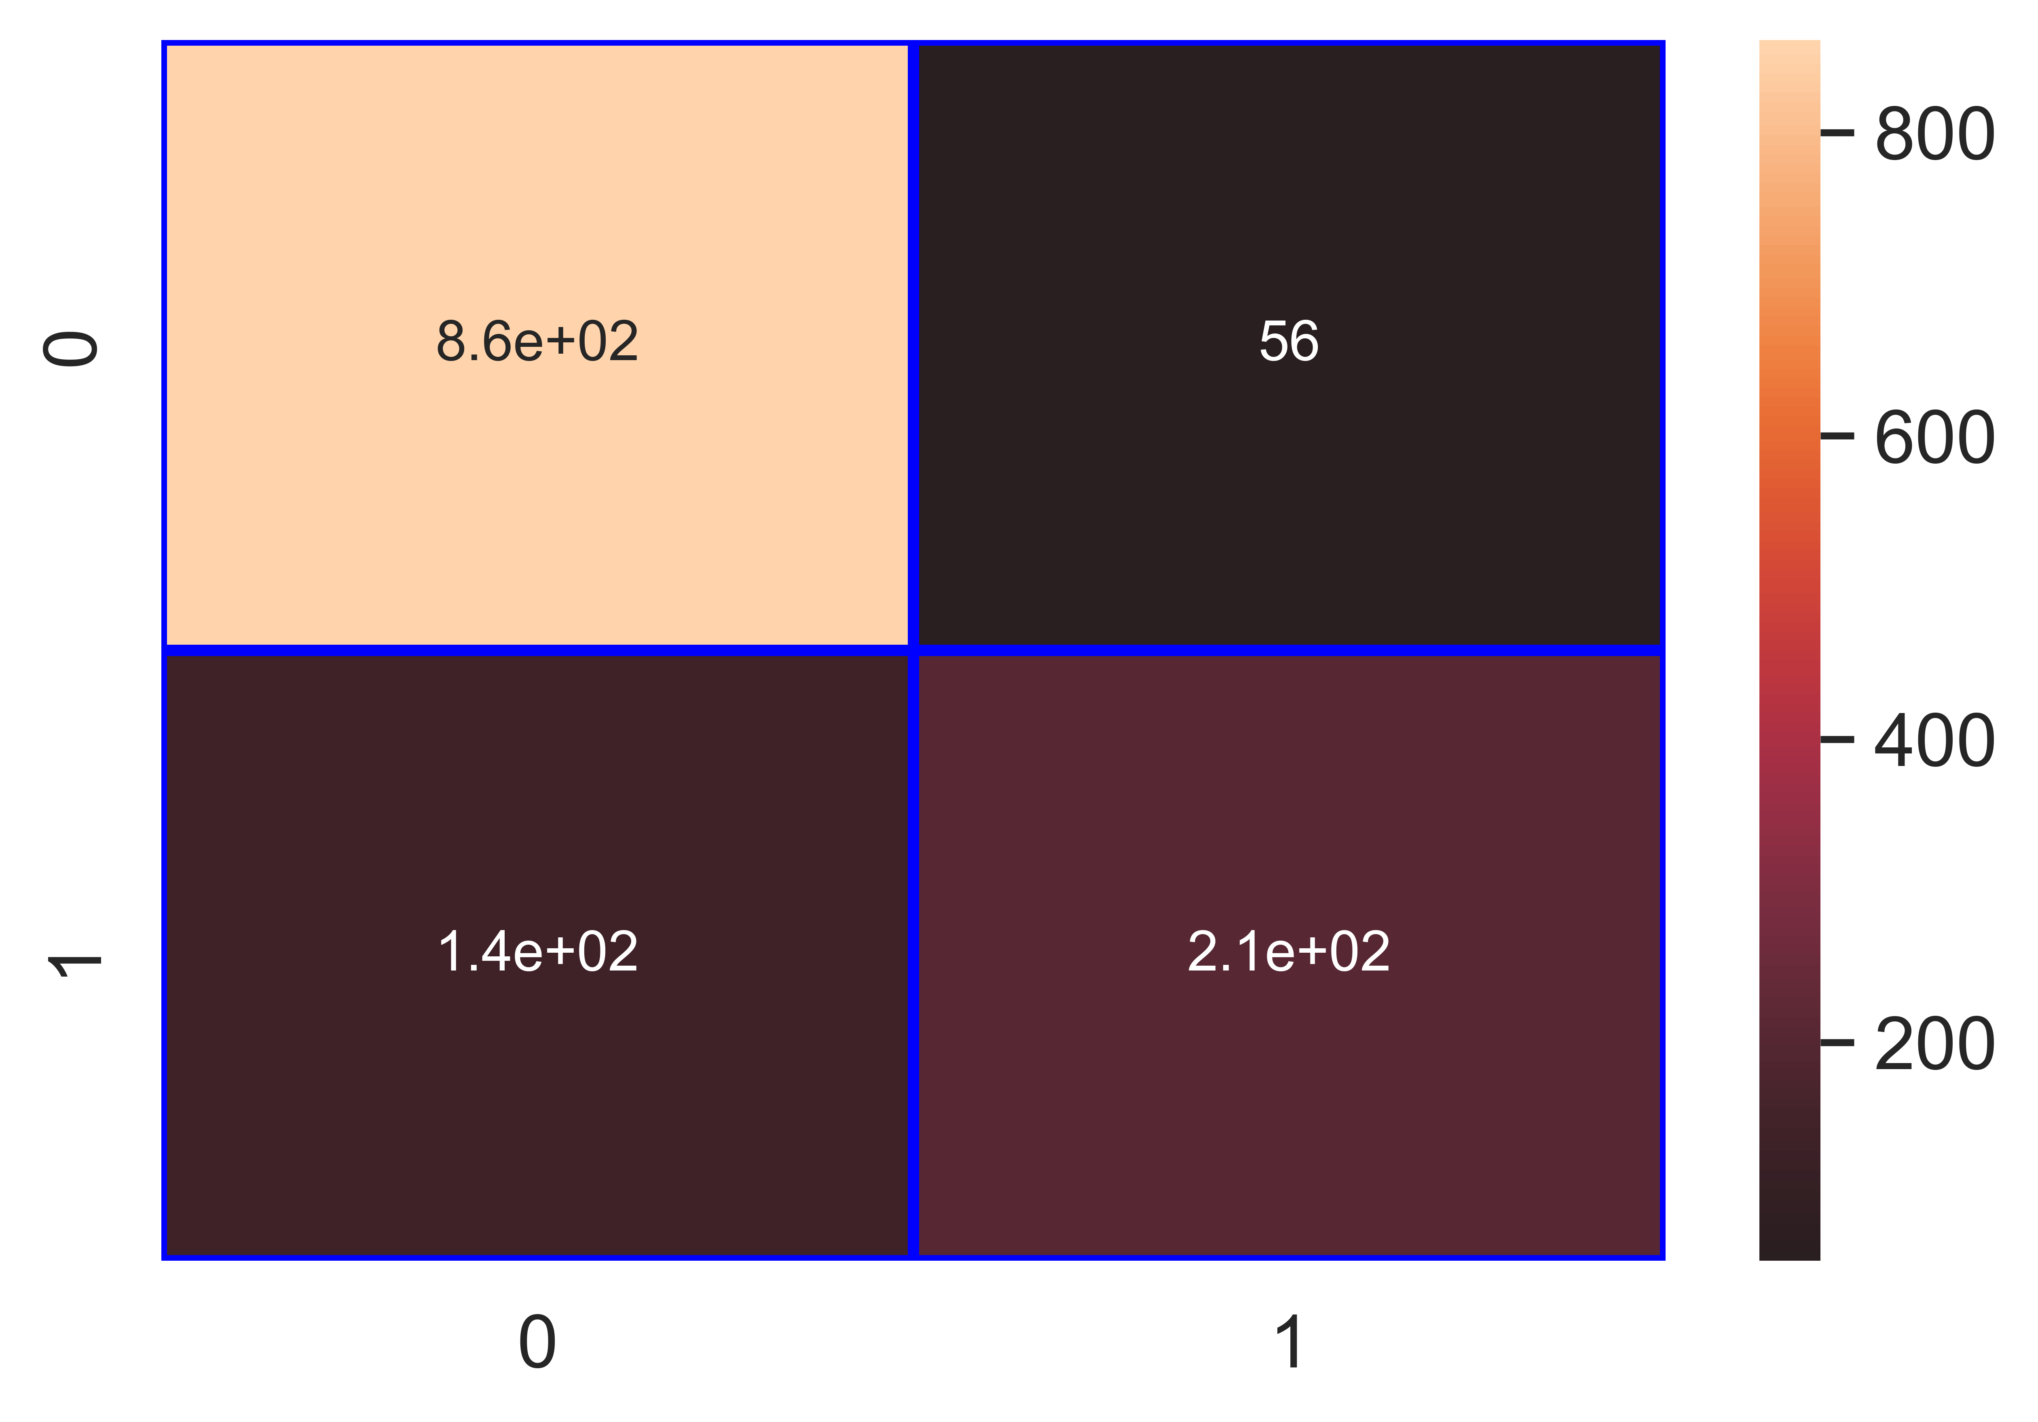

File saved : Type_of_Disease_Bacterial_Blight_Telya__lr_Classifier.pkl

data : {'Accuracy': 84.4, 'Loss': 15.6, 'Precision': 78.95, 'Recall': 59.66, 'f1_score': 67.96, 'Cohen_kappa': 57.91, 'Feature_name': 'Type of Disease (Bacterial Blight/Telya)', 'Model_name': 'lr_Classifier', 'Filename': 'Type_of_Disease_Bacterial_Blight_Telya__lr_Classifier.pkl'}

Model : knn_Classifier

Accuracy_score : 88.02 %

Loss : 11.98 %

Precision : 83.78 %

Recall : 70.45 %

f1_score : 76.54 %

Cohen_kappa_score : 68.58 %

Classification_report :   
 precision recall f1-score support  
  
 0 0.89 0.95 0.92 917  
 1 0.84 0.70 0.77 352  
  
 accuracy 0.88 1269  
 macro avg 0.87 0.83 0.84 1269  
weighted avg 0.88 0.88 0.88 1269

Confusion_matrix :   
[[869 48]  
 [104 248]]

### Image of images/Type_of_Disease_Bacterial_Blight_Telya__knn_Classifier_Accuracy_88.png :

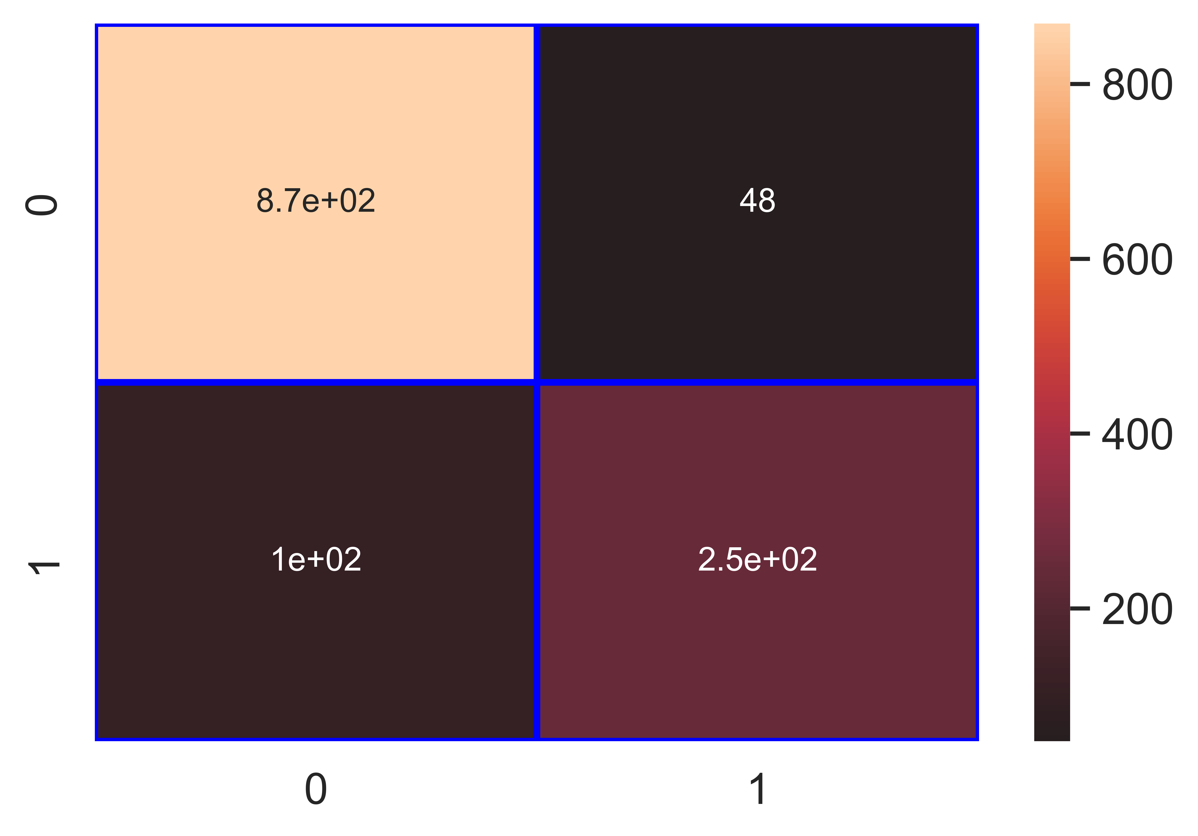

File saved : Type_of_Disease_Bacterial_Blight_Telya__knn_Classifier.pkl

data : {'Accuracy': 88.02, 'Loss': 11.98, 'Precision': 83.78, 'Recall': 70.45, 'f1_score': 76.54, 'Cohen_kappa': 68.58, 'Feature_name': 'Type of Disease (Bacterial Blight/Telya)', 'Model_name': 'knn_Classifier', 'Filename': 'Type_of_Disease_Bacterial_Blight_Telya__knn_Classifier.pkl'}

Model : nb_Classifier

Accuracy_score : 74.39 %

Loss : 25.61 %

Precision : 53.08 %

Recall : 66.19 %

f1_score : 58.91 %

Cohen_kappa_score : 40.63 %

Classification_report :   
 precision recall f1-score support  
  
 0 0.86 0.78 0.81 917  
 1 0.53 0.66 0.59 352  
  
 accuracy 0.74 1269  
 macro avg 0.69 0.72 0.70 1269  
weighted avg 0.77 0.74 0.75 1269

Confusion_matrix :   
[[711 206]  
 [119 233]]

### Image of images/Type_of_Disease_Bacterial_Blight_Telya__nb_Classifier_Accuracy_74.png :

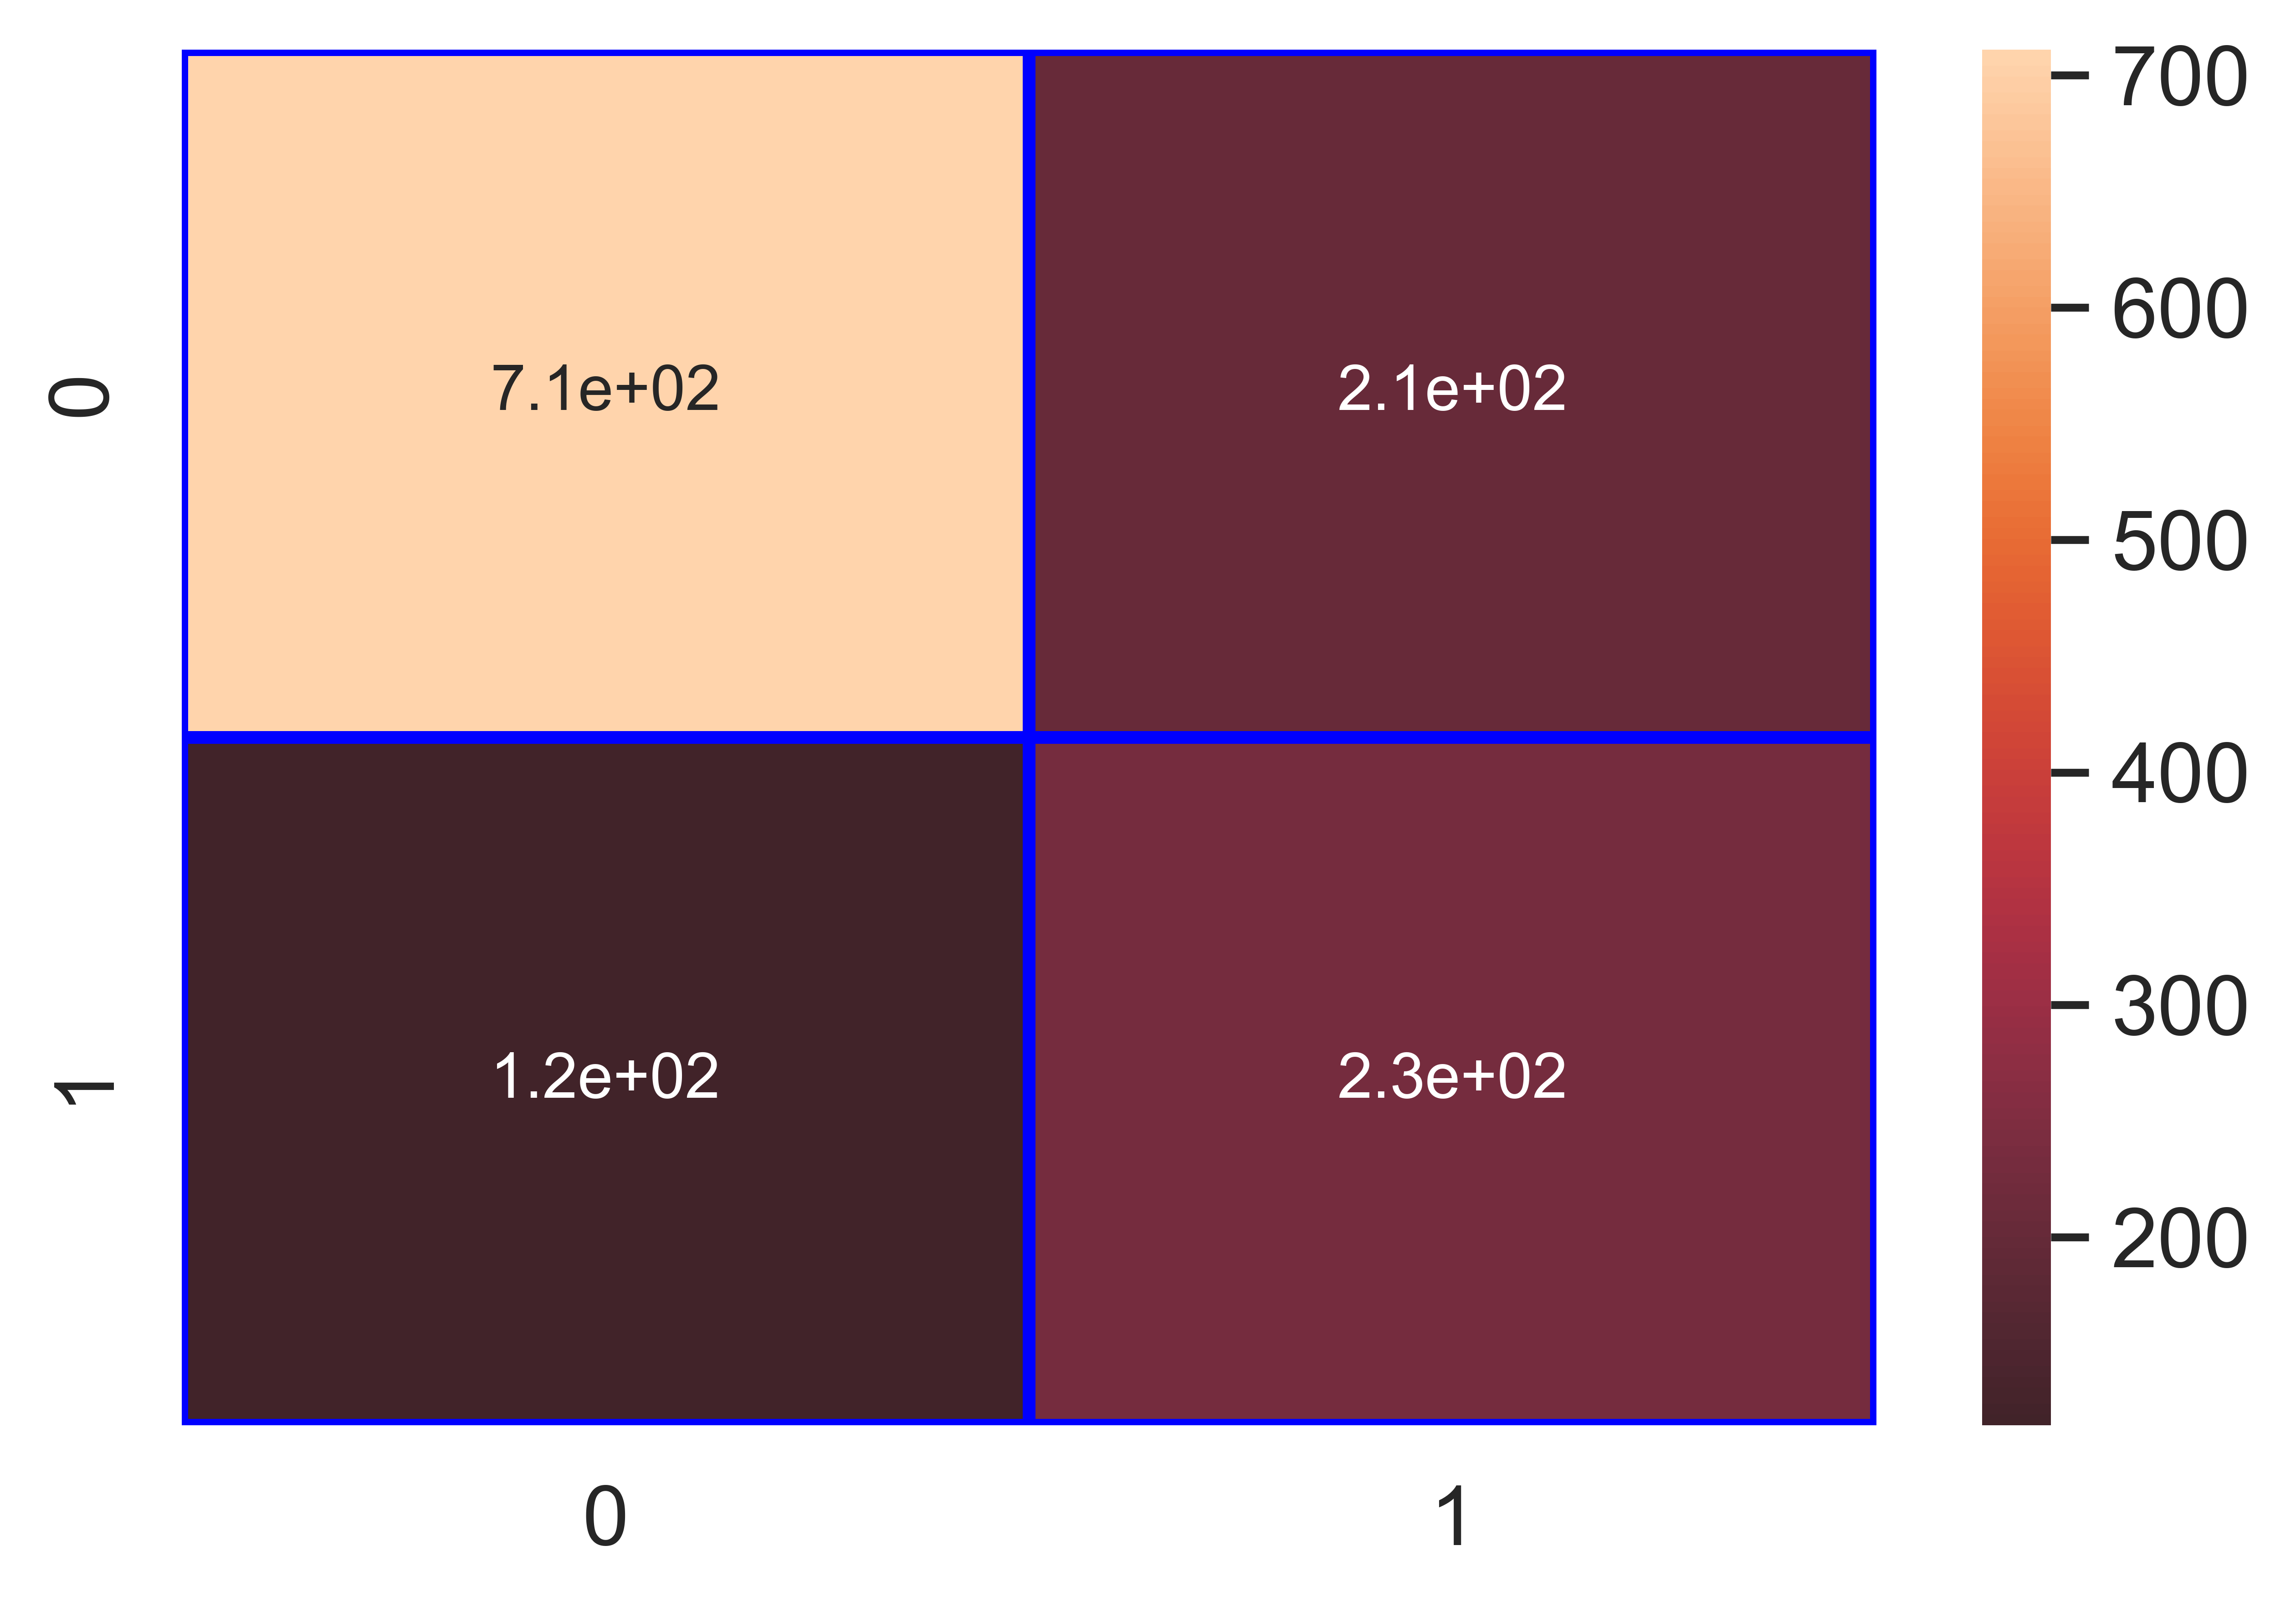

File saved : Type_of_Disease_Bacterial_Blight_Telya__nb_Classifier.pkl

data : {'Accuracy': 74.39, 'Loss': 25.61, 'Precision': 53.08, 'Recall': 66.19, 'f1_score': 58.91, 'Cohen_kappa': 40.63, 'Feature_name': 'Type of Disease (Bacterial Blight/Telya)', 'Model_name': 'nb_Classifier', 'Filename': 'Type_of_Disease_Bacterial_Blight_Telya__nb_Classifier.pkl'}

Model : svm_Classifier

Accuracy_score : 86.29 %

Loss : 13.71 %

Precision : 88.7 %

Recall : 57.95 %

f1_score : 70.1 %

Cohen_kappa_score : 61.71 %

Classification_report :   
 precision recall f1-score support  
  
 0 0.86 0.97 0.91 917  
 1 0.89 0.58 0.70 352  
  
 accuracy 0.86 1269  
 macro avg 0.87 0.78 0.81 1269  
weighted avg 0.87 0.86 0.85 1269

Confusion_matrix :   
[[891 26]  
 [148 204]]

### Image of images/Type_of_Disease_Bacterial_Blight_Telya__svm_Classifier_Accuracy_86.png :

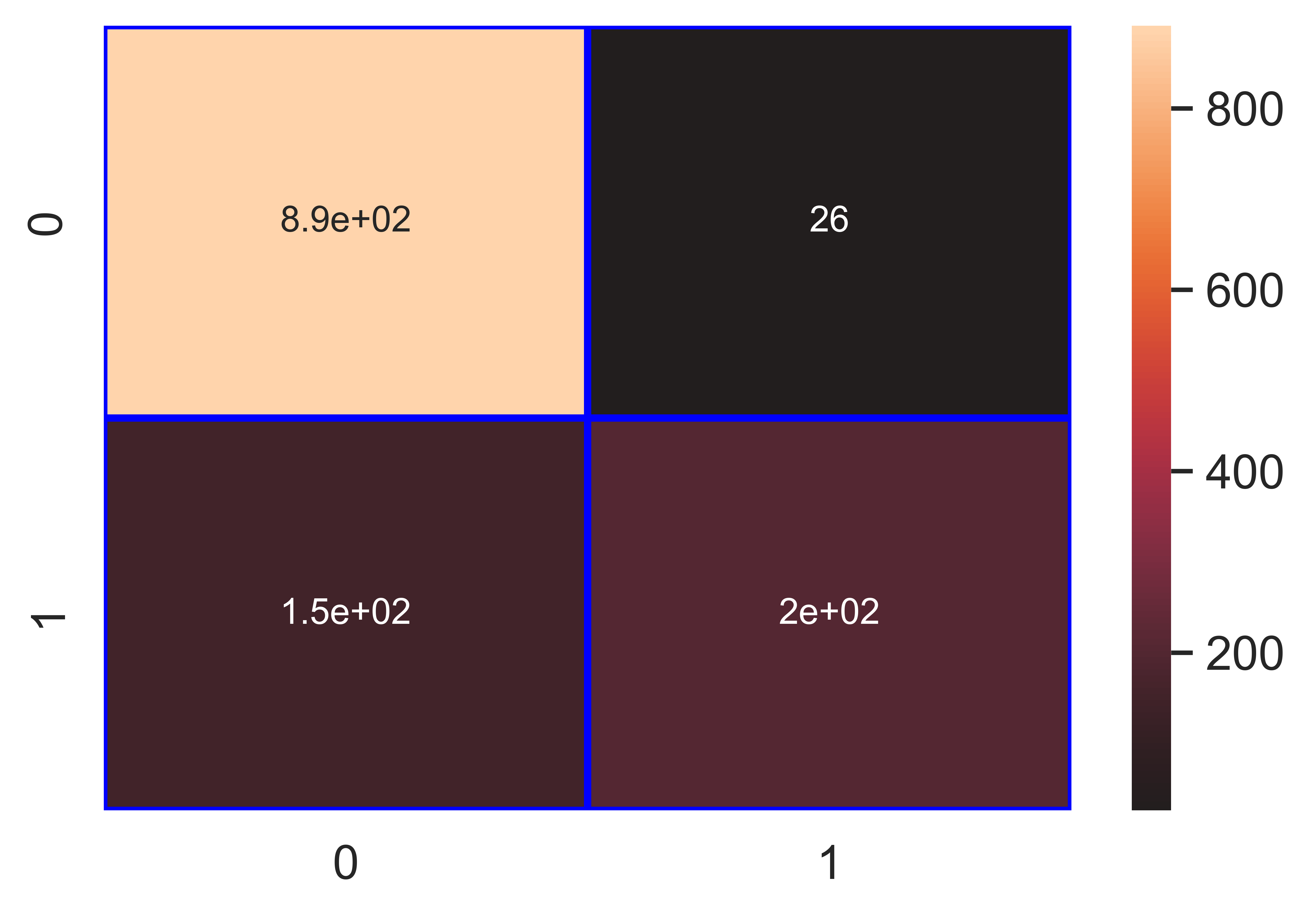

File saved : Type_of_Disease_Bacterial_Blight_Telya__svm_Classifier.pkl

data : {'Accuracy': 86.29, 'Loss': 13.71, 'Precision': 88.7, 'Recall': 57.95, 'f1_score': 70.1, 'Cohen_kappa': 61.71, 'Feature_name': 'Type of Disease (Bacterial Blight/Telya)', 'Model_name': 'svm_Classifier', 'Filename': 'Type_of_Disease_Bacterial_Blight_Telya__svm_Classifier.pkl'}

Model : dt_Classifier

Accuracy_score : 96.3 %

Loss : 3.7 %

Precision : 94.46 %

Recall : 92.05 %

f1_score : 93.24 %

Cohen_kappa_score : 90.69 %

Classification_report :   
 precision recall f1-score support  
  
 0 0.97 0.98 0.97 917  
 1 0.94 0.92 0.93 352  
  
 accuracy 0.96 1269  
 macro avg 0.96 0.95 0.95 1269  
weighted avg 0.96 0.96 0.96 1269

Confusion_matrix :   
[[898 19]  
 [ 28 324]]

### Image of images/Type_of_Disease_Bacterial_Blight_Telya__dt_Classifier_Accuracy_96.png :

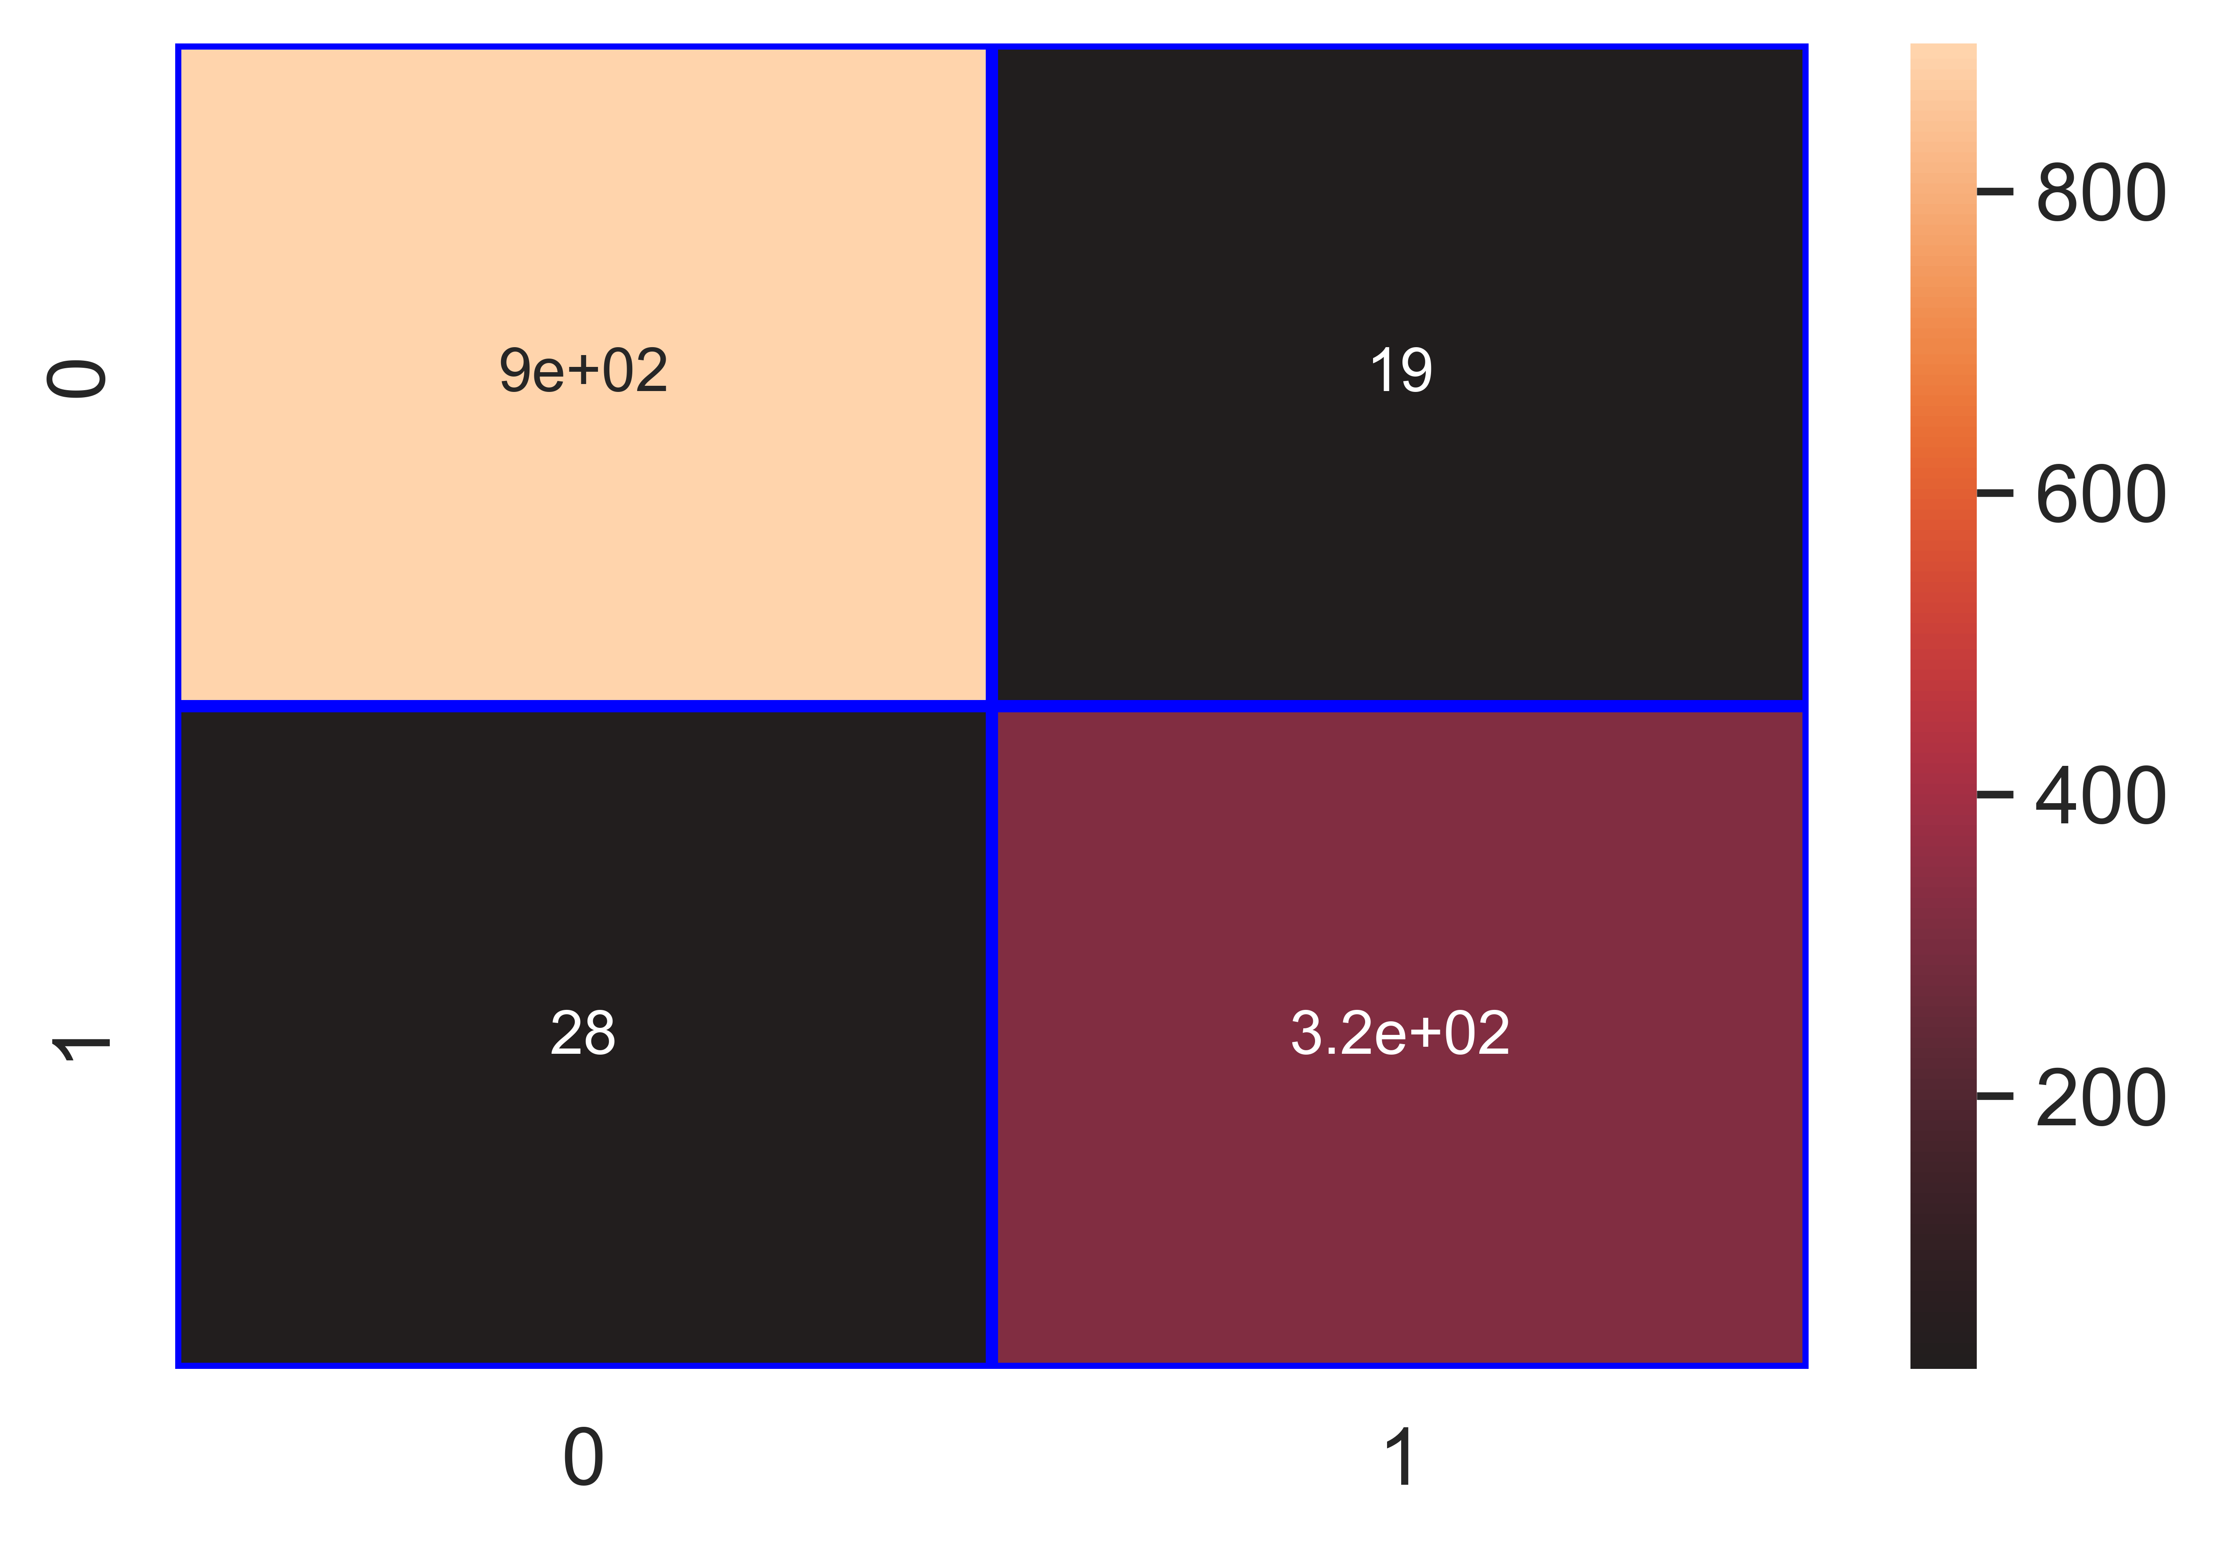

File saved : Type_of_Disease_Bacterial_Blight_Telya__dt_Classifier.pkl

data : {'Accuracy': 96.3, 'Loss': 3.7, 'Precision': 94.46, 'Recall': 92.05, 'f1_score': 93.24, 'Cohen_kappa': 90.69, 'Feature_name': 'Type of Disease (Bacterial Blight/Telya)', 'Model_name': 'dt_Classifier', 'Filename': 'Type_of_Disease_Bacterial_Blight_Telya__dt_Classifier.pkl'}

Model : rf_Classifier

Accuracy_score : 97.87 %

Loss : 2.13 %

Precision : 96.83 %

Recall : 95.45 %

f1_score : 96.14 %

Cohen_kappa_score : 94.67 %

Classification_report :   
 precision recall f1-score support  
  
 0 0.98 0.99 0.99 917  
 1 0.97 0.95 0.96 352  
  
 accuracy 0.98 1269  
 macro avg 0.98 0.97 0.97 1269  
weighted avg 0.98 0.98 0.98 1269

Confusion_matrix :   
[[906 11]  
 [ 16 336]]

### Image of images/Type_of_Disease_Bacterial_Blight_Telya__rf_Classifier_Accuracy_98.png :

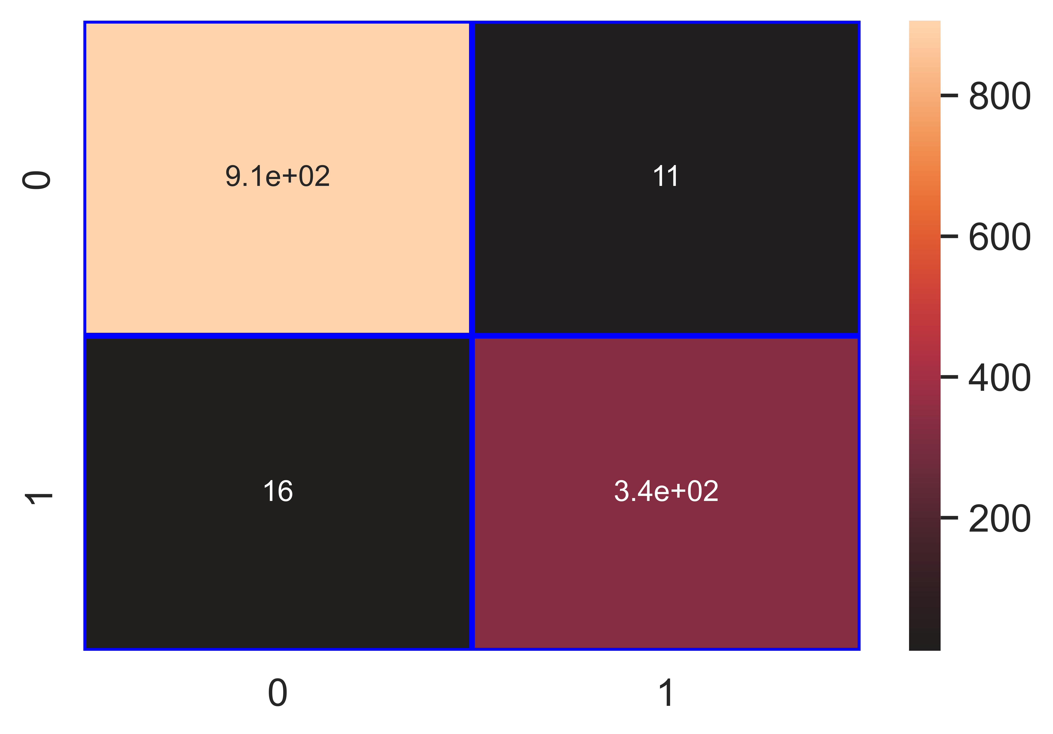

File saved : Type_of_Disease_Bacterial_Blight_Telya__rf_Classifier.pkl

data : {'Accuracy': 97.87, 'Loss': 2.13, 'Precision': 96.83, 'Recall': 95.45, 'f1_score': 96.14, 'Cohen_kappa': 94.67, 'Feature_name': 'Type of Disease (Bacterial Blight/Telya)', 'Model_name': 'rf_Classifier', 'Filename': 'Type_of_Disease_Bacterial_Blight_Telya__rf_Classifier.pkl'}

Model : gb_Classifier

Accuracy_score : 97.56 %

Loss : 2.44 %

Precision : 95.99 %

Recall : 95.17 %

f1_score : 95.58 %

Cohen_kappa_score : 93.89 %

Classification_report :   
 precision recall f1-score support  
  
 0 0.98 0.98 0.98 917  
 1 0.96 0.95 0.96 352  
  
 accuracy 0.98 1269  
 macro avg 0.97 0.97 0.97 1269  
weighted avg 0.98 0.98 0.98 1269

Confusion_matrix :   
[[903 14]  
 [ 17 335]]

### Image of images/Type_of_Disease_Bacterial_Blight_Telya__gb_Classifier_Accuracy_98.png :

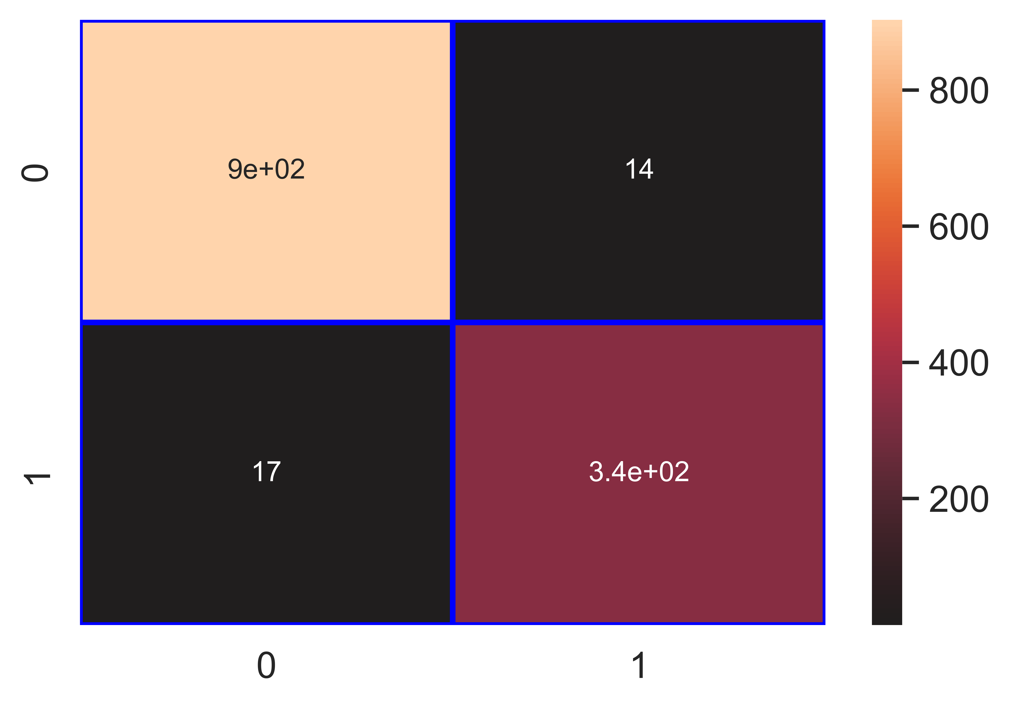

File saved : Type_of_Disease_Bacterial_Blight_Telya__gb_Classifier.pkl

data : {'Accuracy': 97.56, 'Loss': 2.44, 'Precision': 95.99, 'Recall': 95.17, 'f1_score': 95.58, 'Cohen_kappa': 93.89, 'Feature_name': 'Type of Disease (Bacterial Blight/Telya)', 'Model_name': 'gb_Classifier', 'Filename': 'Type_of_Disease_Bacterial_Blight_Telya__gb_Classifier.pkl'}

Model : ab_Classifier

Accuracy_score : 97.56 %

Loss : 2.44 %

Precision : 97.07 %

Recall : 94.03 %

f1_score : 95.53 %

Cohen_kappa_score : 93.85 %

Classification_report :   
 precision recall f1-score support  
  
 0 0.98 0.99 0.98 917  
 1 0.97 0.94 0.96 352  
  
 accuracy 0.98 1269  
 macro avg 0.97 0.96 0.97 1269  
weighted avg 0.98 0.98 0.98 1269

Confusion_matrix :   
[[907 10]  
 [ 21 331]]

### Image of images/Type_of_Disease_Bacterial_Blight_Telya__ab_Classifier_Accuracy_98.png :

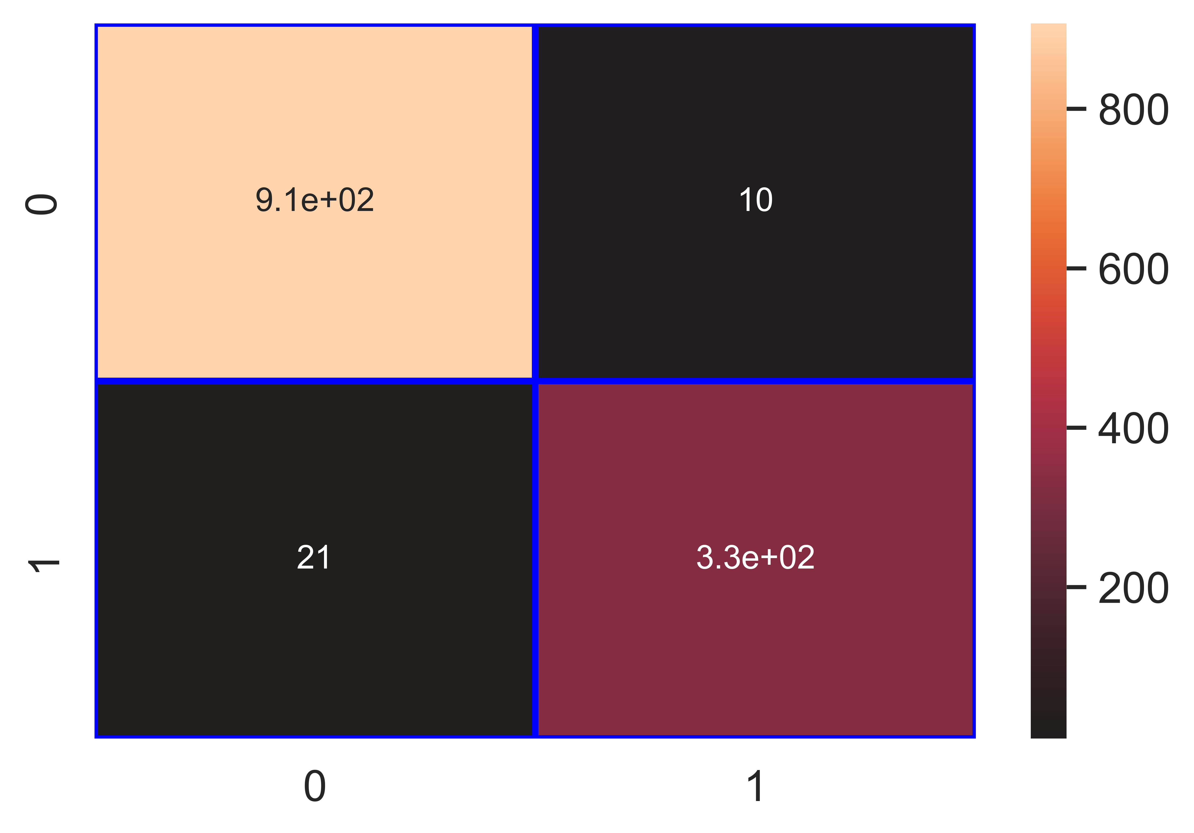

File saved : Type_of_Disease_Bacterial_Blight_Telya__ab_Classifier.pkl

data : {'Accuracy': 97.56, 'Loss': 2.44, 'Precision': 97.07, 'Recall': 94.03, 'f1_score': 95.53, 'Cohen_kappa': 93.85, 'Feature_name': 'Type of Disease (Bacterial Blight/Telya)', 'Model_name': 'ab_Classifier', 'Filename': 'Type_of_Disease_Bacterial_Blight_Telya__ab_Classifier.pkl'}

## Column : Anthracnose

Model : lr_Classifier

Accuracy_score : 83.06 %

Loss : 16.94 %

Precision : 40.32 %

Recall : 12.32 %

f1_score : 18.87 %

Cohen_kappa_score : 12.3 %

Classification_report :   
 precision recall f1-score support  
  
 0 0.85 0.97 0.91 1066  
 1 0.40 0.12 0.19 203  
  
 accuracy 0.83 1269  
 macro avg 0.63 0.54 0.55 1269  
weighted avg 0.78 0.83 0.79 1269

Confusion_matrix :   
[[1029 37]  
 [ 178 25]]

### Image of images/Anthracnose_lr_Classifier_Accuracy_83.png :

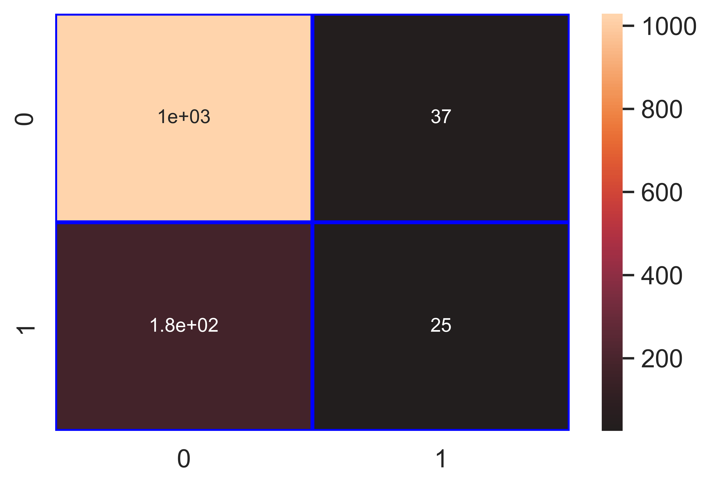

File saved : Anthracnose_lr_Classifier.pkl

data : {'Accuracy': 83.06, 'Loss': 16.94, 'Precision': 40.32, 'Recall': 12.32, 'f1_score': 18.87, 'Cohen_kappa': 12.3, 'Feature_name': 'Anthracnose', 'Model_name': 'lr_Classifier', 'Filename': 'Anthracnose_lr_Classifier.pkl'}

Model : knn_Classifier

Accuracy_score : 94.72 %

Loss : 5.28 %

Precision : 83.33 %

Recall : 83.74 %

f1_score : 83.54 %

Cohen_kappa_score : 80.39 %

Classification_report :   
 precision recall f1-score support  
  
 0 0.97 0.97 0.97 1066  
 1 0.83 0.84 0.84 203  
  
 accuracy 0.95 1269  
 macro avg 0.90 0.90 0.90 1269  
weighted avg 0.95 0.95 0.95 1269

Confusion_matrix :   
[[1032 34]  
 [ 33 170]]

### Image of images/Anthracnose_knn_Classifier_Accuracy_95.png :

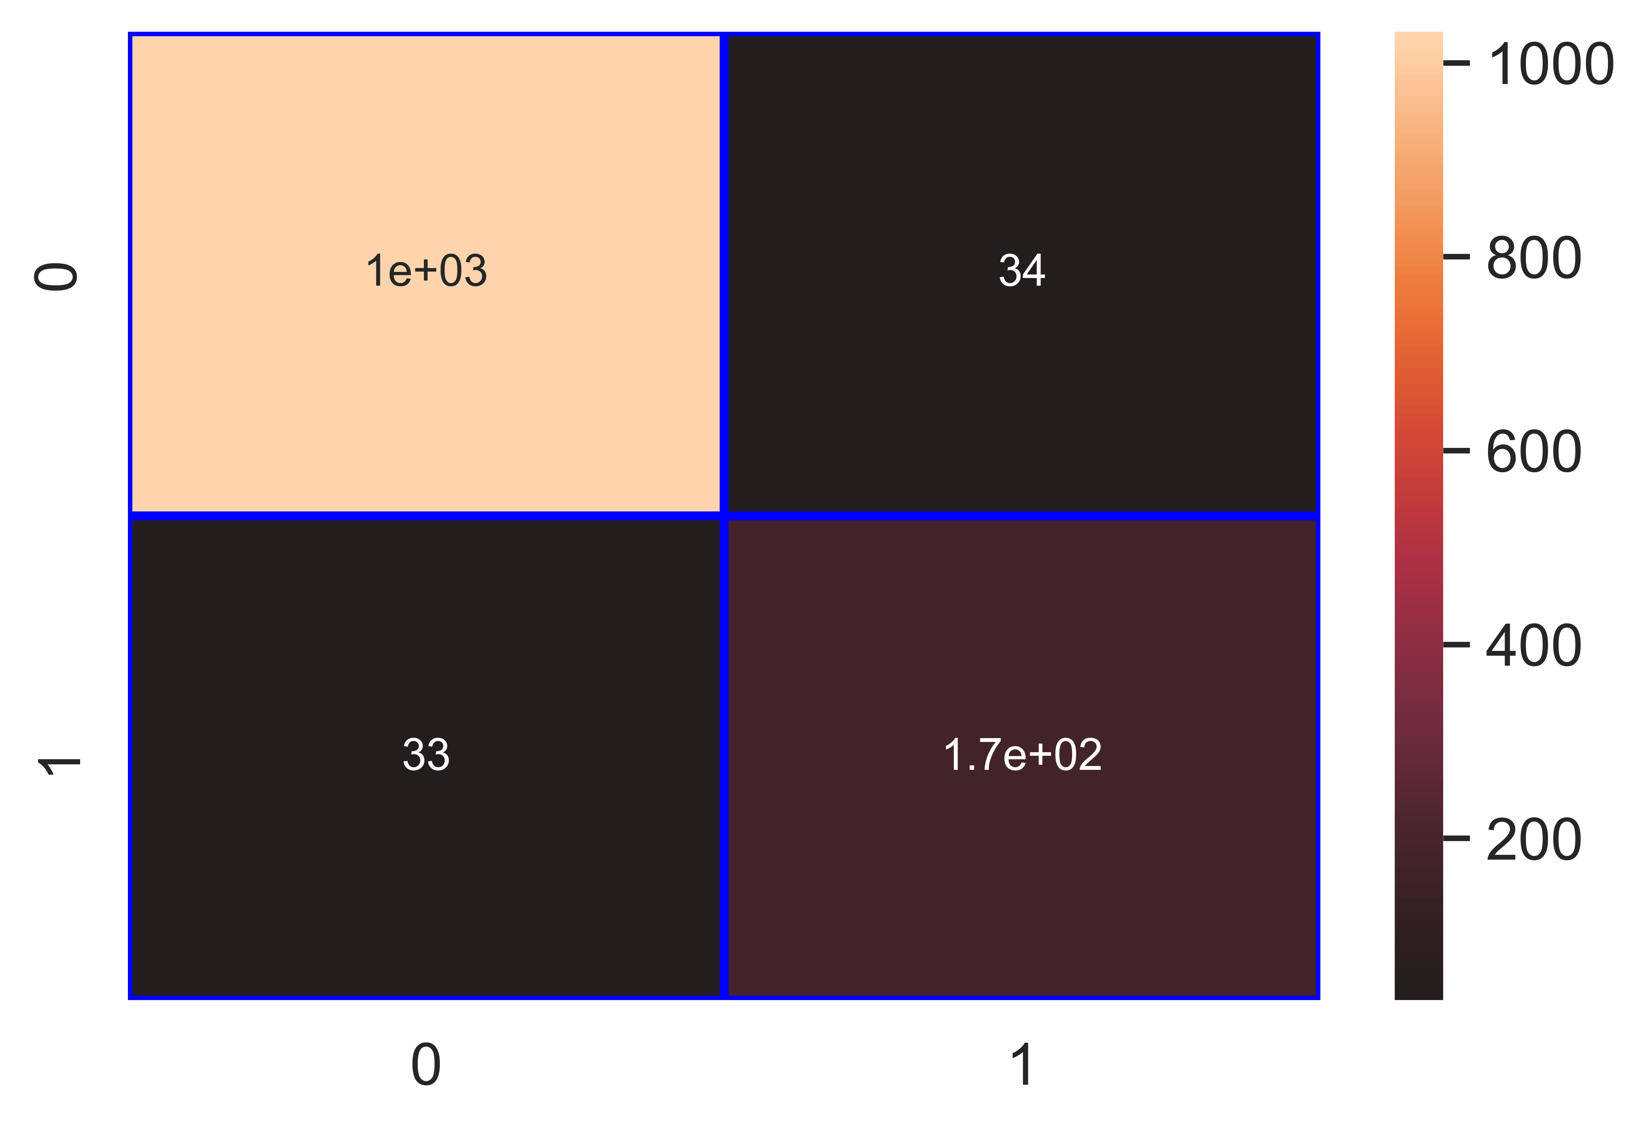

File saved : Anthracnose_knn_Classifier.pkl

data : {'Accuracy': 94.72, 'Loss': 5.28, 'Precision': 83.33, 'Recall': 83.74, 'f1_score': 83.54, 'Cohen_kappa': 80.39, 'Feature_name': 'Anthracnose', 'Model_name': 'knn_Classifier', 'Filename': 'Anthracnose_knn_Classifier.pkl'}

Model : nb_Classifier

Accuracy_score : 80.06 %

Loss : 19.94 %

Precision : 43.49 %

Recall : 82.27 %

f1_score : 56.9 %

Cohen_kappa_score : 45.49 %

Classification_report :   
 precision recall f1-score support  
  
 0 0.96 0.80 0.87 1066  
 1 0.43 0.82 0.57 203  
  
 accuracy 0.80 1269  
 macro avg 0.70 0.81 0.72 1269  
weighted avg 0.88 0.80 0.82 1269

Confusion_matrix :   
[[849 217]  
 [ 36 167]]

### Image of images/Anthracnose_nb_Classifier_Accuracy_80.png :

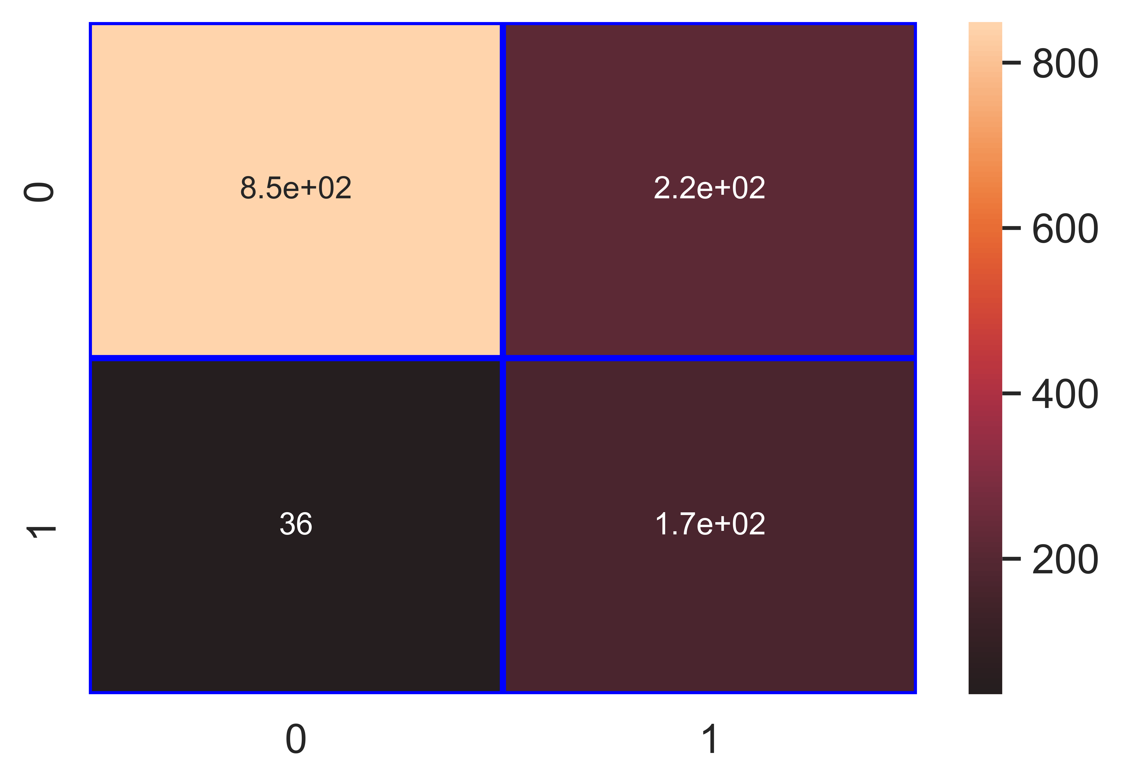

File saved : Anthracnose_nb_Classifier.pkl

data : {'Accuracy': 80.06, 'Loss': 19.94, 'Precision': 43.49, 'Recall': 82.27, 'f1_score': 56.9, 'Cohen_kappa': 45.49, 'Feature_name': 'Anthracnose', 'Model_name': 'nb_Classifier', 'Filename': 'Anthracnose_nb_Classifier.pkl'}

Model : svm_Classifier

Accuracy_score : 92.83 %

Loss : 7.17 %

Precision : 91.79 %

Recall : 60.59 %

f1_score : 73.0 %

Cohen_kappa_score : 69.06 %

Classification_report :   
 precision recall f1-score support  
  
 0 0.93 0.99 0.96 1066  
 1 0.92 0.61 0.73 203  
  
 accuracy 0.93 1269  
 macro avg 0.92 0.80 0.84 1269  
weighted avg 0.93 0.93 0.92 1269

Confusion_matrix :   
[[1055 11]  
 [ 80 123]]

### Image of images/Anthracnose_svm_Classifier_Accuracy_93.png :

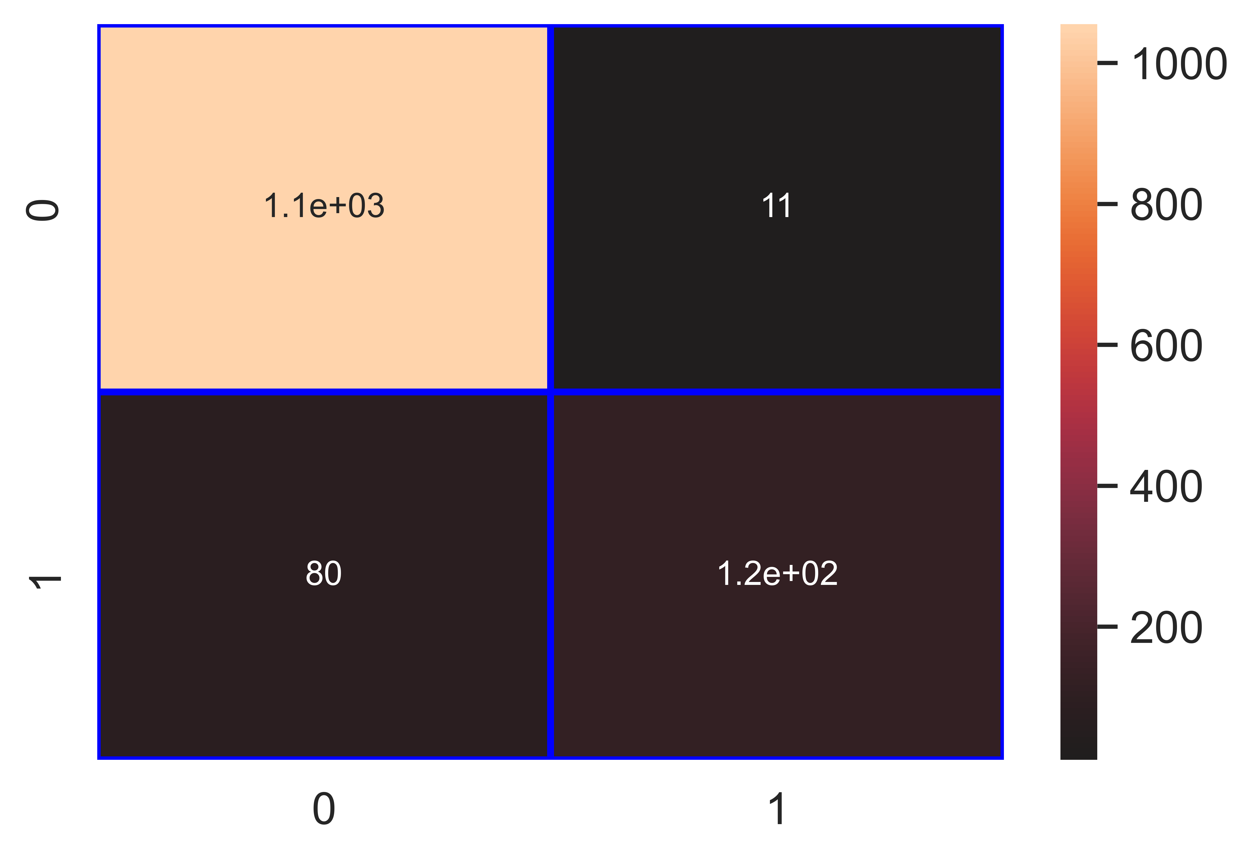

File saved : Anthracnose_svm_Classifier.pkl

data : {'Accuracy': 92.83, 'Loss': 7.17, 'Precision': 91.79, 'Recall': 60.59, 'f1_score': 73.0, 'Cohen_kappa': 69.06, 'Feature_name': 'Anthracnose', 'Model_name': 'svm_Classifier', 'Filename': 'Anthracnose_svm_Classifier.pkl'}

Model : dt_Classifier

Accuracy_score : 97.56 %

Loss : 2.44 %

Precision : 95.26 %

Recall : 89.16 %

f1_score : 92.11 %

Cohen_kappa_score : 90.67 %

Classification_report :   
 precision recall f1-score support  
  
 0 0.98 0.99 0.99 1066  
 1 0.95 0.89 0.92 203  
  
 accuracy 0.98 1269  
 macro avg 0.97 0.94 0.95 1269  
weighted avg 0.98 0.98 0.98 1269

Confusion_matrix :   
[[1057 9]  
 [ 22 181]]

### Image of images/Anthracnose_dt_Classifier_Accuracy_98.png :

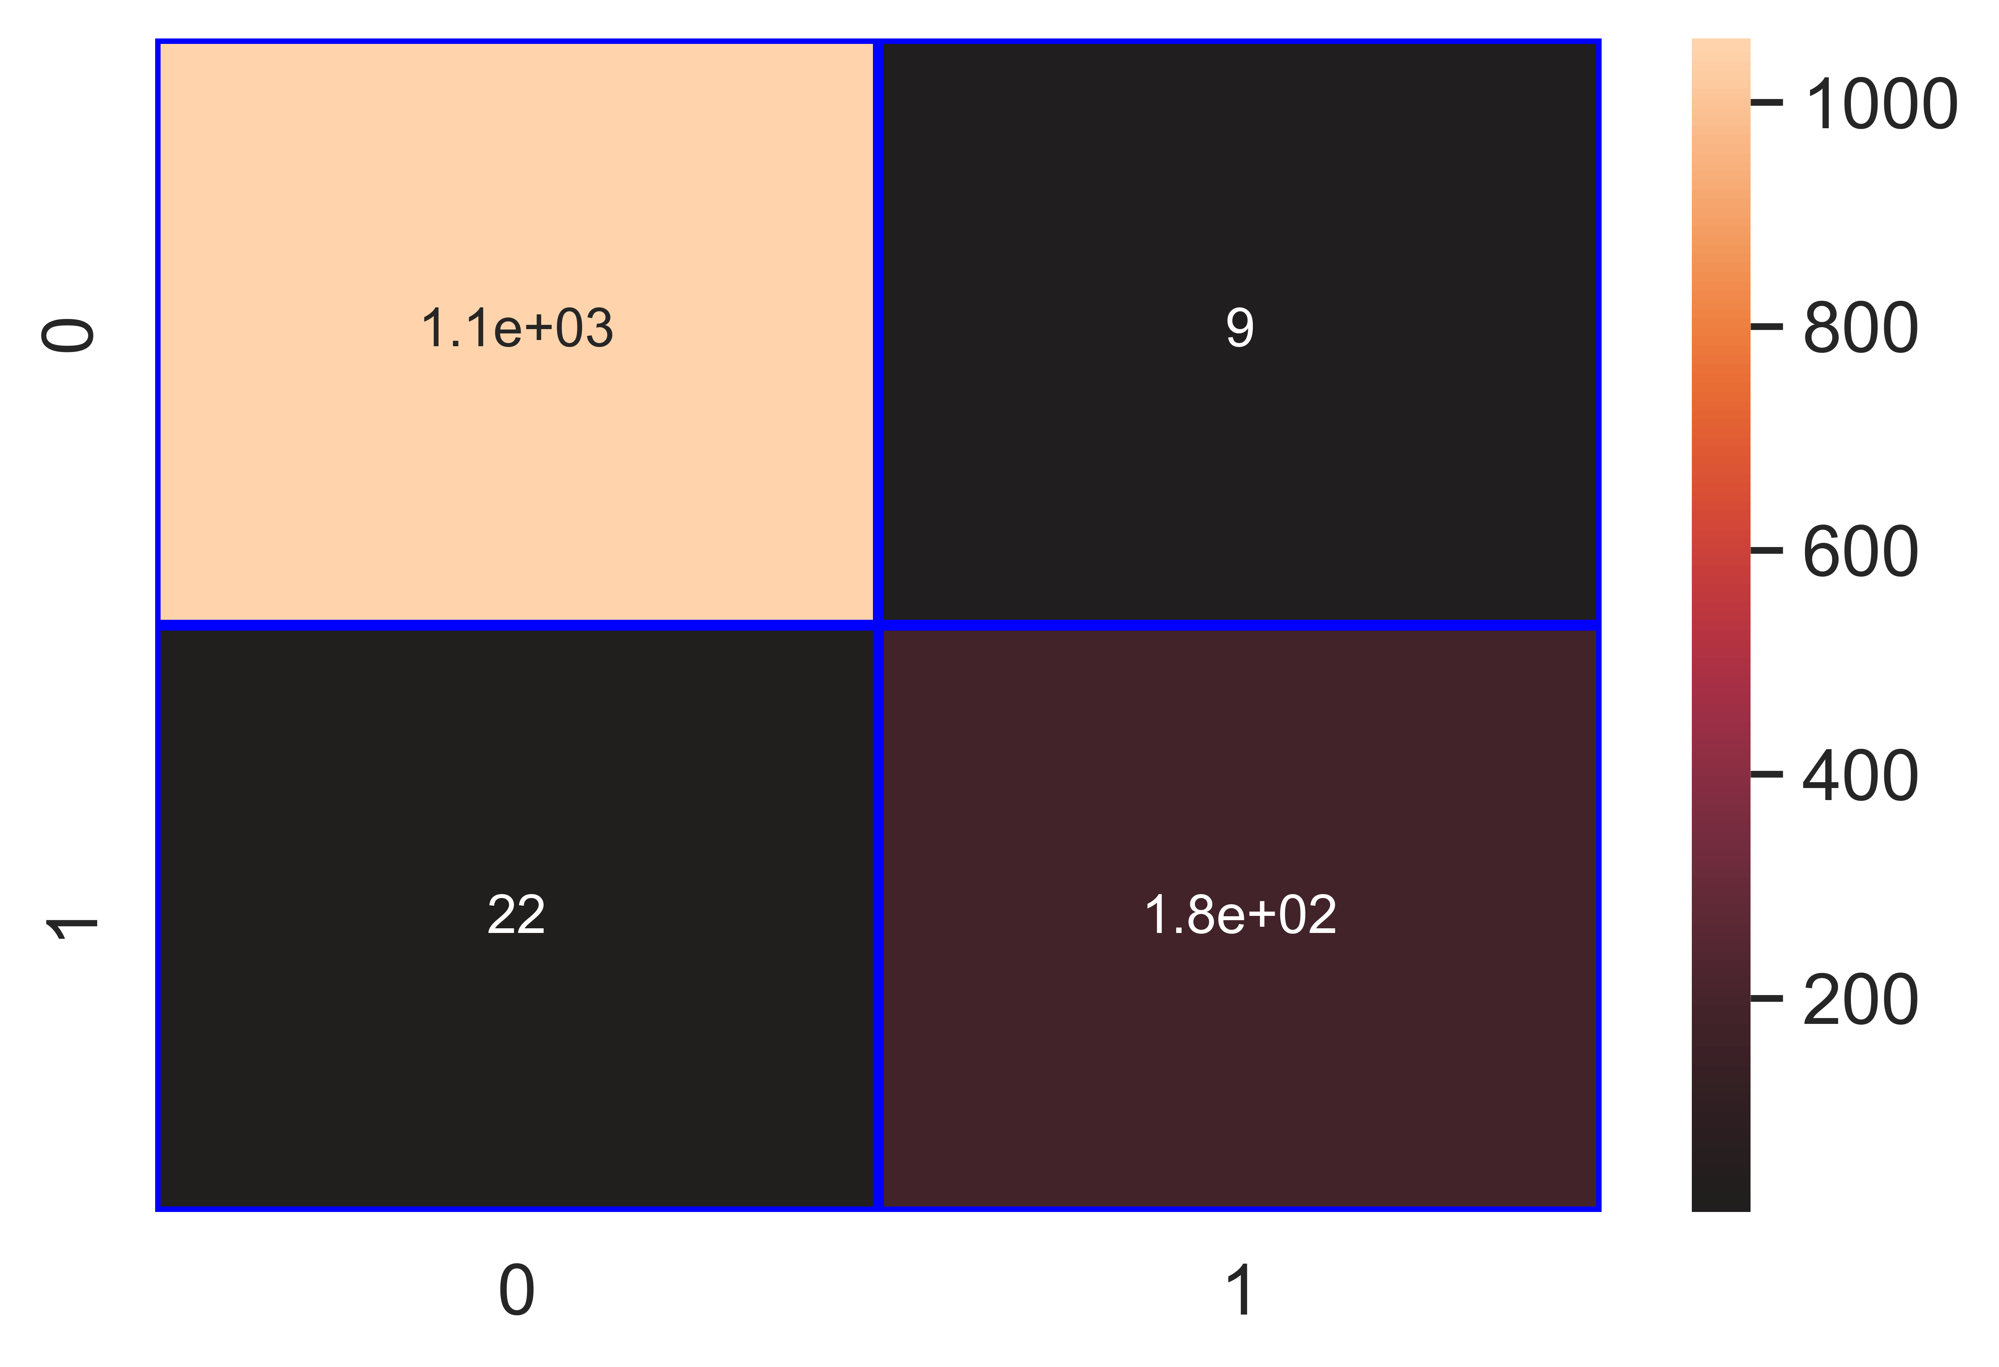

File saved : Anthracnose_dt_Classifier.pkl

data : {'Accuracy': 97.56, 'Loss': 2.44, 'Precision': 95.26, 'Recall': 89.16, 'f1_score': 92.11, 'Cohen_kappa': 90.67, 'Feature_name': 'Anthracnose', 'Model_name': 'dt_Classifier', 'Filename': 'Anthracnose_dt_Classifier.pkl'}

Model : rf_Classifier

Accuracy_score : 98.66 %

Loss : 1.34 %

Precision : 97.45 %

Recall : 94.09 %

f1_score : 95.74 %

Cohen_kappa_score : 94.94 %

Classification_report :   
 precision recall f1-score support  
  
 0 0.99 1.00 0.99 1066  
 1 0.97 0.94 0.96 203  
  
 accuracy 0.99 1269  
 macro avg 0.98 0.97 0.97 1269  
weighted avg 0.99 0.99 0.99 1269

Confusion_matrix :   
[[1061 5]  
 [ 12 191]]

### Image of images/Anthracnose_rf_Classifier_Accuracy_99.png :

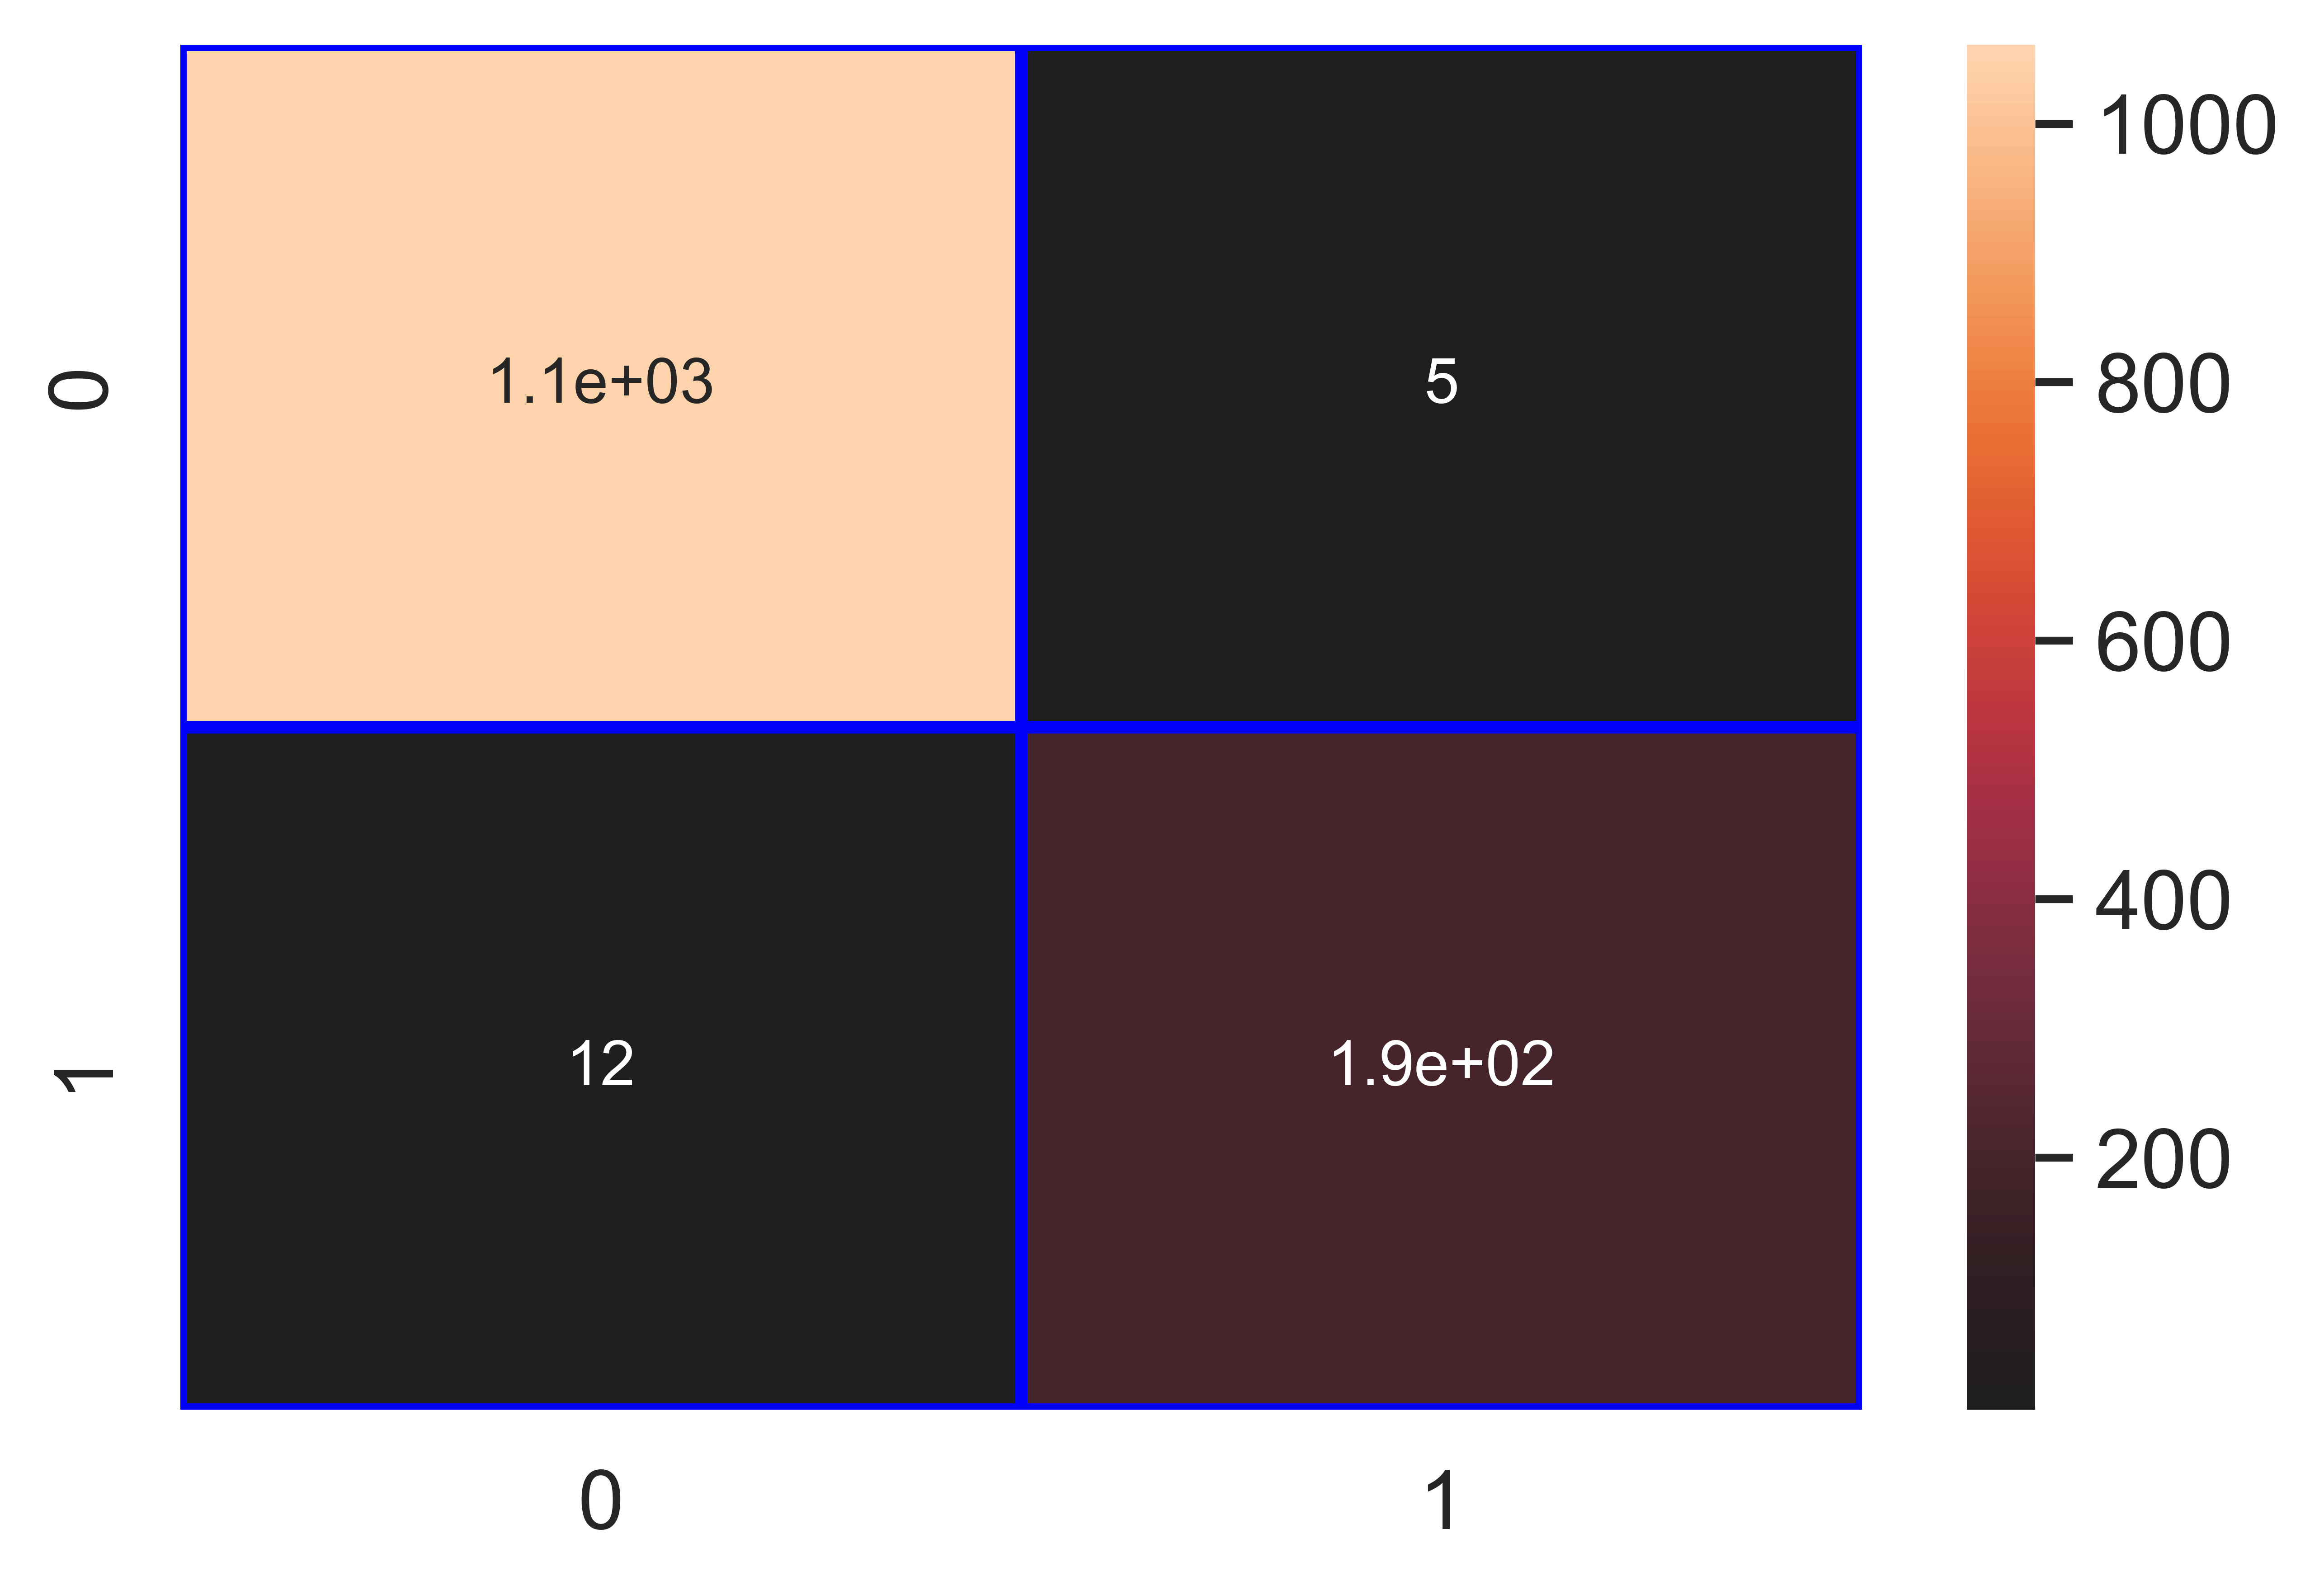

File saved : Anthracnose_rf_Classifier.pkl

data : {'Accuracy': 98.66, 'Loss': 1.34, 'Precision': 97.45, 'Recall': 94.09, 'f1_score': 95.74, 'Cohen_kappa': 94.94, 'Feature_name': 'Anthracnose', 'Model_name': 'rf_Classifier', 'Filename': 'Anthracnose_rf_Classifier.pkl'}

Model : gb_Classifier

Accuracy_score : 98.19 %

Loss : 1.81 %

Precision : 94.55 %

Recall : 94.09 %

f1_score : 94.32 %

Cohen_kappa_score : 93.24 %

Classification_report :   
 precision recall f1-score support  
  
 0 0.99 0.99 0.99 1066  
 1 0.95 0.94 0.94 203  
  
 accuracy 0.98 1269  
 macro avg 0.97 0.97 0.97 1269  
weighted avg 0.98 0.98 0.98 1269

Confusion_matrix :   
[[1055 11]  
 [ 12 191]]

### Image of images/Anthracnose_gb_Classifier_Accuracy_98.png :

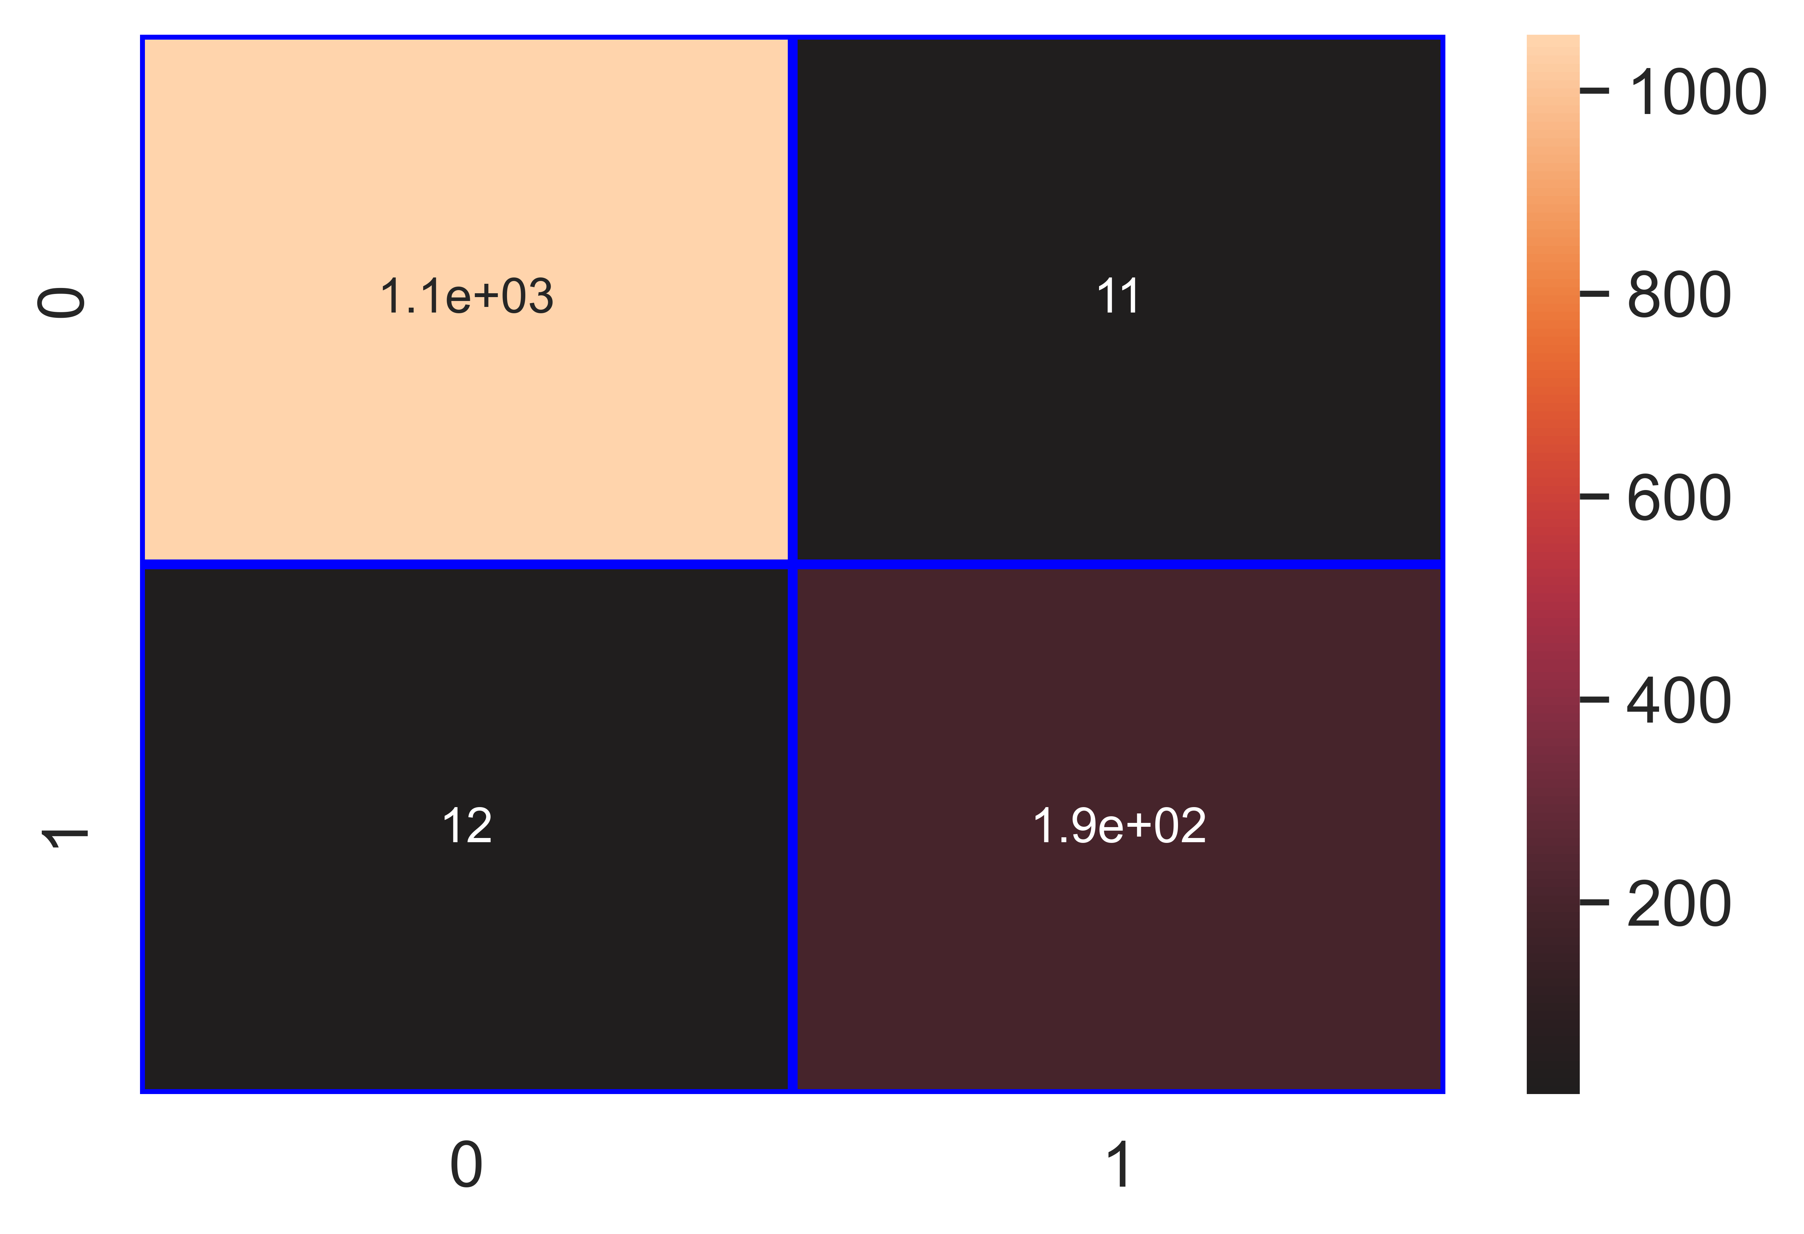

File saved : Anthracnose_gb_Classifier.pkl

data : {'Accuracy': 98.19, 'Loss': 1.81, 'Precision': 94.55, 'Recall': 94.09, 'f1_score': 94.32, 'Cohen_kappa': 93.24, 'Feature_name': 'Anthracnose', 'Model_name': 'gb_Classifier', 'Filename': 'Anthracnose_gb_Classifier.pkl'}

Model : ab_Classifier

Accuracy_score : 98.03 %

Loss : 1.97 %

Precision : 94.06 %

Recall : 93.6 %

f1_score : 93.83 %

Cohen_kappa_score : 92.66 %

Classification_report :   
 precision recall f1-score support  
  
 0 0.99 0.99 0.99 1066  
 1 0.94 0.94 0.94 203  
  
 accuracy 0.98 1269  
 macro avg 0.96 0.96 0.96 1269  
weighted avg 0.98 0.98 0.98 1269

Confusion_matrix :   
[[1054 12]  
 [ 13 190]]

### Image of images/Anthracnose_ab_Classifier_Accuracy_98.png :

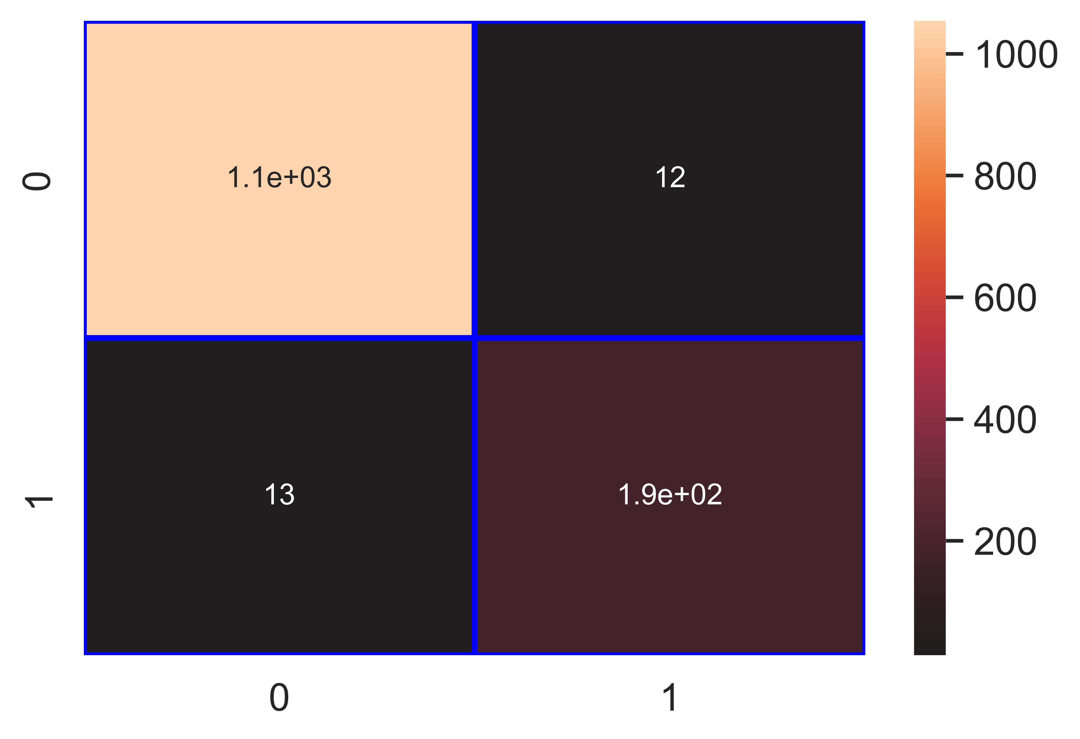

File saved : Anthracnose_ab_Classifier.pkl

data : {'Accuracy': 98.03, 'Loss': 1.97, 'Precision': 94.06, 'Recall': 93.6, 'f1_score': 93.83, 'Cohen_kappa': 92.66, 'Feature_name': 'Anthracnose', 'Model_name': 'ab_Classifier', 'Filename': 'Anthracnose_ab_Classifier.pkl'}

## Column : Fruit Spot/ Rot

Model : lr_Classifier

Accuracy_score : 97.95 %

Loss : 2.05 %

Precision : 92.48 %

Recall : 88.49 %

f1_score : 90.44 %

Cohen_kappa_score : 89.29 %

Classification_report :   
 precision recall f1-score support  
  
 0 0.99 0.99 0.99 1130  
 1 0.92 0.88 0.90 139  
  
 accuracy 0.98 1269  
 macro avg 0.96 0.94 0.95 1269  
weighted avg 0.98 0.98 0.98 1269

Confusion_matrix :   
[[1120 10]  
 [ 16 123]]

### Image of images/Fruit_Spot_Rot_lr_Classifier_Accuracy_98.png :

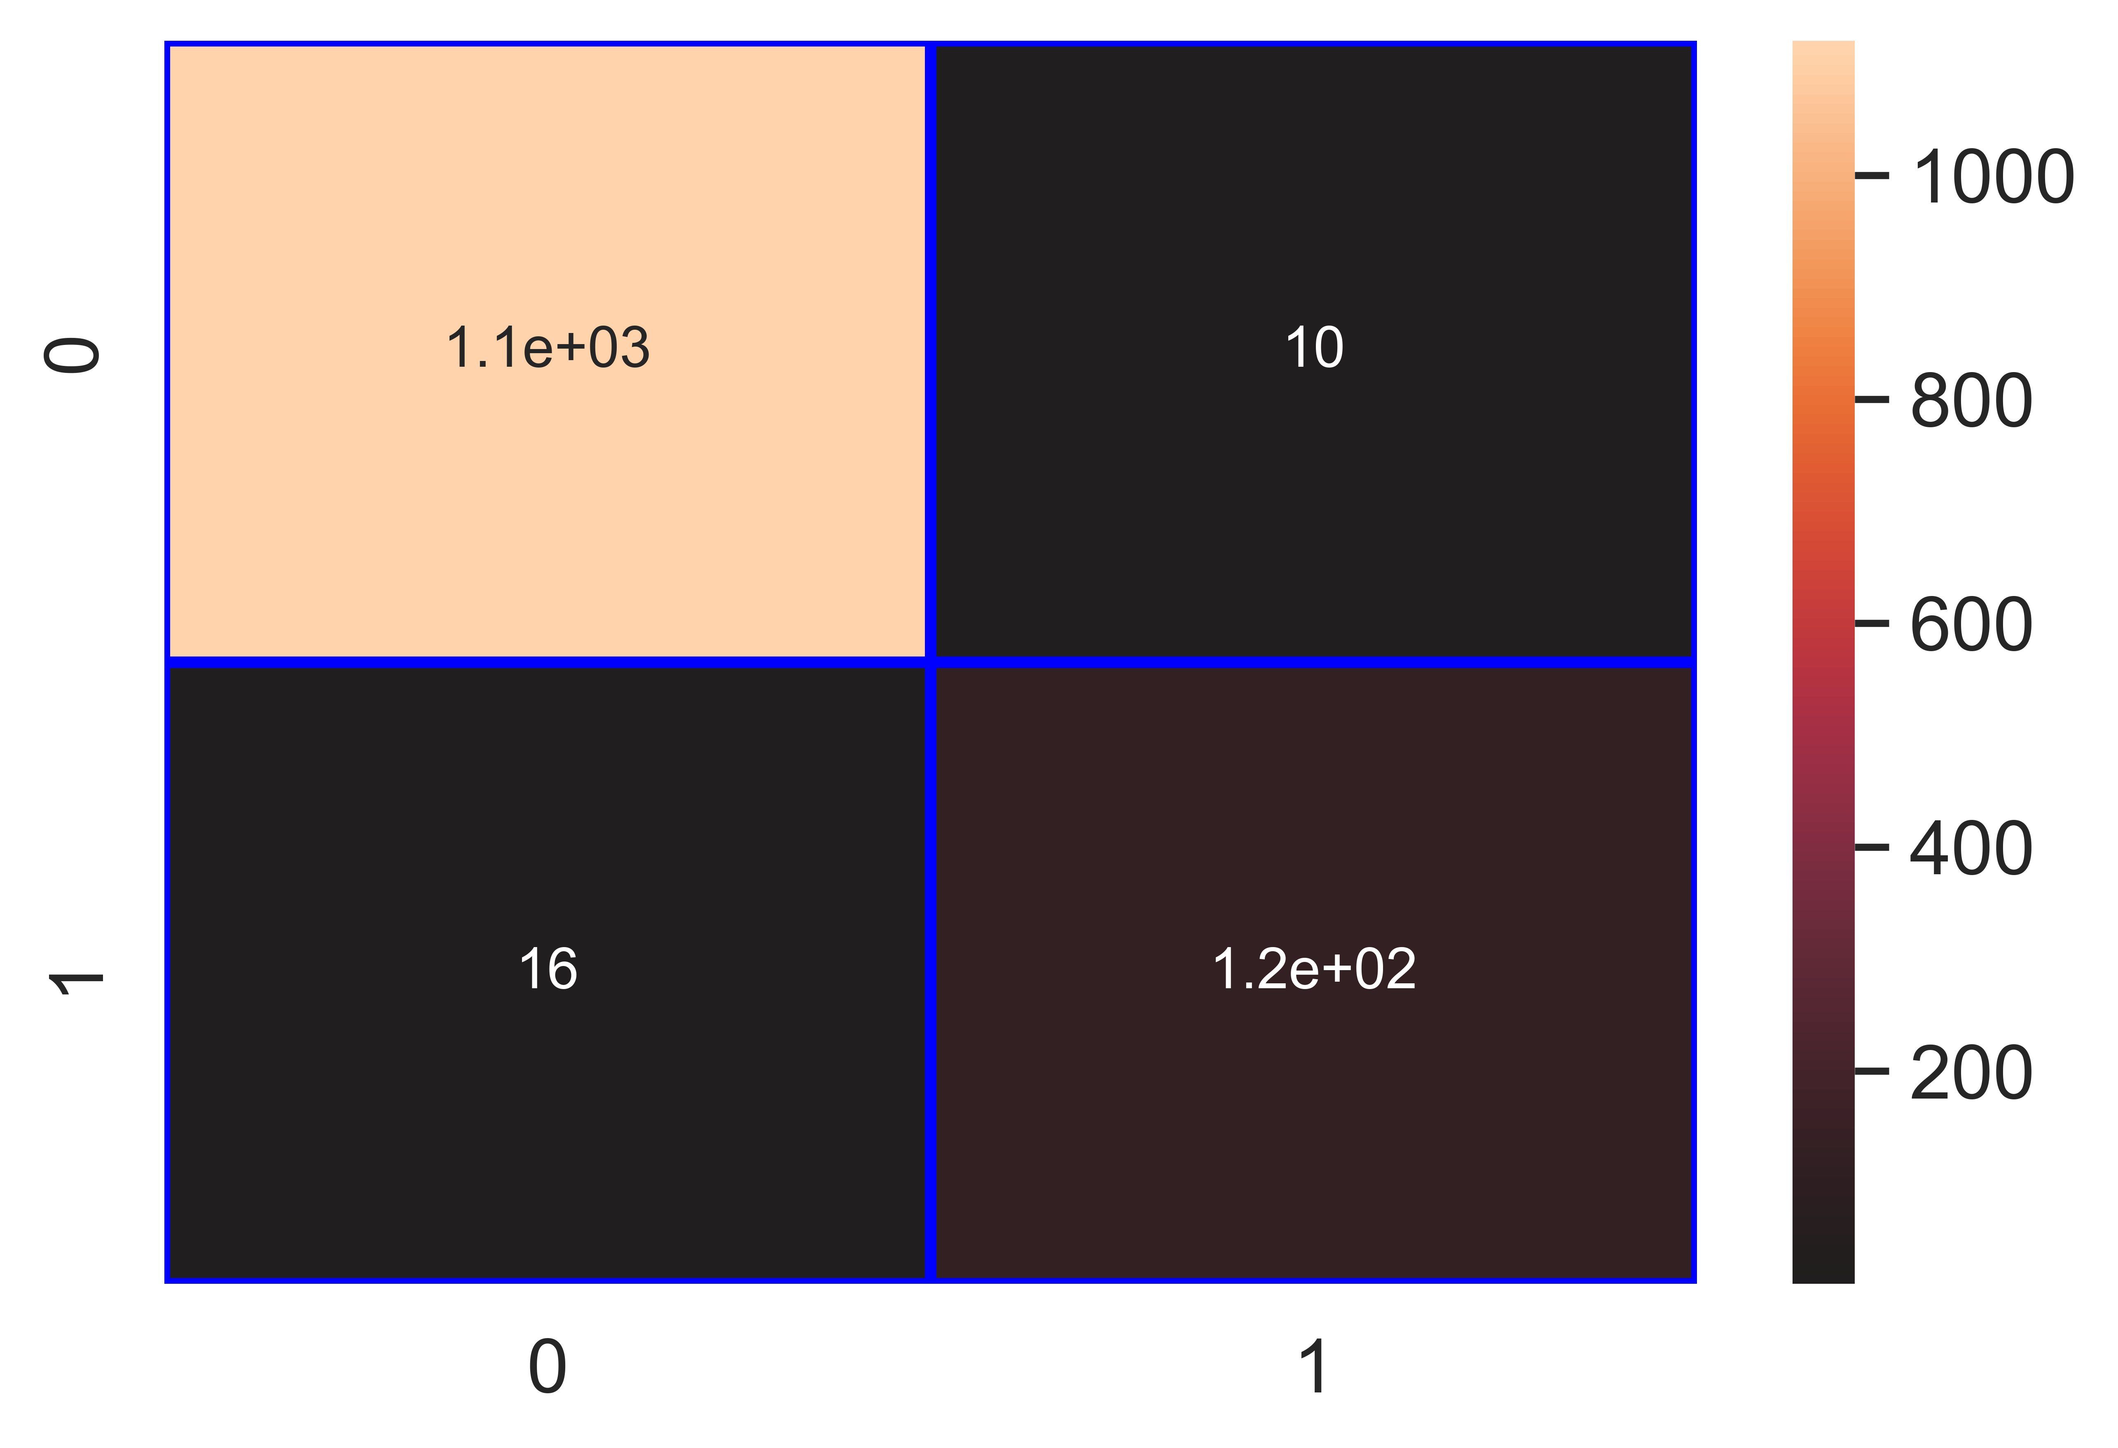

File saved : Fruit_Spot_Rot_lr_Classifier.pkl

data : {'Accuracy': 97.95, 'Loss': 2.05, 'Precision': 92.48, 'Recall': 88.49, 'f1_score': 90.44, 'Cohen_kappa': 89.29, 'Feature_name': 'Fruit Spot/ Rot', 'Model_name': 'lr_Classifier', 'Filename': 'Fruit_Spot_Rot_lr_Classifier.pkl'}

Model : knn_Classifier

Accuracy_score : 99.21 %

Loss : 0.79 %

Precision : 94.48 %

Recall : 98.56 %

f1_score : 96.48 %

Cohen_kappa_score : 96.04 %

Classification_report :   
 precision recall f1-score support  
  
 0 1.00 0.99 1.00 1130  
 1 0.94 0.99 0.96 139  
  
 accuracy 0.99 1269  
 macro avg 0.97 0.99 0.98 1269  
weighted avg 0.99 0.99 0.99 1269

Confusion_matrix :   
[[1122 8]  
 [ 2 137]]

### Image of images/Fruit_Spot_Rot_knn_Classifier_Accuracy_99.png :

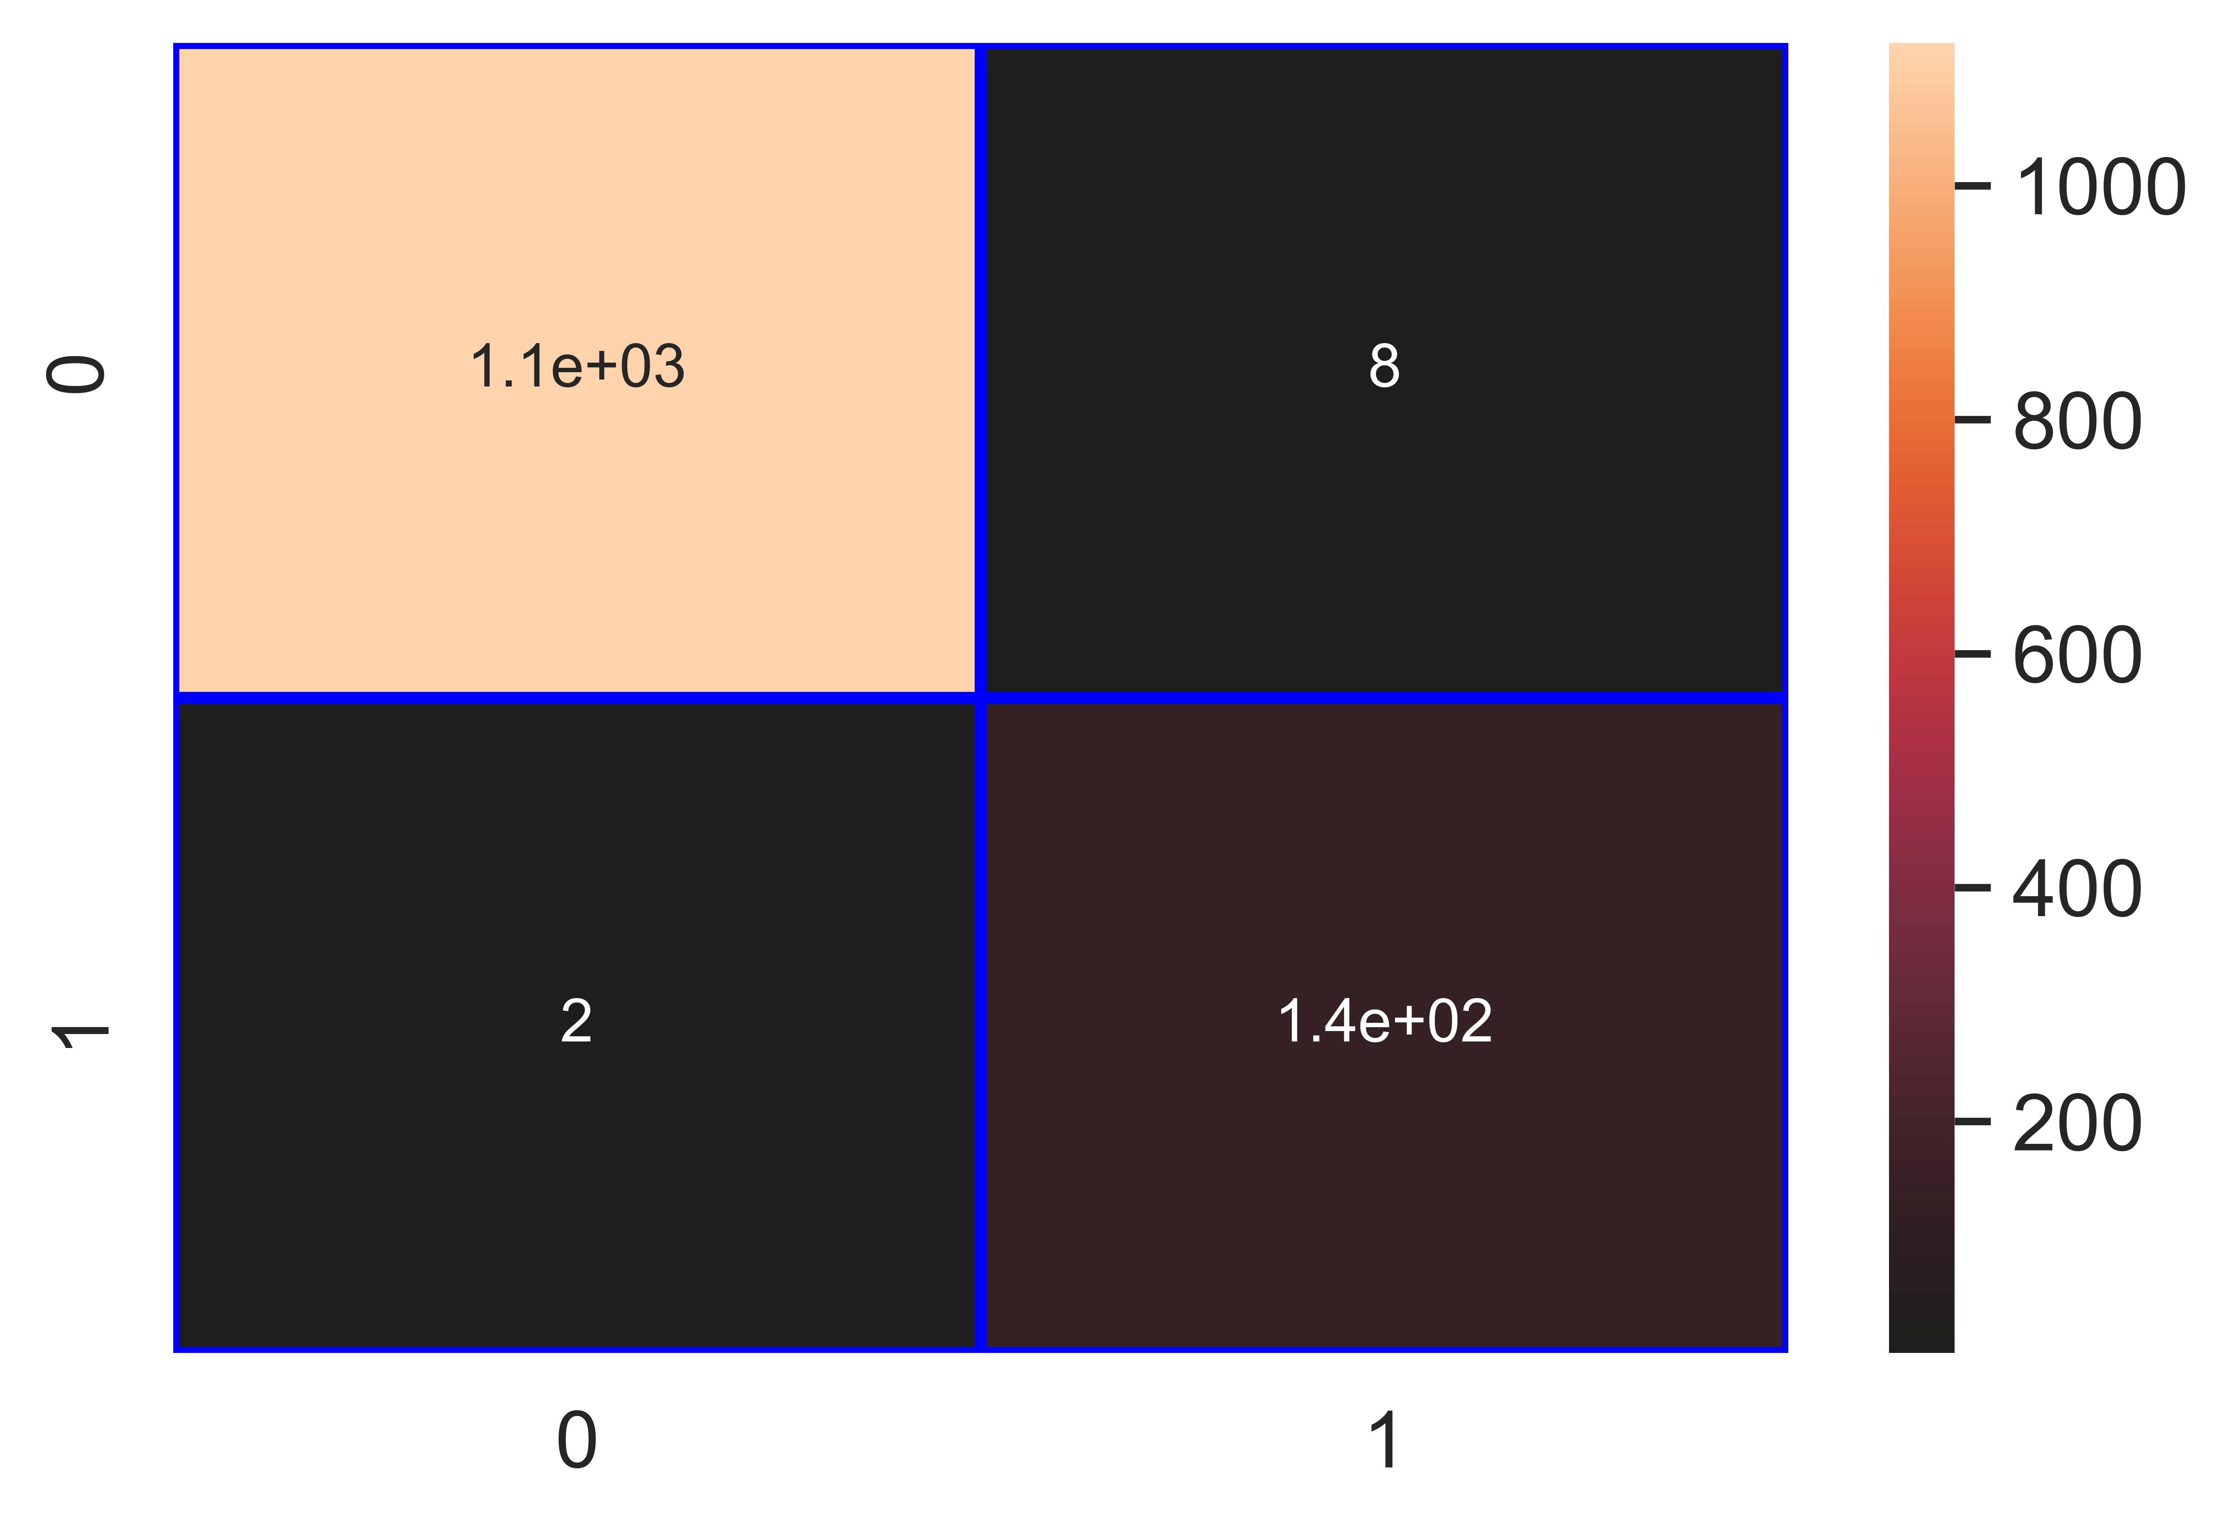

File saved : Fruit_Spot_Rot_knn_Classifier.pkl

data : {'Accuracy': 99.21, 'Loss': 0.79, 'Precision': 94.48, 'Recall': 98.56, 'f1_score': 96.48, 'Cohen_kappa': 96.04, 'Feature_name': 'Fruit Spot/ Rot', 'Model_name': 'knn_Classifier', 'Filename': 'Fruit_Spot_Rot_knn_Classifier.pkl'}

Model : nb_Classifier

Accuracy_score : 92.28 %

Loss : 7.72 %

Precision : 58.8 %

Recall : 98.56 %

f1_score : 73.66 %

Cohen_kappa_score : 69.47 %

Classification_report :   
 precision recall f1-score support  
  
 0 1.00 0.92 0.95 1130  
 1 0.59 0.99 0.74 139  
  
 accuracy 0.92 1269  
 macro avg 0.79 0.95 0.85 1269  
weighted avg 0.95 0.92 0.93 1269

Confusion_matrix :   
[[1034 96]  
 [ 2 137]]

### Image of images/Fruit_Spot_Rot_nb_Classifier_Accuracy_92.png :

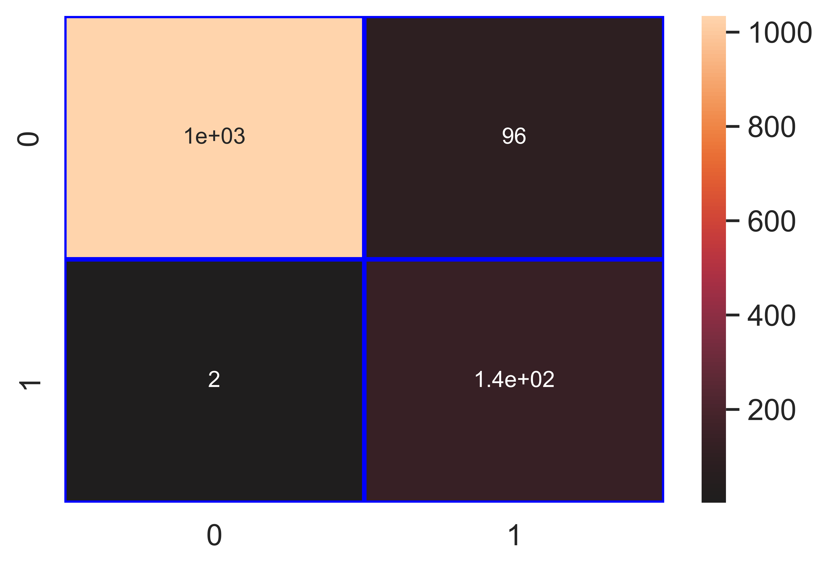

File saved : Fruit_Spot_Rot_nb_Classifier.pkl

data : {'Accuracy': 92.28, 'Loss': 7.72, 'Precision': 58.8, 'Recall': 98.56, 'f1_score': 73.66, 'Cohen_kappa': 69.47, 'Feature_name': 'Fruit Spot/ Rot', 'Model_name': 'nb_Classifier', 'Filename': 'Fruit_Spot_Rot_nb_Classifier.pkl'}

Model : svm_Classifier

Accuracy_score : 97.24 %

Loss : 2.76 %

Precision : 100.0 %

Recall : 74.82 %

f1_score : 85.6 %

Cohen_kappa_score : 84.11 %

Classification_report :   
 precision recall f1-score support  
  
 0 0.97 1.00 0.98 1130  
 1 1.00 0.75 0.86 139  
  
 accuracy 0.97 1269  
 macro avg 0.98 0.87 0.92 1269  
weighted avg 0.97 0.97 0.97 1269

Confusion_matrix :   
[[1130 0]  
 [ 35 104]]

### Image of images/Fruit_Spot_Rot_svm_Classifier_Accuracy_97.png :

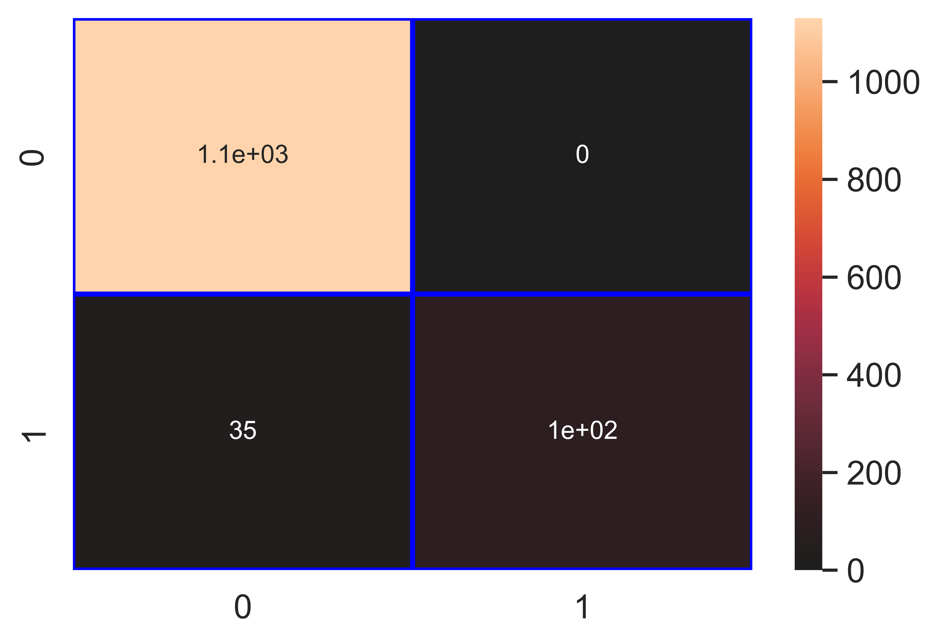

File saved : Fruit_Spot_Rot_svm_Classifier.pkl

data : {'Accuracy': 97.24, 'Loss': 2.76, 'Precision': 100.0, 'Recall': 74.82, 'f1_score': 85.6, 'Cohen_kappa': 84.11, 'Feature_name': 'Fruit Spot/ Rot', 'Model_name': 'svm_Classifier', 'Filename': 'Fruit_Spot_Rot_svm_Classifier.pkl'}

Model : dt_Classifier

Accuracy_score : 99.84 %

Loss : 0.16 %

Precision : 100.0 %

Recall : 98.56 %

f1_score : 99.28 %

Cohen_kappa_score : 99.19 %

Classification_report :   
 precision recall f1-score support  
  
 0 1.00 1.00 1.00 1130  
 1 1.00 0.99 0.99 139  
  
 accuracy 1.00 1269  
 macro avg 1.00 0.99 1.00 1269  
weighted avg 1.00 1.00 1.00 1269

Confusion_matrix :   
[[1130 0]  
 [ 2 137]]

### Image of images/Fruit_Spot_Rot_dt_Classifier_Accuracy_100.png :

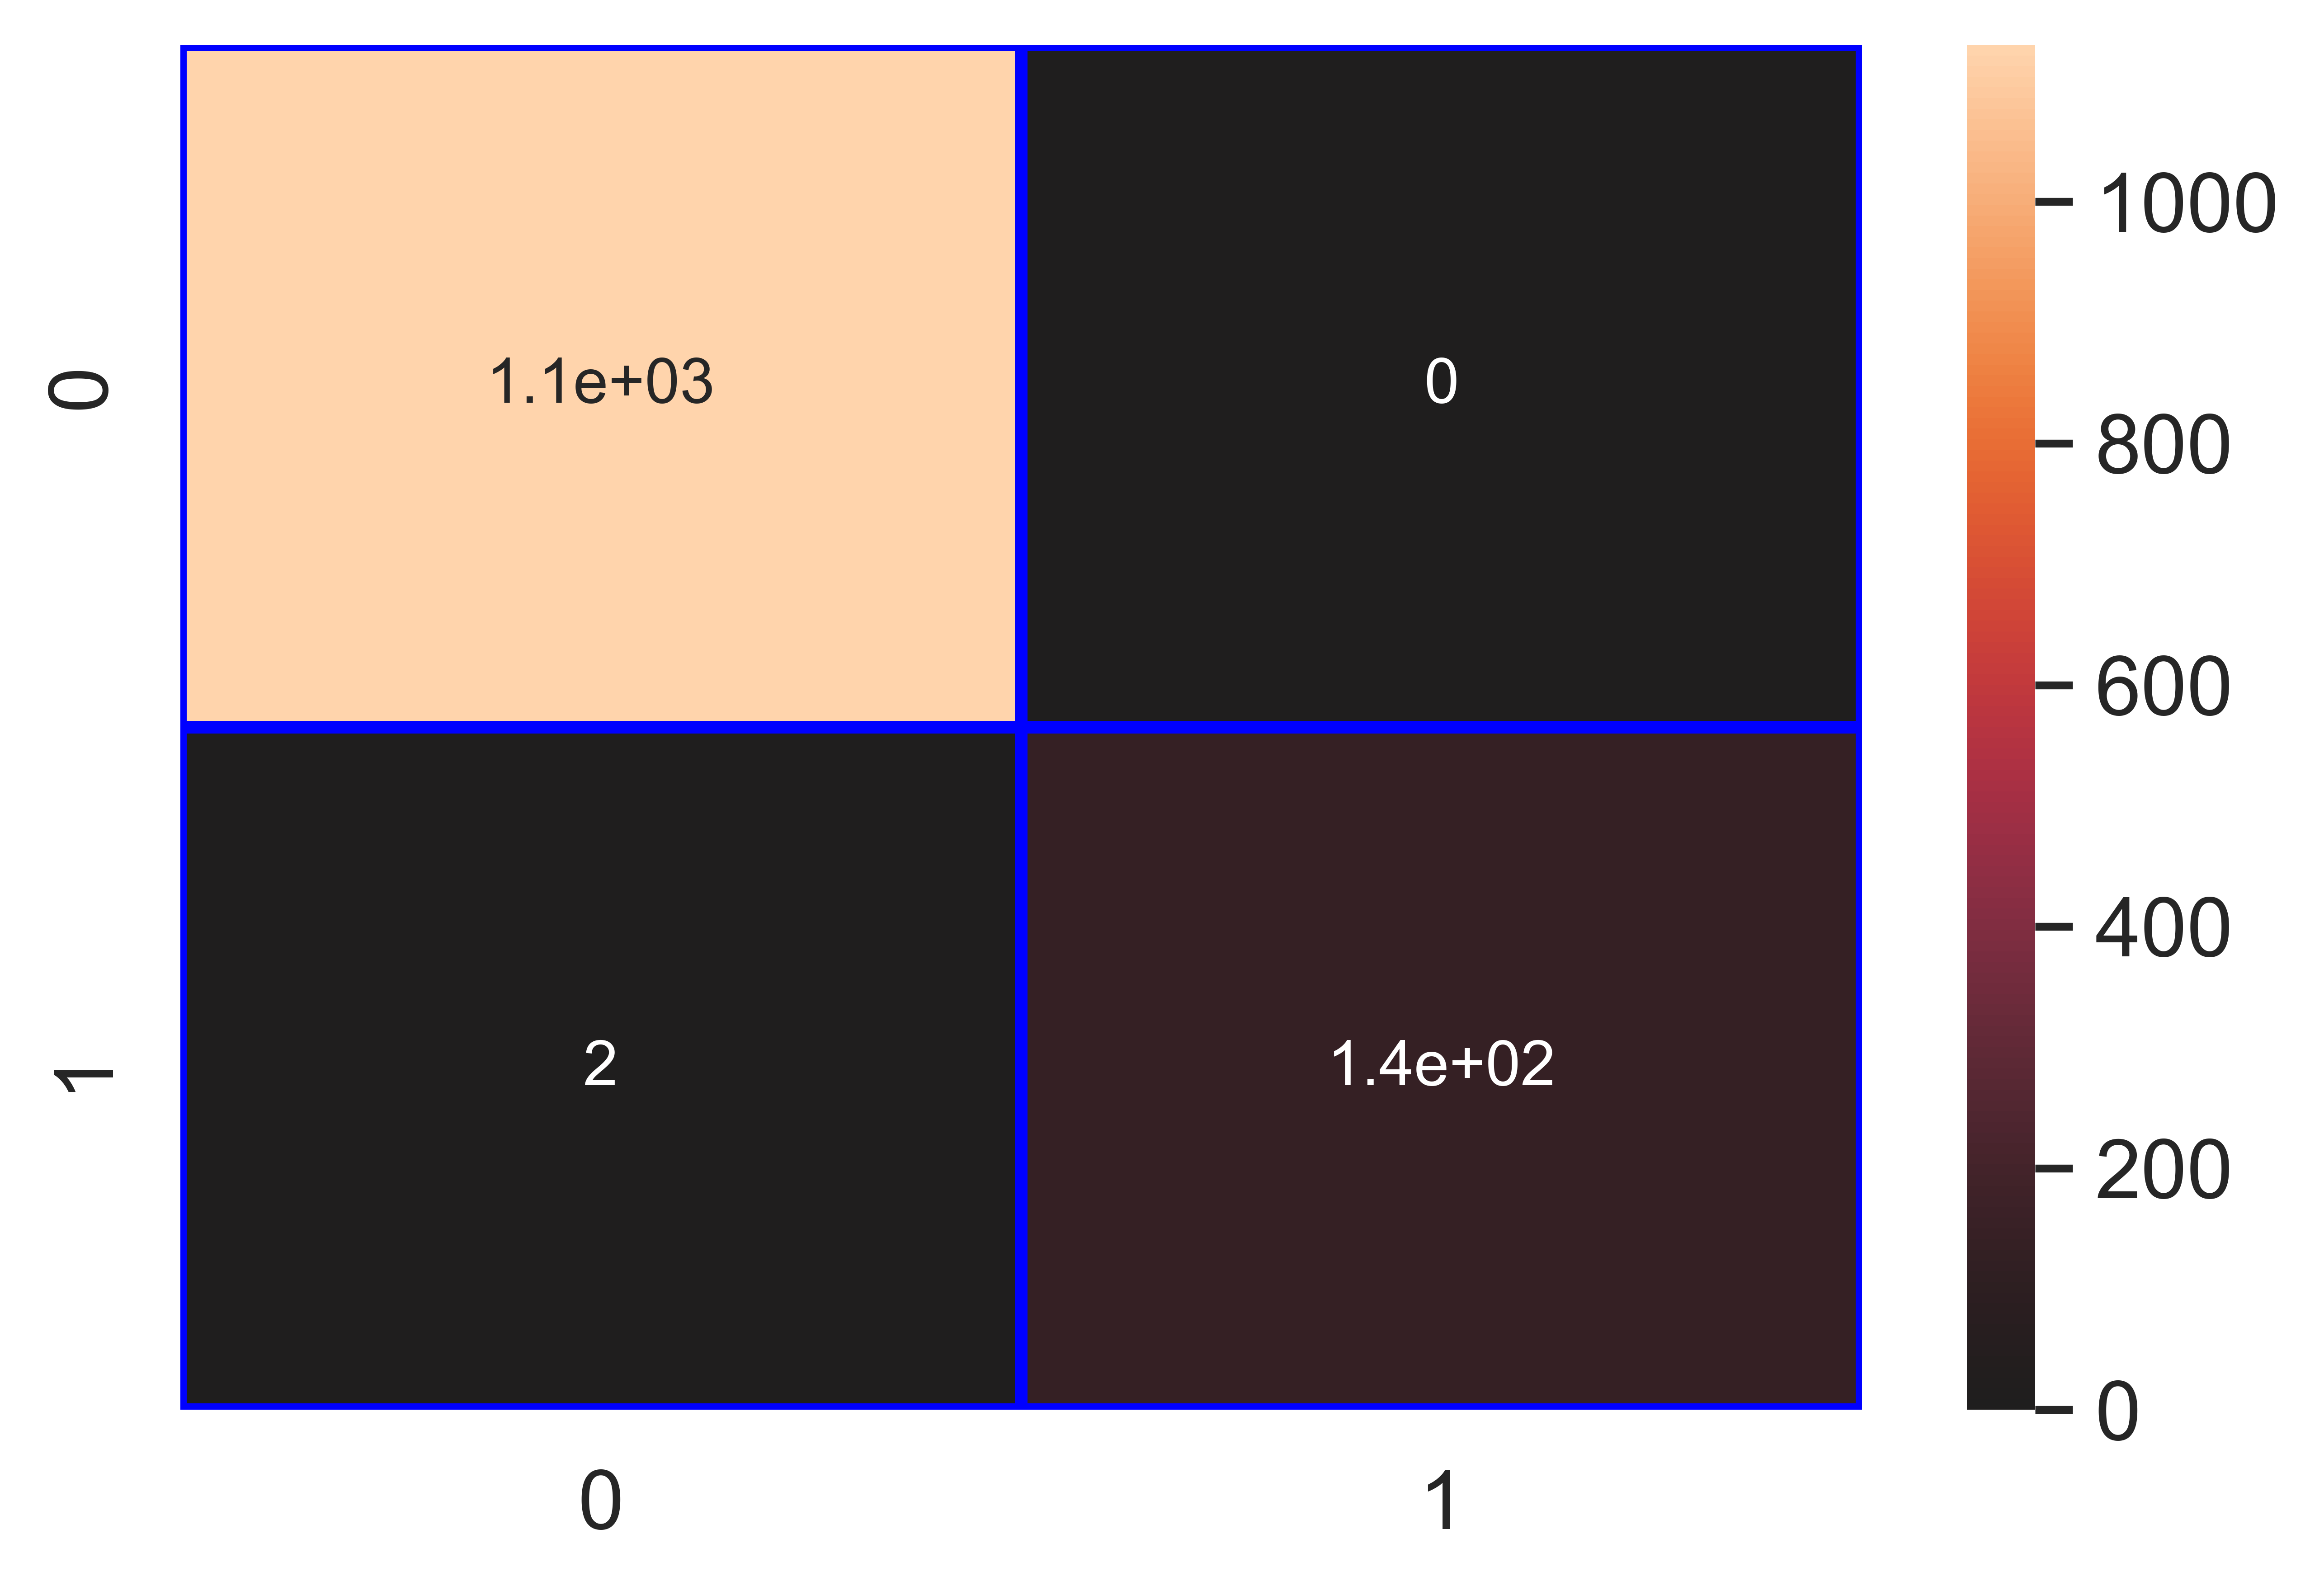

File saved : Fruit_Spot_Rot_dt_Classifier.pkl

data : {'Accuracy': 99.84, 'Loss': 0.16, 'Precision': 100.0, 'Recall': 98.56, 'f1_score': 99.28, 'Cohen_kappa': 99.19, 'Feature_name': 'Fruit Spot/ Rot', 'Model_name': 'dt_Classifier', 'Filename': 'Fruit_Spot_Rot_dt_Classifier.pkl'}

Model : rf_Classifier

Accuracy_score : 99.92 %

Loss : 0.08 %

Precision : 100.0 %

Recall : 99.28 %

f1_score : 99.64 %

Cohen_kappa_score : 99.59 %

Classification_report :   
 precision recall f1-score support  
  
 0 1.00 1.00 1.00 1130  
 1 1.00 0.99 1.00 139  
  
 accuracy 1.00 1269  
 macro avg 1.00 1.00 1.00 1269  
weighted avg 1.00 1.00 1.00 1269

Confusion_matrix :   
[[1130 0]  
 [ 1 138]]

### Image of images/Fruit_Spot_Rot_rf_Classifier_Accuracy_100.png :

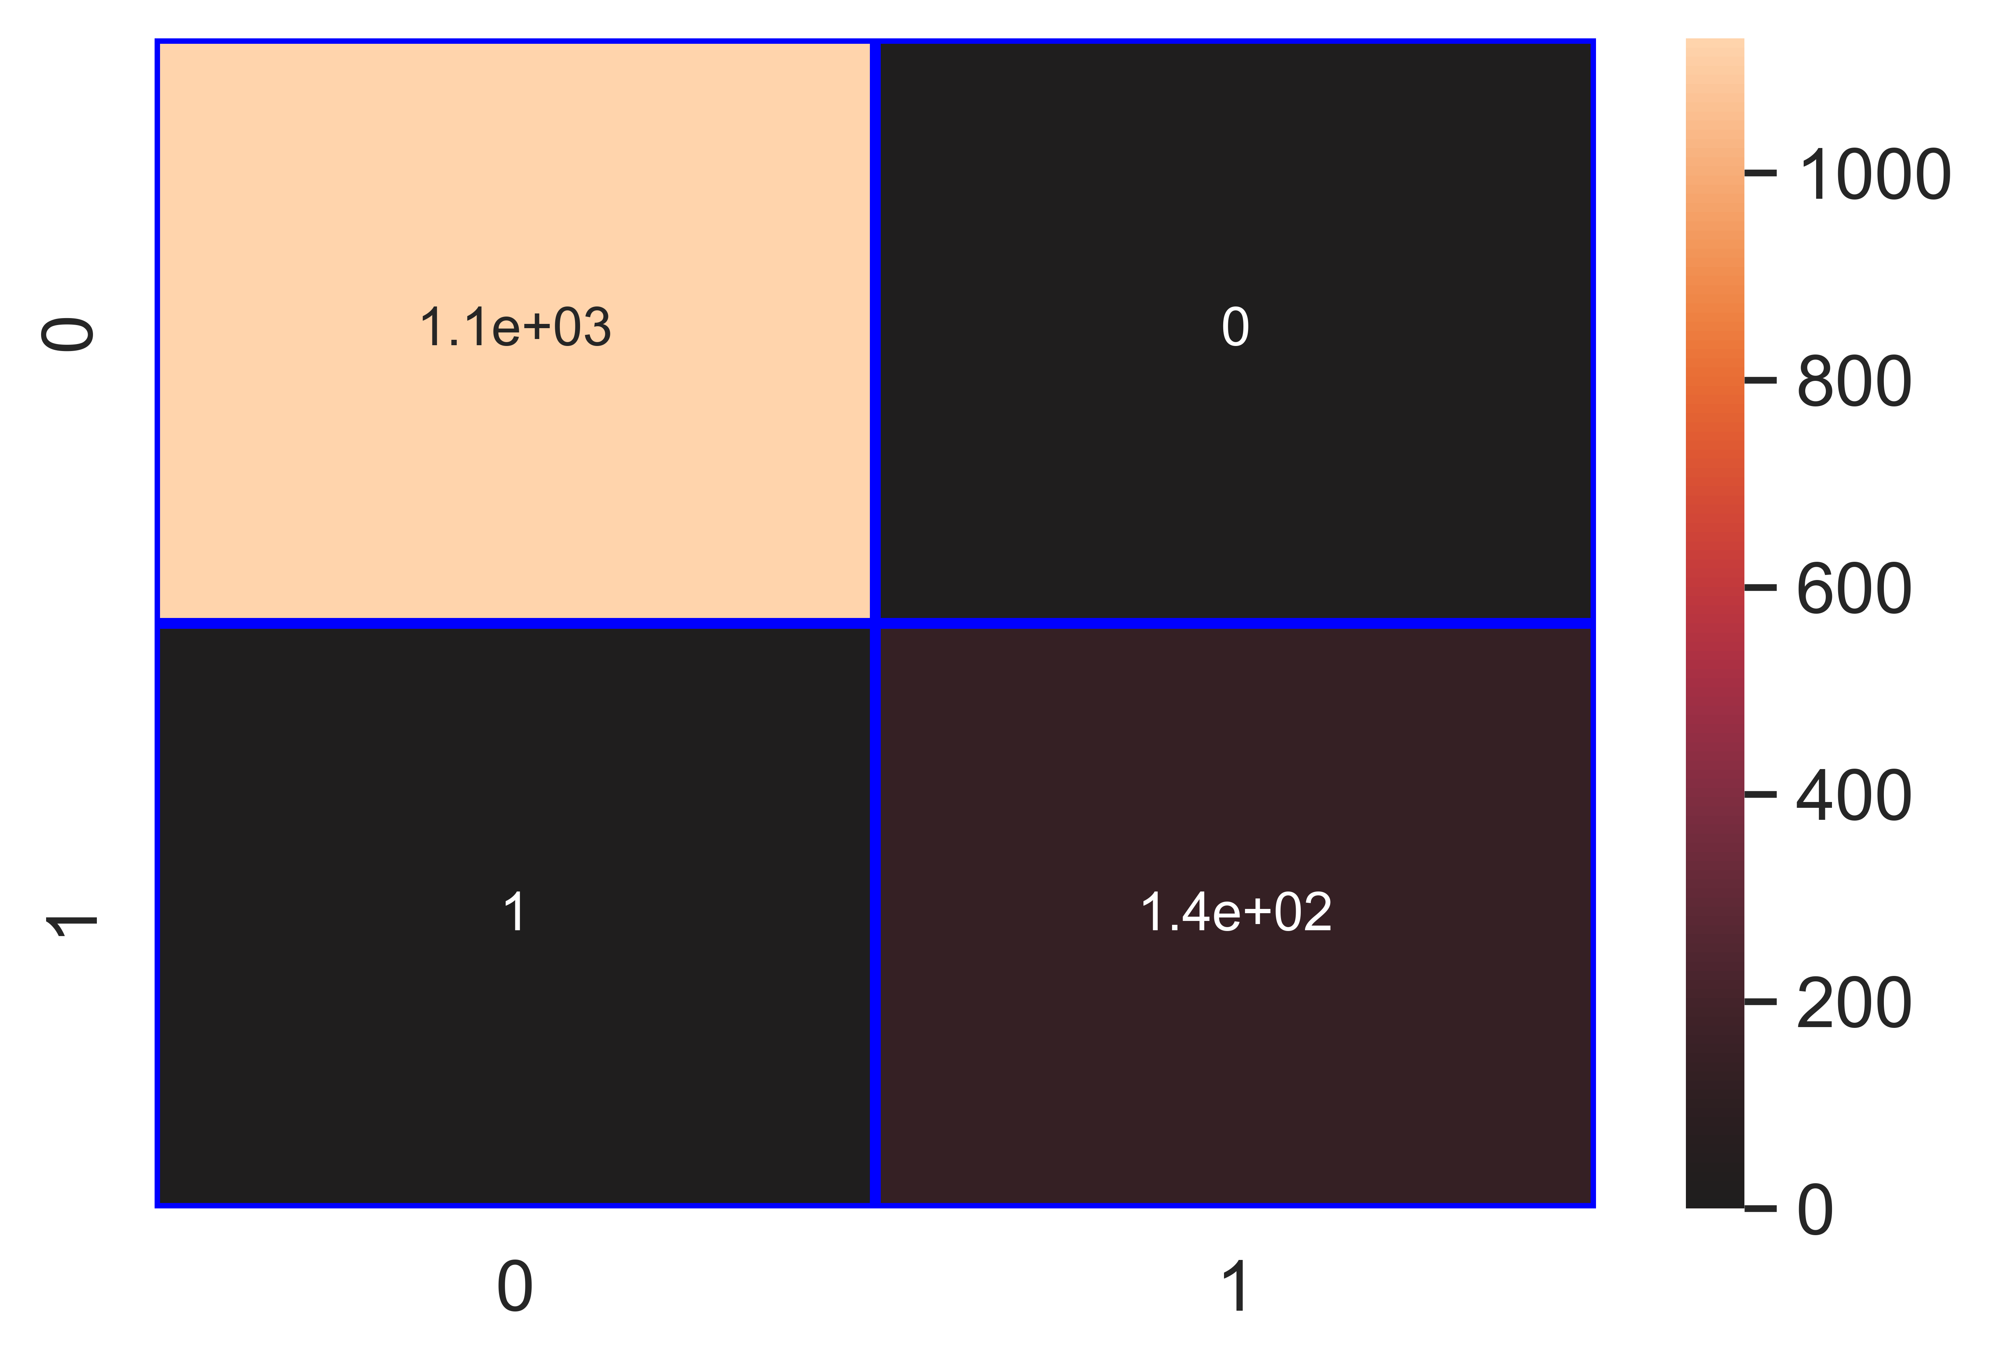

File saved : Fruit_Spot_Rot_rf_Classifier.pkl

data : {'Accuracy': 99.92, 'Loss': 0.08, 'Precision': 100.0, 'Recall': 99.28, 'f1_score': 99.64, 'Cohen_kappa': 99.59, 'Feature_name': 'Fruit Spot/ Rot', 'Model_name': 'rf_Classifier', 'Filename': 'Fruit_Spot_Rot_rf_Classifier.pkl'}

Model : gb_Classifier

Accuracy_score : 99.84 %

Loss : 0.16 %

Precision : 100.0 %

Recall : 98.56 %

f1_score : 99.28 %

Cohen_kappa_score : 99.19 %

Classification_report :   
 precision recall f1-score support  
  
 0 1.00 1.00 1.00 1130  
 1 1.00 0.99 0.99 139  
  
 accuracy 1.00 1269  
 macro avg 1.00 0.99 1.00 1269  
weighted avg 1.00 1.00 1.00 1269

Confusion_matrix :   
[[1130 0]  
 [ 2 137]]

### Image of images/Fruit_Spot_Rot_gb_Classifier_Accuracy_100.png :



File saved : Fruit_Spot_Rot_gb_Classifier.pkl

data : {'Accuracy': 99.84, 'Loss': 0.16, 'Precision': 100.0, 'Recall': 98.56, 'f1_score': 99.28, 'Cohen_kappa': 99.19, 'Feature_name': 'Fruit Spot/ Rot', 'Model_name': 'gb_Classifier', 'Filename': 'Fruit_Spot_Rot_gb_Classifier.pkl'}

Model : ab_Classifier

Accuracy_score : 99.76 %

Loss : 0.24 %

Precision : 99.28 %

Recall : 98.56 %

f1_score : 98.92 %

Cohen_kappa_score : 98.78 %

Classification_report :   
 precision recall f1-score support  
  
 0 1.00 1.00 1.00 1130  
 1 0.99 0.99 0.99 139  
  
 accuracy 1.00 1269  
 macro avg 1.00 0.99 0.99 1269  
weighted avg 1.00 1.00 1.00 1269

Confusion_matrix :   
[[1129 1]  
 [ 2 137]]

### Image of images/Fruit_Spot_Rot_ab_Classifier_Accuracy_100.png :

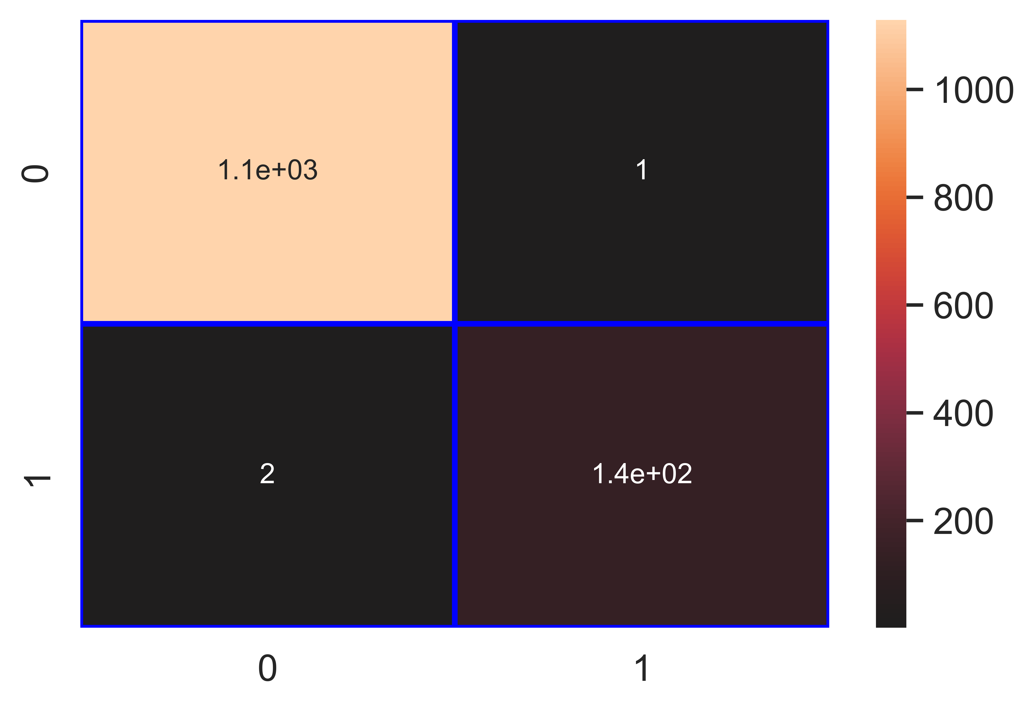

File saved : Fruit_Spot_Rot_ab_Classifier.pkl

data : {'Accuracy': 99.76, 'Loss': 0.24, 'Precision': 99.28, 'Recall': 98.56, 'f1_score': 98.92, 'Cohen_kappa': 98.78, 'Feature_name': 'Fruit Spot/ Rot', 'Model_name': 'ab_Classifier', 'Filename': 'Fruit_Spot_Rot_ab_Classifier.pkl'}

## Column : Fusarium Wilt

Model : lr_Classifier

Accuracy_score : 99.84 %

Loss : 0.16 %

Precision : 100.0 %

Recall : 93.55 %

f1_score : 96.67 %

Cohen_kappa_score : 96.59 %

Classification_report :   
 precision recall f1-score support  
  
 0 1.00 1.00 1.00 1238  
 1 1.00 0.94 0.97 31  
  
 accuracy 1.00 1269  
 macro avg 1.00 0.97 0.98 1269  
weighted avg 1.00 1.00 1.00 1269

Confusion_matrix :   
[[1238 0]  
 [ 2 29]]

### Image of images/Fusarium_Wilt_lr_Classifier_Accuracy_100.png :

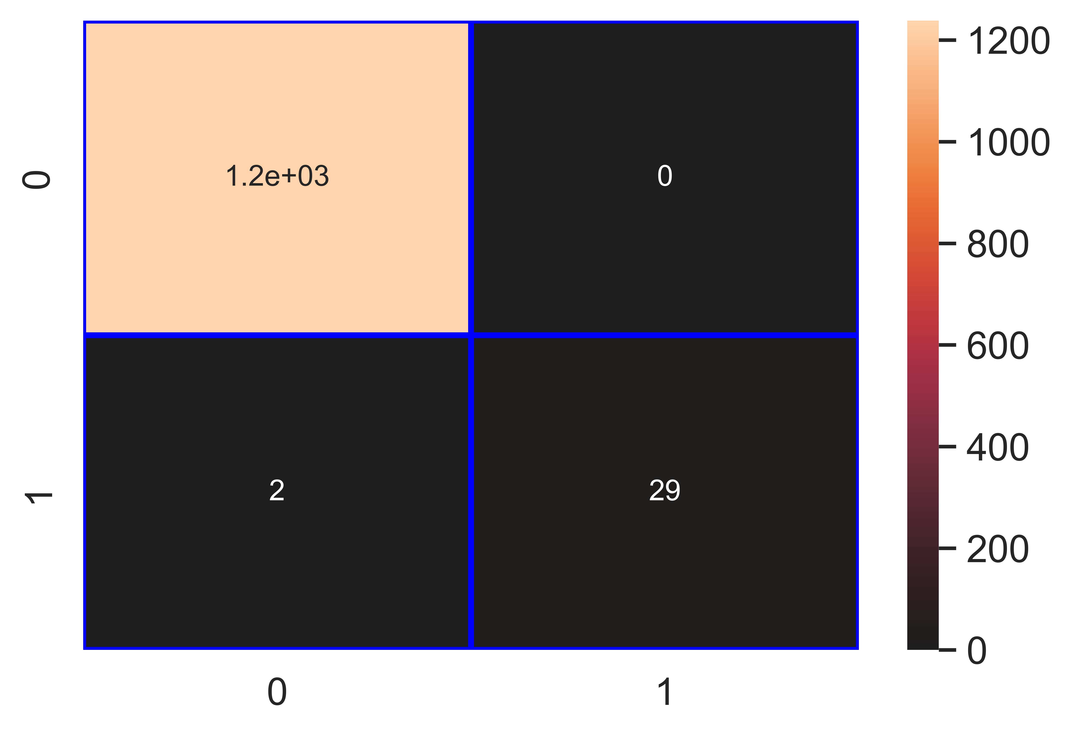

File saved : Fusarium_Wilt_lr_Classifier.pkl

data : {'Accuracy': 99.84, 'Loss': 0.16, 'Precision': 100.0, 'Recall': 93.55, 'f1_score': 96.67, 'Cohen_kappa': 96.59, 'Feature_name': 'Fusarium Wilt', 'Model_name': 'lr_Classifier', 'Filename': 'Fusarium_Wilt_lr_Classifier.pkl'}

Model : knn_Classifier

Accuracy_score : 99.05 %

Loss : 0.95 %

Precision : 100.0 %

Recall : 61.29 %

f1_score : 76.0 %

Cohen_kappa_score : 75.55 %

Classification_report :   
 precision recall f1-score support  
  
 0 0.99 1.00 1.00 1238  
 1 1.00 0.61 0.76 31  
  
 accuracy 0.99 1269  
 macro avg 1.00 0.81 0.88 1269  
weighted avg 0.99 0.99 0.99 1269

Confusion_matrix :   
[[1238 0]  
 [ 12 19]]

### Image of images/Fusarium_Wilt_knn_Classifier_Accuracy_99.png :

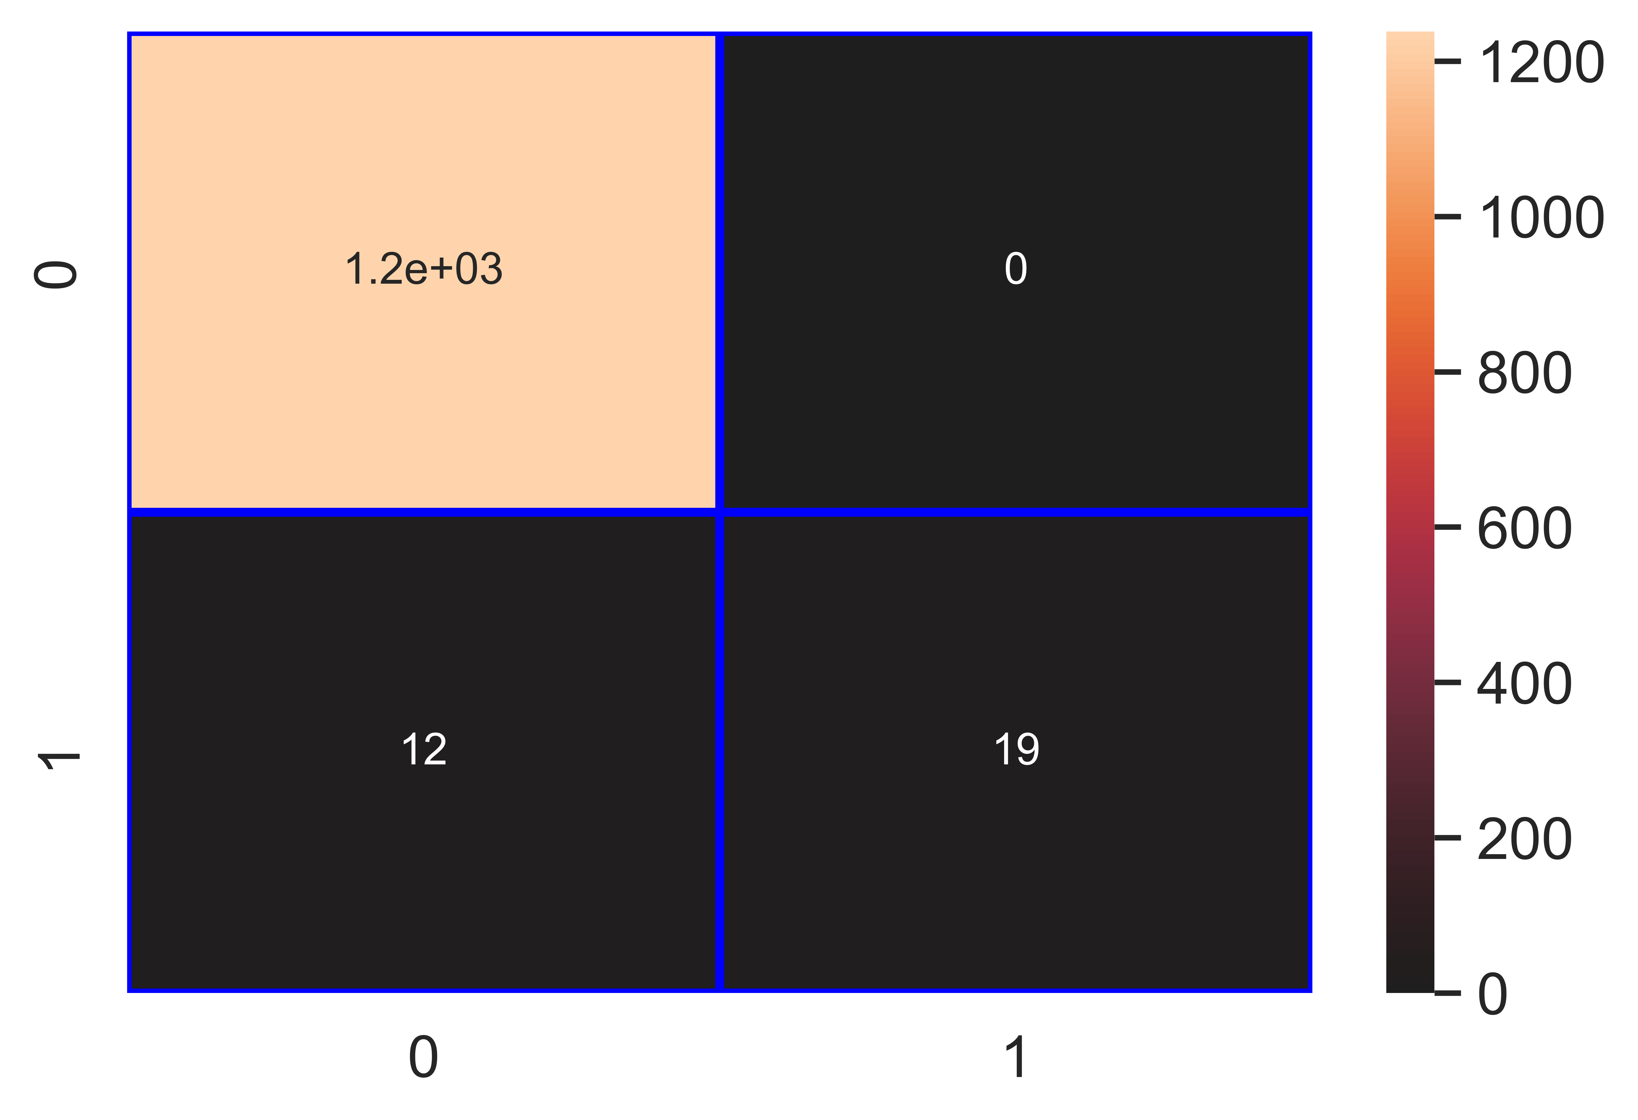

File saved : Fusarium_Wilt_knn_Classifier.pkl

data : {'Accuracy': 99.05, 'Loss': 0.95, 'Precision': 100.0, 'Recall': 61.29, 'f1_score': 76.0, 'Cohen_kappa': 75.55, 'Feature_name': 'Fusarium Wilt', 'Model_name': 'knn_Classifier', 'Filename': 'Fusarium_Wilt_knn_Classifier.pkl'}

Model : nb_Classifier

Accuracy_score : 93.93 %

Loss : 6.07 %

Precision : 27.88 %

Recall : 93.55 %

f1_score : 42.96 %

Cohen_kappa_score : 40.73 %

Classification_report :   
 precision recall f1-score support  
  
 0 1.00 0.94 0.97 1238  
 1 0.28 0.94 0.43 31  
  
 accuracy 0.94 1269  
 macro avg 0.64 0.94 0.70 1269  
weighted avg 0.98 0.94 0.95 1269

Confusion_matrix :   
[[1163 75]  
 [ 2 29]]

### Image of images/Fusarium_Wilt_nb_Classifier_Accuracy_94.png :

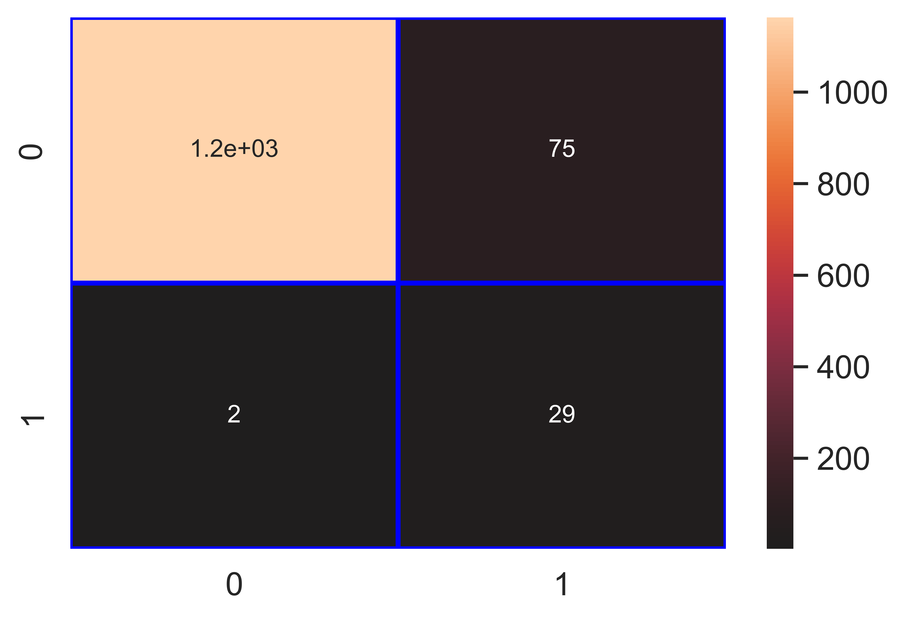

File saved : Fusarium_Wilt_nb_Classifier.pkl

data : {'Accuracy': 93.93, 'Loss': 6.07, 'Precision': 27.88, 'Recall': 93.55, 'f1_score': 42.96, 'Cohen_kappa': 40.73, 'Feature_name': 'Fusarium Wilt', 'Model_name': 'nb_Classifier', 'Filename': 'Fusarium_Wilt_nb_Classifier.pkl'}

Model : svm_Classifier

Accuracy_score : 97.64 %

Loss : 2.36 %

Precision : 100.0 %

Recall : 3.23 %

f1_score : 6.25 %

Cohen_kappa_score : 6.11 %

Classification_report :   
 precision recall f1-score support  
  
 0 0.98 1.00 0.99 1238  
 1 1.00 0.03 0.06 31  
  
 accuracy 0.98 1269  
 macro avg 0.99 0.52 0.53 1269  
weighted avg 0.98 0.98 0.97 1269

Confusion_matrix :   
[[1238 0]  
 [ 30 1]]

### Image of images/Fusarium_Wilt_svm_Classifier_Accuracy_98.png :

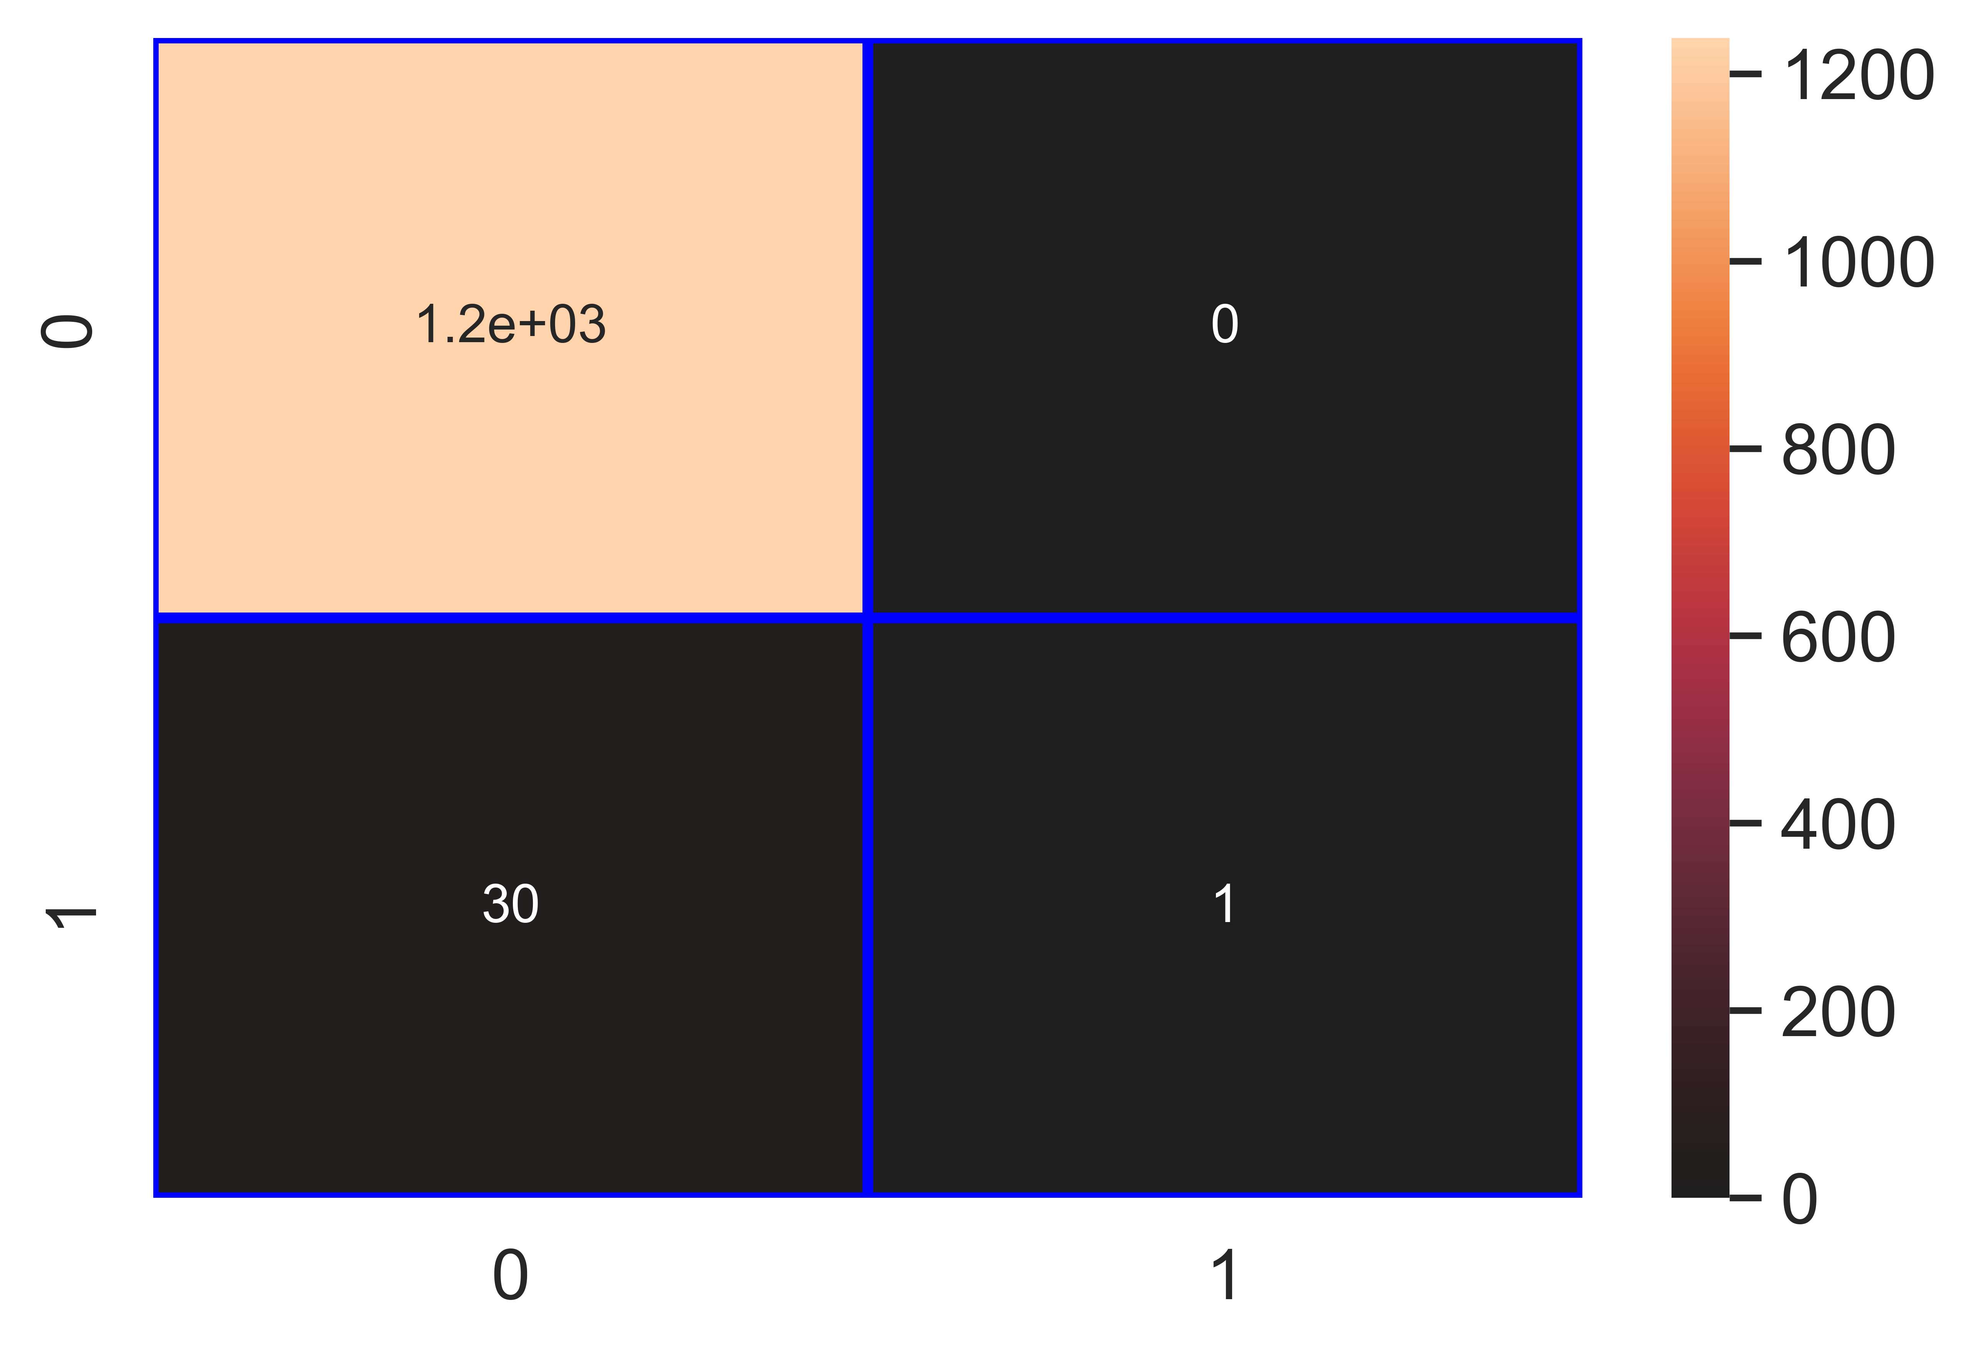

File saved : Fusarium_Wilt_svm_Classifier.pkl

data : {'Accuracy': 97.64, 'Loss': 2.36, 'Precision': 100.0, 'Recall': 3.23, 'f1_score': 6.25, 'Cohen_kappa': 6.11, 'Feature_name': 'Fusarium Wilt', 'Model_name': 'svm_Classifier', 'Filename': 'Fusarium_Wilt_svm_Classifier.pkl'}

Model : dt_Classifier

Accuracy_score : 99.92 %

Loss : 0.08 %

Precision : 100.0 %

Recall : 96.77 %

f1_score : 98.36 %

Cohen_kappa_score : 98.32 %

Classification_report :   
 precision recall f1-score support  
  
 0 1.00 1.00 1.00 1238  
 1 1.00 0.97 0.98 31  
  
 accuracy 1.00 1269  
 macro avg 1.00 0.98 0.99 1269  
weighted avg 1.00 1.00 1.00 1269

Confusion_matrix :   
[[1238 0]  
 [ 1 30]]

### Image of images/Fusarium_Wilt_dt_Classifier_Accuracy_100.png :

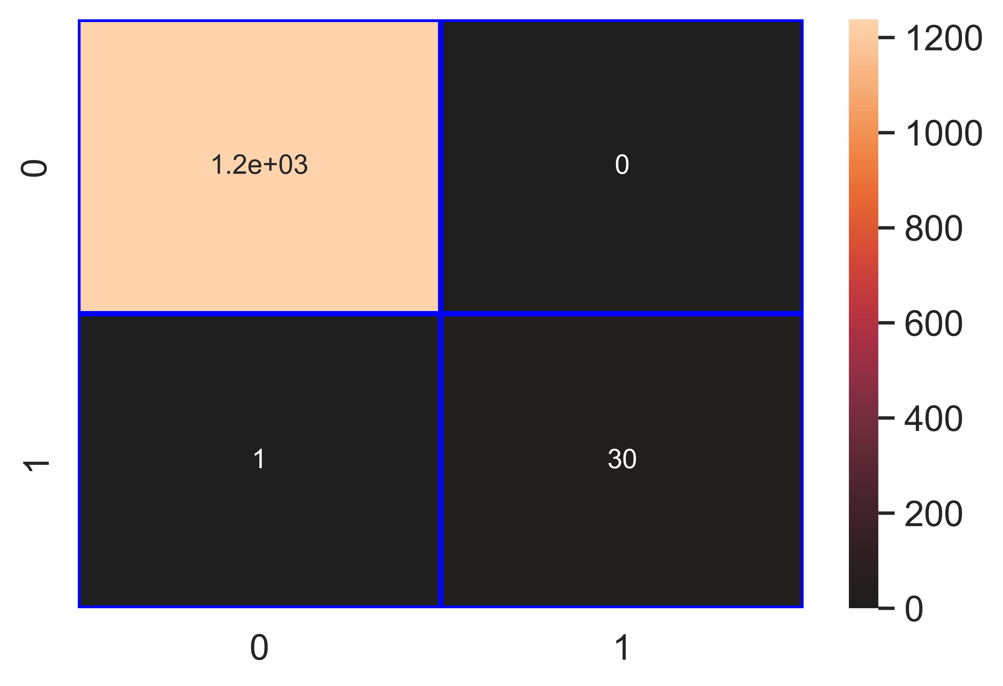

File saved : Fusarium_Wilt_dt_Classifier.pkl

data : {'Accuracy': 99.92, 'Loss': 0.08, 'Precision': 100.0, 'Recall': 96.77, 'f1_score': 98.36, 'Cohen_kappa': 98.32, 'Feature_name': 'Fusarium Wilt', 'Model_name': 'dt_Classifier', 'Filename': 'Fusarium_Wilt_dt_Classifier.pkl'}

Model : rf_Classifier

Accuracy_score : 99.84 %

Loss : 0.16 %

Precision : 100.0 %

Recall : 93.55 %

f1_score : 96.67 %

Cohen_kappa_score : 96.59 %

Classification_report :   
 precision recall f1-score support  
  
 0 1.00 1.00 1.00 1238  
 1 1.00 0.94 0.97 31  
  
 accuracy 1.00 1269  
 macro avg 1.00 0.97 0.98 1269  
weighted avg 1.00 1.00 1.00 1269

Confusion_matrix :   
[[1238 0]  
 [ 2 29]]

### Image of images/Fusarium_Wilt_rf_Classifier_Accuracy_100.png :



File saved : Fusarium_Wilt_rf_Classifier.pkl

data : {'Accuracy': 99.84, 'Loss': 0.16, 'Precision': 100.0, 'Recall': 93.55, 'f1_score': 96.67, 'Cohen_kappa': 96.59, 'Feature_name': 'Fusarium Wilt', 'Model_name': 'rf_Classifier', 'Filename': 'Fusarium_Wilt_rf_Classifier.pkl'}

Model : gb_Classifier

Accuracy_score : 99.84 %

Loss : 0.16 %

Precision : 100.0 %

Recall : 93.55 %

f1_score : 96.67 %

Cohen_kappa_score : 96.59 %

Classification_report :   
 precision recall f1-score support  
  
 0 1.00 1.00 1.00 1238  
 1 1.00 0.94 0.97 31  
  
 accuracy 1.00 1269  
 macro avg 1.00 0.97 0.98 1269  
weighted avg 1.00 1.00 1.00 1269

Confusion_matrix :   
[[1238 0]  
 [ 2 29]]

### Image of images/Fusarium_Wilt_gb_Classifier_Accuracy_100.png :



File saved : Fusarium_Wilt_gb_Classifier.pkl

data : {'Accuracy': 99.84, 'Loss': 0.16, 'Precision': 100.0, 'Recall': 93.55, 'f1_score': 96.67, 'Cohen_kappa': 96.59, 'Feature_name': 'Fusarium Wilt', 'Model_name': 'gb_Classifier', 'Filename': 'Fusarium_Wilt_gb_Classifier.pkl'}

Model : ab_Classifier

Accuracy_score : 99.84 %

Loss : 0.16 %

Precision : 100.0 %

Recall : 93.55 %

f1_score : 96.67 %

Cohen_kappa_score : 96.59 %

Classification_report :   
 precision recall f1-score support  
  
 0 1.00 1.00 1.00 1238  
 1 1.00 0.94 0.97 31  
  
 accuracy 1.00 1269  
 macro avg 1.00 0.97 0.98 1269  
weighted avg 1.00 1.00 1.00 1269

Confusion_matrix :   
[[1238 0]  
 [ 2 29]]

### Image of images/Fusarium_Wilt_ab_Classifier_Accuracy_100.png :



File saved : Fusarium_Wilt_ab_Classifier.pkl

data : {'Accuracy': 99.84, 'Loss': 0.16, 'Precision': 100.0, 'Recall': 93.55, 'f1_score': 96.67, 'Cohen_kappa': 96.59, 'Feature_name': 'Fusarium Wilt', 'Model_name': 'ab_Classifier', 'Filename': 'Fusarium_Wilt_ab_Classifier.pkl'}

## Column : Fruit Borer / Blight Blora

Model : lr_Classifier

Accuracy_score : 95.59 %

Loss : 4.41 %

Precision : 86.29 %

Recall : 90.68 %

f1_score : 88.43 %

Cohen_kappa_score : 85.71 %

Classification_report :   
 precision recall f1-score support  
  
 0 0.98 0.97 0.97 1033  
 1 0.86 0.91 0.88 236  
  
 accuracy 0.96 1269  
 macro avg 0.92 0.94 0.93 1269  
weighted avg 0.96 0.96 0.96 1269

Confusion_matrix :   
[[999 34]  
 [ 22 214]]

### Image of images/Fruit_Borer_Blight_Blora_lr_Classifier_Accuracy_96.png :

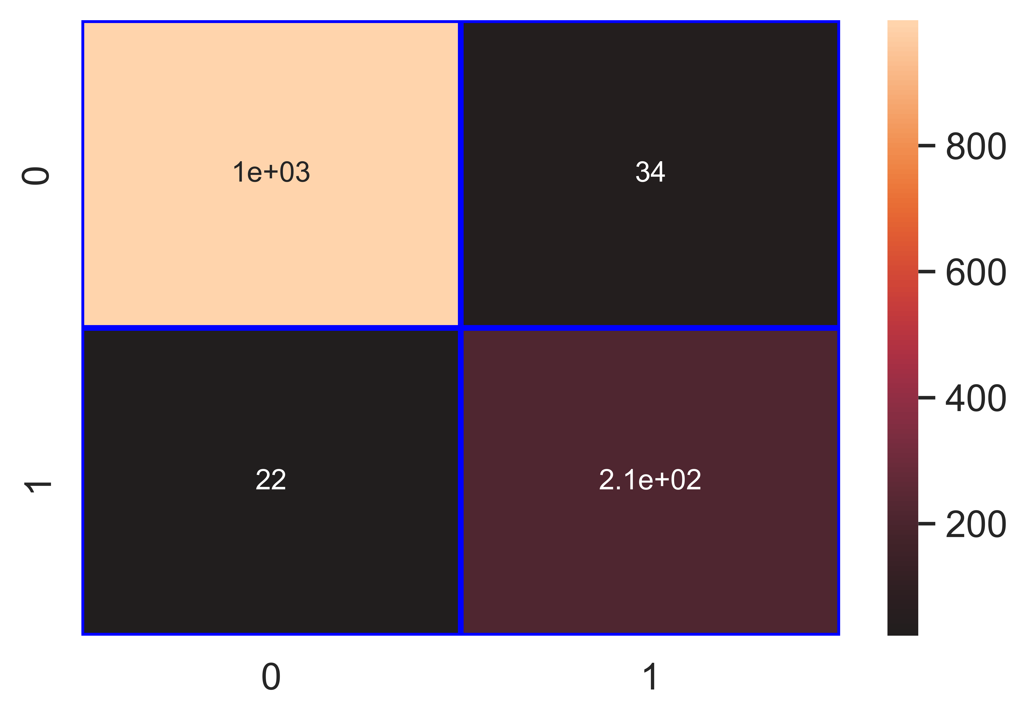

File saved : Fruit_Borer_Blight_Blora_lr_Classifier.pkl

data : {'Accuracy': 95.59, 'Loss': 4.41, 'Precision': 86.29, 'Recall': 90.68, 'f1_score': 88.43, 'Cohen_kappa': 85.71, 'Feature_name': 'Fruit Borer / Blight Blora', 'Model_name': 'lr_Classifier', 'Filename': 'Fruit_Borer_Blight_Blora_lr_Classifier.pkl'}

Model : knn_Classifier

Accuracy_score : 98.19 %

Loss : 1.81 %

Precision : 93.12 %

Recall : 97.46 %

f1_score : 95.24 %

Cohen_kappa_score : 94.12 %

Classification_report :   
 precision recall f1-score support  
  
 0 0.99 0.98 0.99 1033  
 1 0.93 0.97 0.95 236  
  
 accuracy 0.98 1269  
 macro avg 0.96 0.98 0.97 1269  
weighted avg 0.98 0.98 0.98 1269

Confusion_matrix :   
[[1016 17]  
 [ 6 230]]

### Image of images/Fruit_Borer_Blight_Blora_knn_Classifier_Accuracy_98.png :

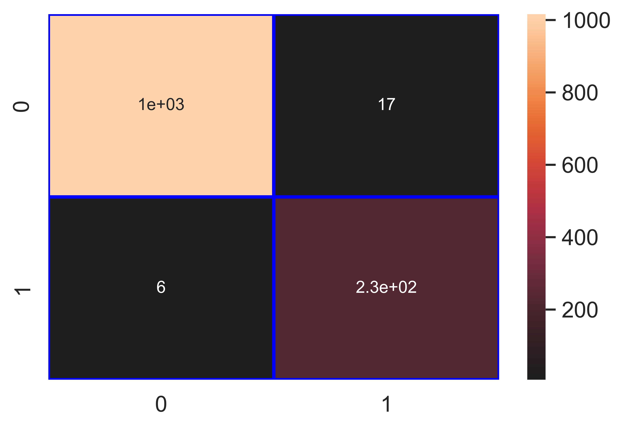

File saved : Fruit_Borer_Blight_Blora_knn_Classifier.pkl

data : {'Accuracy': 98.19, 'Loss': 1.81, 'Precision': 93.12, 'Recall': 97.46, 'f1_score': 95.24, 'Cohen_kappa': 94.12, 'Feature_name': 'Fruit Borer / Blight Blora', 'Model_name': 'knn_Classifier', 'Filename': 'Fruit_Borer_Blight_Blora_knn_Classifier.pkl'}

Model : nb_Classifier

Accuracy_score : 91.73 %

Loss : 8.27 %

Precision : 70.03 %

Recall : 97.03 %

f1_score : 81.35 %

Cohen_kappa_score : 76.21 %

Classification_report :   
 precision recall f1-score support  
  
 0 0.99 0.91 0.95 1033  
 1 0.70 0.97 0.81 236  
  
 accuracy 0.92 1269  
 macro avg 0.85 0.94 0.88 1269  
weighted avg 0.94 0.92 0.92 1269

Confusion_matrix :   
[[935 98]  
 [ 7 229]]

### Image of images/Fruit_Borer_Blight_Blora_nb_Classifier_Accuracy_92.png :

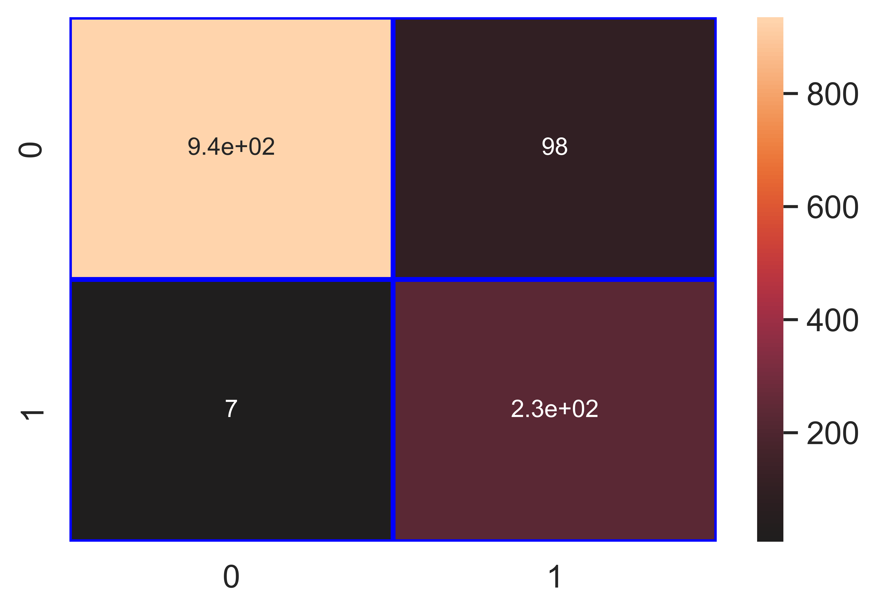

File saved : Fruit_Borer_Blight_Blora_nb_Classifier.pkl

data : {'Accuracy': 91.73, 'Loss': 8.27, 'Precision': 70.03, 'Recall': 97.03, 'f1_score': 81.35, 'Cohen_kappa': 76.21, 'Feature_name': 'Fruit Borer / Blight Blora', 'Model_name': 'nb_Classifier', 'Filename': 'Fruit_Borer_Blight_Blora_nb_Classifier.pkl'}

Model : svm_Classifier

Accuracy_score : 95.82 %

Loss : 4.18 %

Precision : 98.41 %

Recall : 78.81 %

f1_score : 87.53 %

Cohen_kappa_score : 85.06 %

Classification_report :   
 precision recall f1-score support  
  
 0 0.95 1.00 0.97 1033  
 1 0.98 0.79 0.88 236  
  
 accuracy 0.96 1269  
 macro avg 0.97 0.89 0.93 1269  
weighted avg 0.96 0.96 0.96 1269

Confusion_matrix :   
[[1030 3]  
 [ 50 186]]

### Image of images/Fruit_Borer_Blight_Blora_svm_Classifier_Accuracy_96.png :

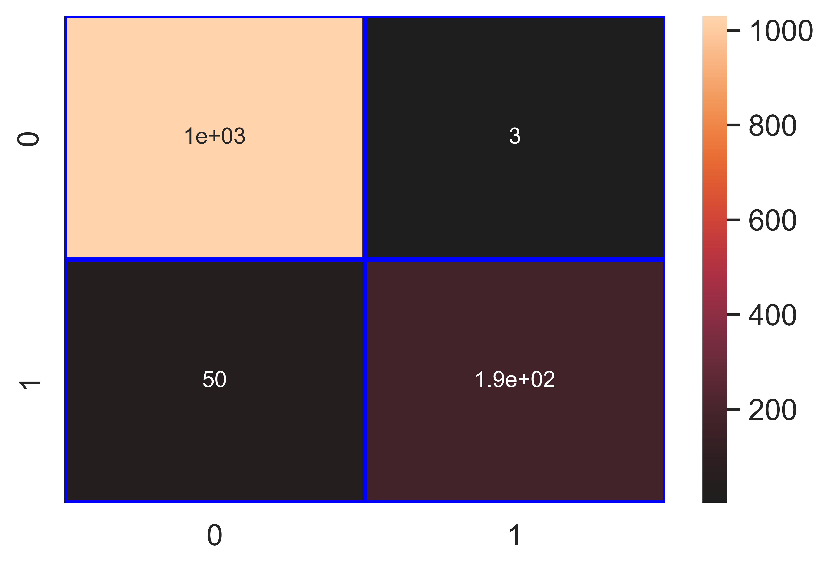

File saved : Fruit_Borer_Blight_Blora_svm_Classifier.pkl

data : {'Accuracy': 95.82, 'Loss': 4.18, 'Precision': 98.41, 'Recall': 78.81, 'f1_score': 87.53, 'Cohen_kappa': 85.06, 'Feature_name': 'Fruit Borer / Blight Blora', 'Model_name': 'svm_Classifier', 'Filename': 'Fruit_Borer_Blight_Blora_svm_Classifier.pkl'}

Model : dt_Classifier

Accuracy_score : 99.76 %

Loss : 0.24 %

Precision : 99.57 %

Recall : 99.15 %

f1_score : 99.36 %

Cohen_kappa_score : 99.22 %

Classification_report :   
 precision recall f1-score support  
  
 0 1.00 1.00 1.00 1033  
 1 1.00 0.99 0.99 236  
  
 accuracy 1.00 1269  
 macro avg 1.00 1.00 1.00 1269  
weighted avg 1.00 1.00 1.00 1269

Confusion_matrix :   
[[1032 1]  
 [ 2 234]]

### Image of images/Fruit_Borer_Blight_Blora_dt_Classifier_Accuracy_100.png :

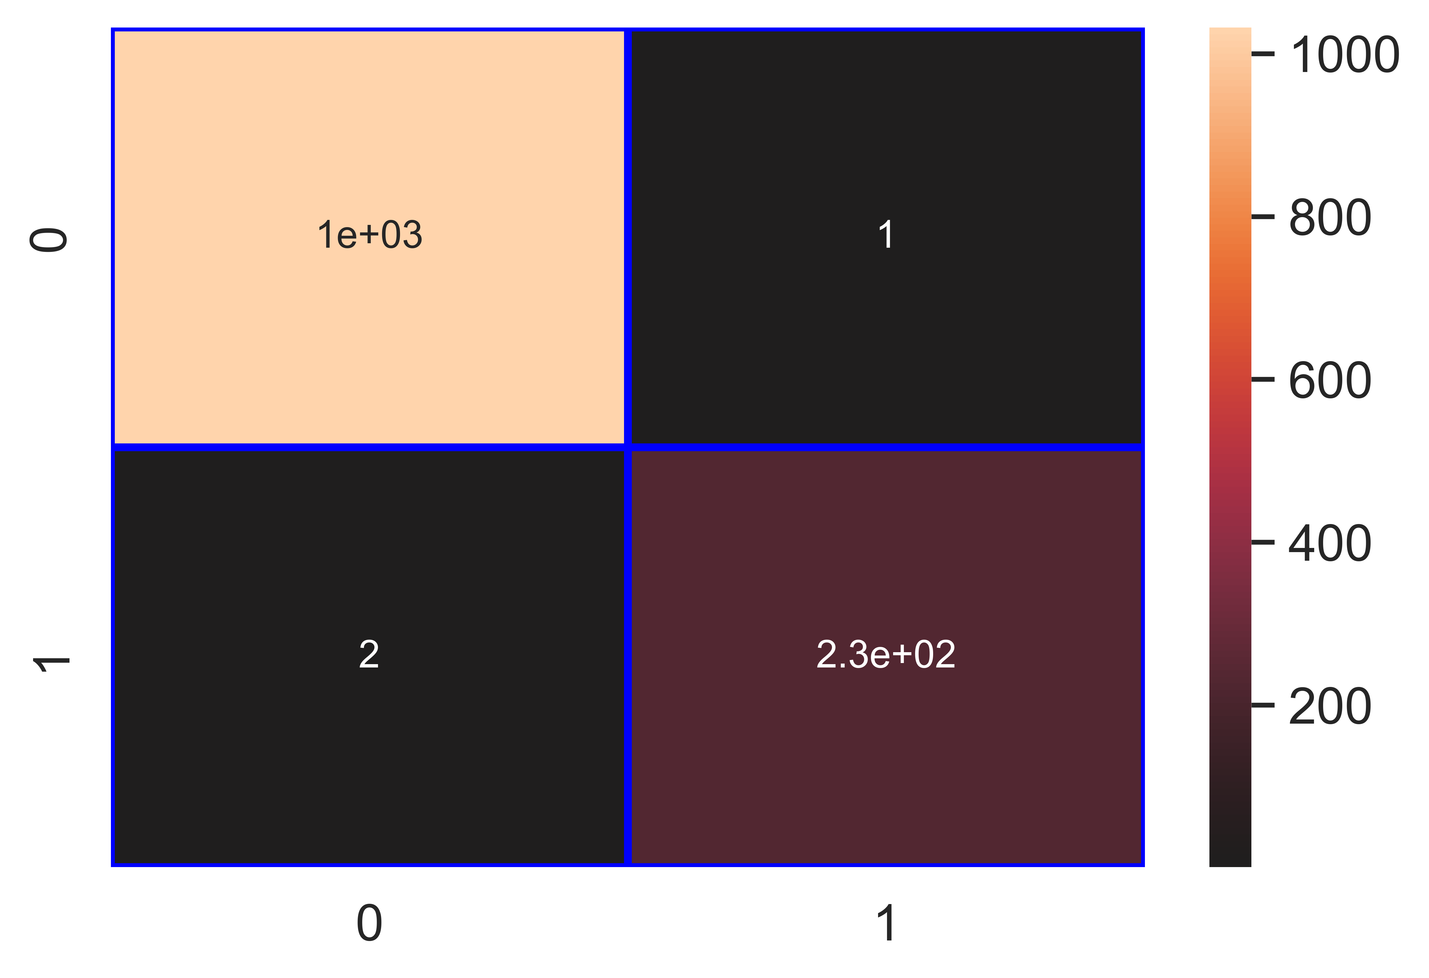

File saved : Fruit_Borer_Blight_Blora_dt_Classifier.pkl

data : {'Accuracy': 99.76, 'Loss': 0.24, 'Precision': 99.57, 'Recall': 99.15, 'f1_score': 99.36, 'Cohen_kappa': 99.22, 'Feature_name': 'Fruit Borer / Blight Blora', 'Model_name': 'dt_Classifier', 'Filename': 'Fruit_Borer_Blight_Blora_dt_Classifier.pkl'}

Model : rf_Classifier

Accuracy_score : 99.68 %

Loss : 0.32 %

Precision : 99.15 %

Recall : 99.15 %

f1_score : 99.15 %

Cohen_kappa_score : 98.96 %

Classification_report :   
 precision recall f1-score support  
  
 0 1.00 1.00 1.00 1033  
 1 0.99 0.99 0.99 236  
  
 accuracy 1.00 1269  
 macro avg 0.99 0.99 0.99 1269  
weighted avg 1.00 1.00 1.00 1269

Confusion_matrix :   
[[1031 2]  
 [ 2 234]]

### Image of images/Fruit_Borer_Blight_Blora_rf_Classifier_Accuracy_100.png :

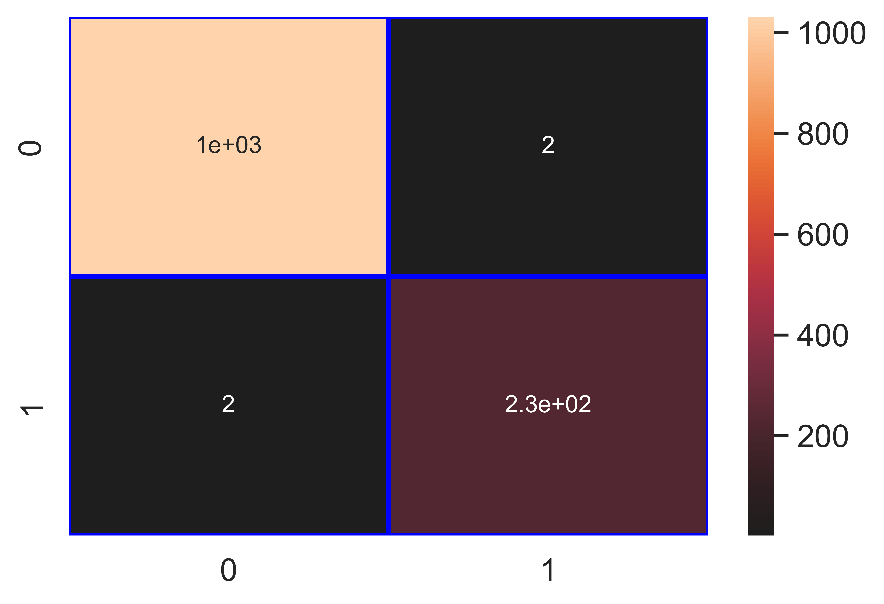

File saved : Fruit_Borer_Blight_Blora_rf_Classifier.pkl

data : {'Accuracy': 99.68, 'Loss': 0.32, 'Precision': 99.15, 'Recall': 99.15, 'f1_score': 99.15, 'Cohen_kappa': 98.96, 'Feature_name': 'Fruit Borer / Blight Blora', 'Model_name': 'rf_Classifier', 'Filename': 'Fruit_Borer_Blight_Blora_rf_Classifier.pkl'}

Model : gb_Classifier

Accuracy_score : 99.68 %

Loss : 0.32 %

Precision : 99.15 %

Recall : 99.15 %

f1_score : 99.15 %

Cohen_kappa_score : 98.96 %

Classification_report :   
 precision recall f1-score support  
  
 0 1.00 1.00 1.00 1033  
 1 0.99 0.99 0.99 236  
  
 accuracy 1.00 1269  
 macro avg 0.99 0.99 0.99 1269  
weighted avg 1.00 1.00 1.00 1269

Confusion_matrix :   
[[1031 2]  
 [ 2 234]]

### Image of images/Fruit_Borer_Blight_Blora_gb_Classifier_Accuracy_100.png :



File saved : Fruit_Borer_Blight_Blora_gb_Classifier.pkl

data : {'Accuracy': 99.68, 'Loss': 0.32, 'Precision': 99.15, 'Recall': 99.15, 'f1_score': 99.15, 'Cohen_kappa': 98.96, 'Feature_name': 'Fruit Borer / Blight Blora', 'Model_name': 'gb_Classifier', 'Filename': 'Fruit_Borer_Blight_Blora_gb_Classifier.pkl'}

Model : ab_Classifier

Accuracy_score : 99.76 %

Loss : 0.24 %

Precision : 99.57 %

Recall : 99.15 %

f1_score : 99.36 %

Cohen_kappa_score : 99.22 %

Classification_report :   
 precision recall f1-score support  
  
 0 1.00 1.00 1.00 1033  
 1 1.00 0.99 0.99 236  
  
 accuracy 1.00 1269  
 macro avg 1.00 1.00 1.00 1269  
weighted avg 1.00 1.00 1.00 1269

Confusion_matrix :   
[[1032 1]  
 [ 2 234]]

### Image of images/Fruit_Borer_Blight_Blora_ab_Classifier_Accuracy_100.png :



File saved : Fruit_Borer_Blight_Blora_ab_Classifier.pkl

data : {'Accuracy': 99.76, 'Loss': 0.24, 'Precision': 99.57, 'Recall': 99.15, 'f1_score': 99.36, 'Cohen_kappa': 99.22, 'Feature_name': 'Fruit Borer / Blight Blora', 'Model_name': 'ab_Classifier', 'Filename': 'Fruit_Borer_Blight_Blora_ab_Classifier.pkl'}